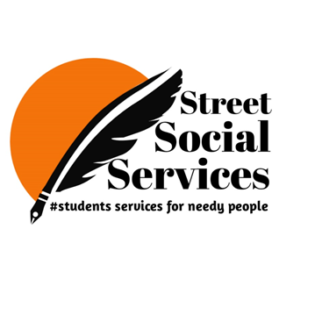

**STREET SOCIAL SERVICES**

Street social services is an initiative taken by us (the students of Malla Reddy Engineering College) to work and contribute our share to the society, the agenda is mainly to help those in need of basic essential commodities at these very tough times, it’s only fair that everyone in the country deserve to not suffer the wrath of hunger especially when you are unnoticed, lying around the streets because you don’t have place to live in. We felt it’s our responsibility to do something about it; we came up with some exciting events within the funds and budget we have, in the span of 1 year we were able to feed 600 people and distribute groceries to 100 families, distributed blankets to 140 people who are sleeping beside the roads, conducted vaccination drive in MALLA REDDY ENGINEERING COLLEGE, 900 people (students and faculties) are benefited from this event and also conducted different competitions in college to encourage the talent of students.

**ORGANIZATION NAME: STREET SOCIAL SERVICES**

**STARTED: 1st April 2021**

**EXECUTIVE MEMBERS:**

**K. GIRI BHARGAV (President)**

**M. KALYAN (Vice – President)**

**T. NITHIN (General Secretary)**

**P. CHANDU (Joint Secretary)**

**G. SAI RAM (Treasurer)**

**P. VISHAL (Event Organizer)**

**K. AJAY (Executive Member)**

**CH. PRUDHVI (Executive Member)**

**K. NAVEEN (Executive Member)**

**K. SAI TEJA (Executive Member)**

**A. SWATHI (Executive Member)**

**EVENT-1**

**We have distributed food for around 30 people in KOTHAGUDEM on 11th of April 2021.**

**(By K.GIRI BHARGAV, M.KALYAN, K.SAI TEJA)**

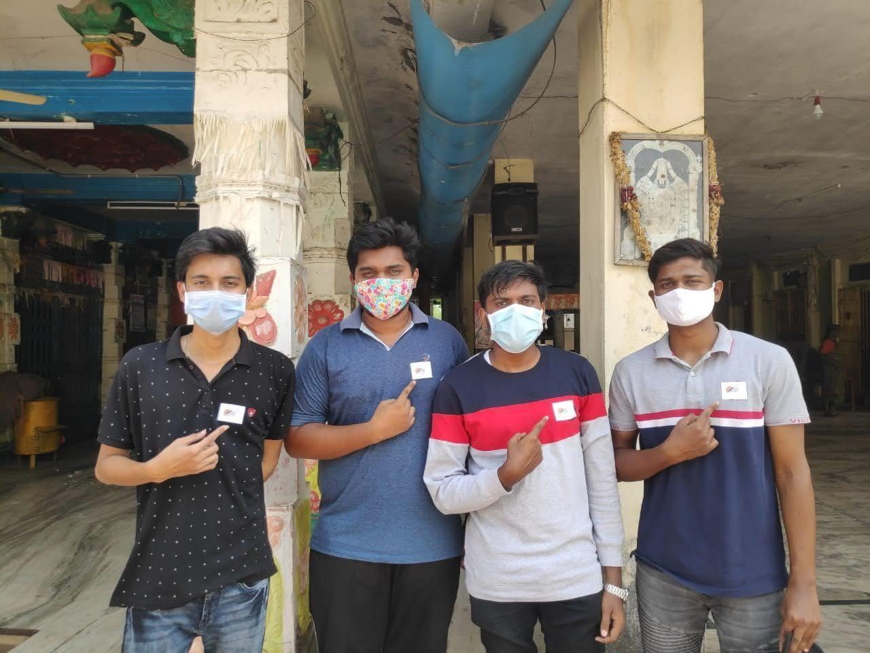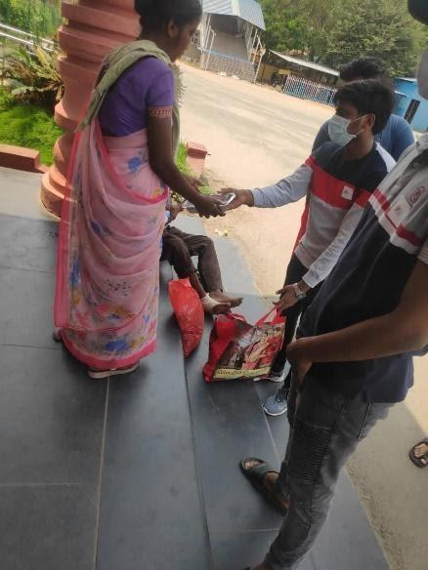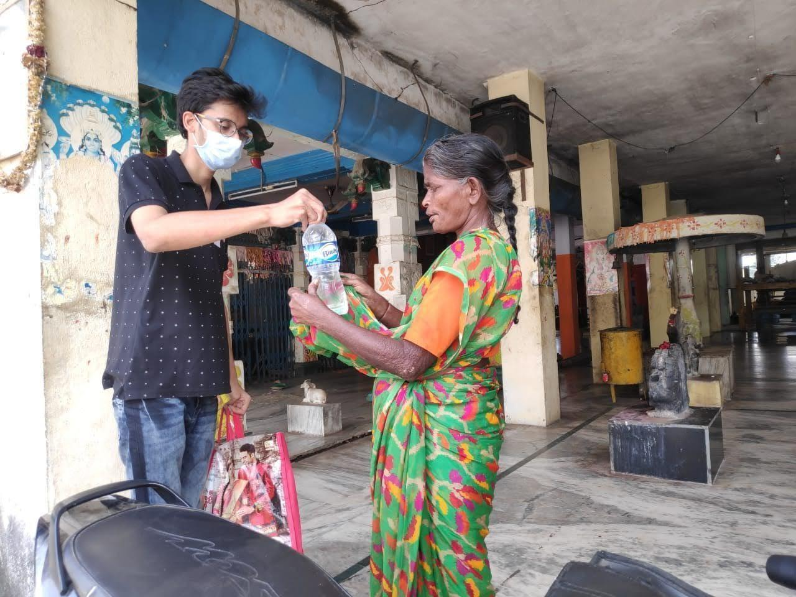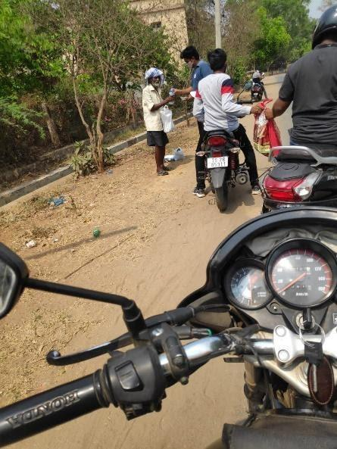

**EVENT-2**

**We have distributed food for around 50 people in KHAMMAM on 13th of April 2021. (By NITHIN SAI)**

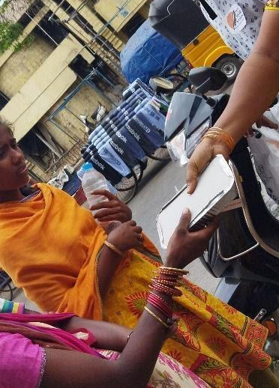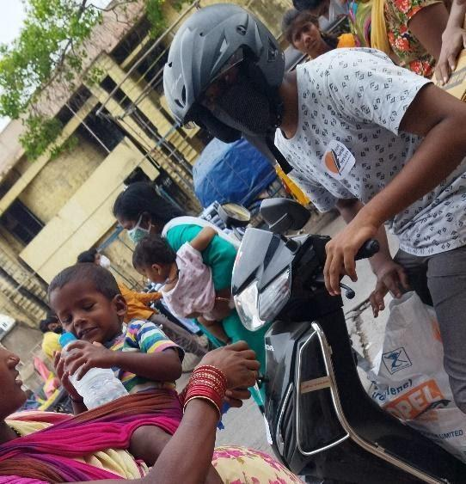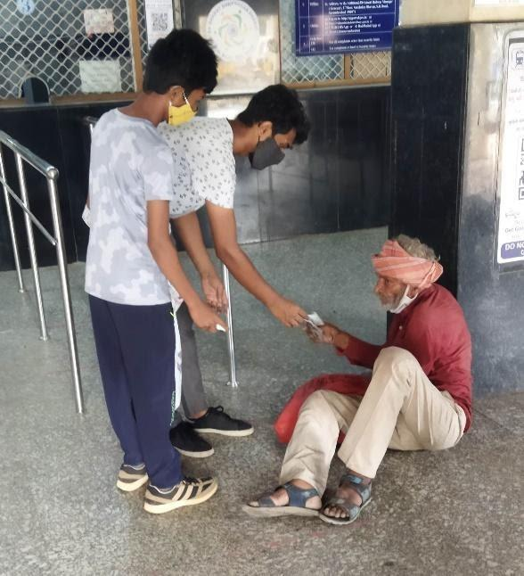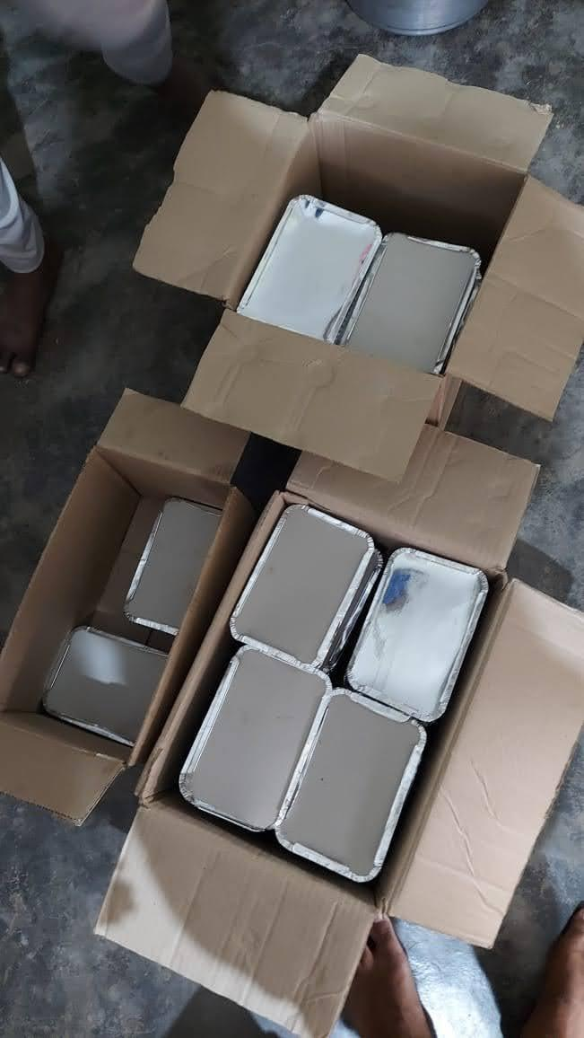

**EVENT-3**

**We have distributed food for around 30 people in KARIMNAGAR on 22nd of April 2021. (By AJAY)**

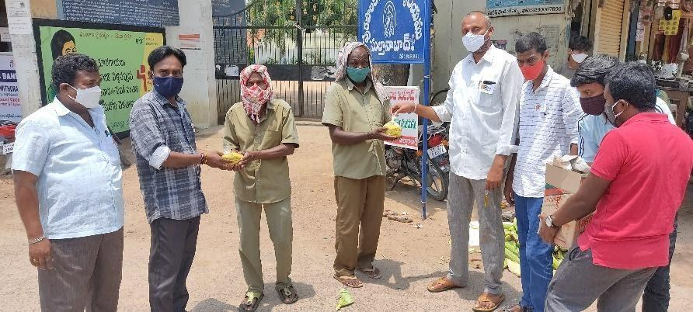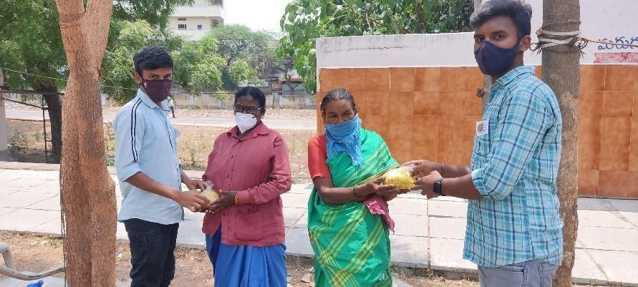

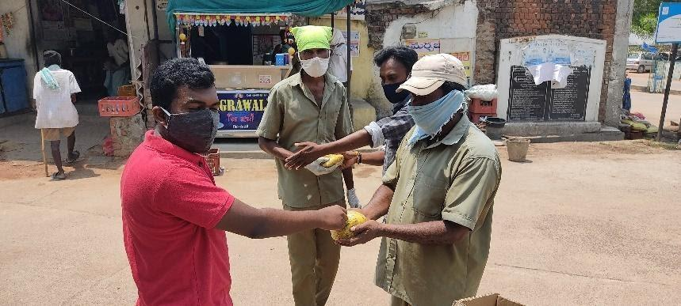

**EVENT-4**

**We have distributed food for around 30 people in MANUGURU on 23rd of April 2021. (By A. SWATHI)**

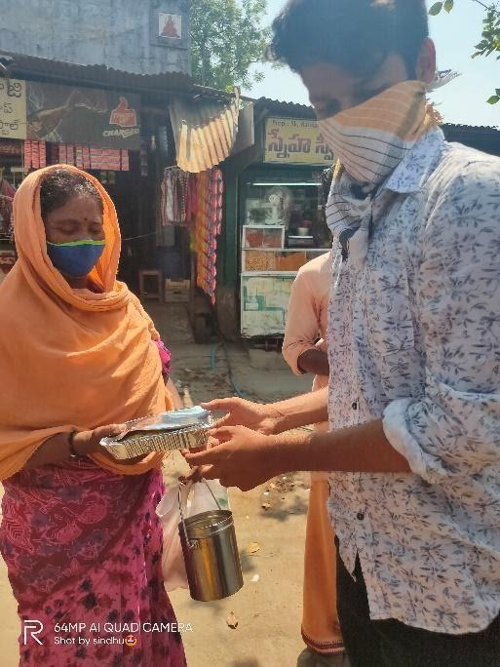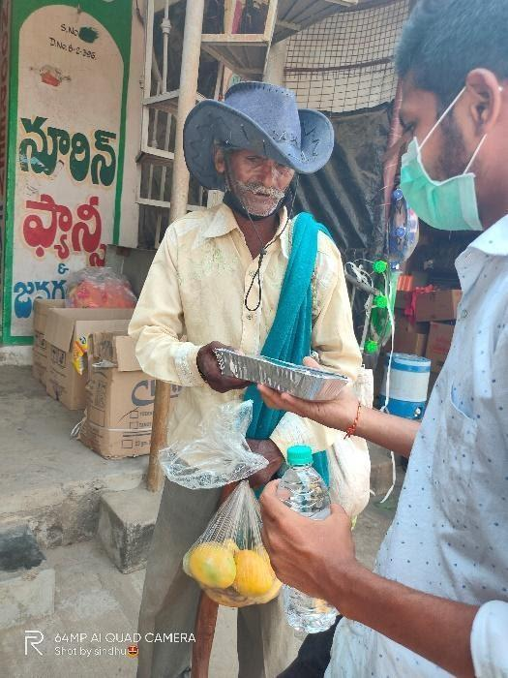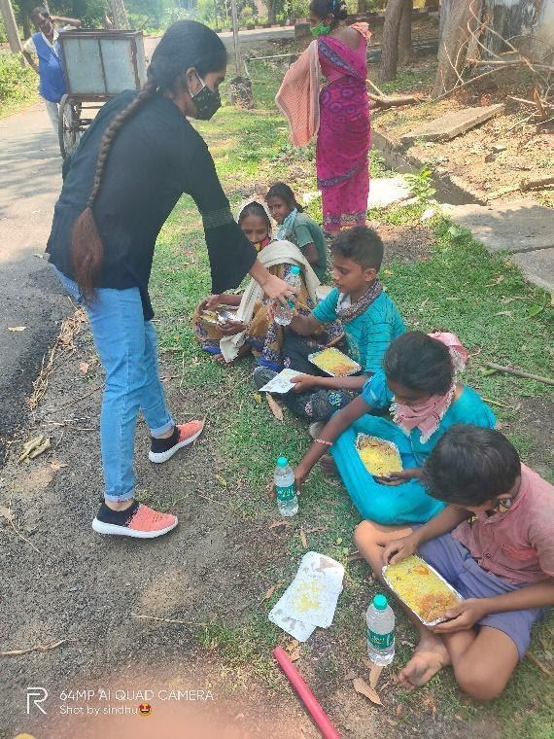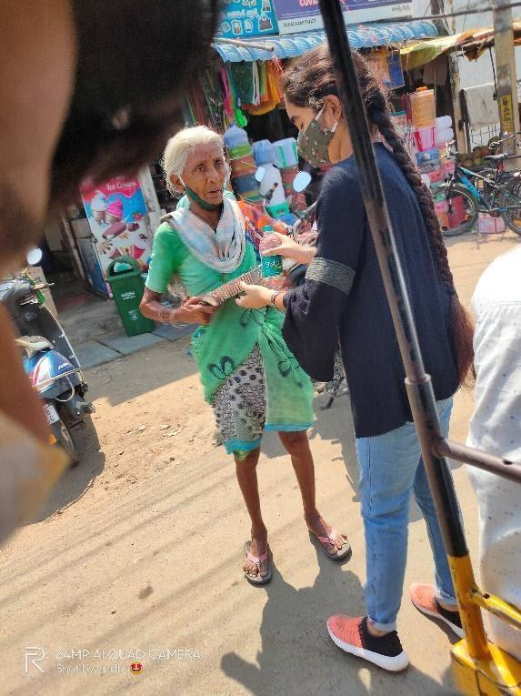

**EVENT-5**

**We have fed street dogs in HYDERABAD on 24th of April 2021. (By NITHIN SAI)**

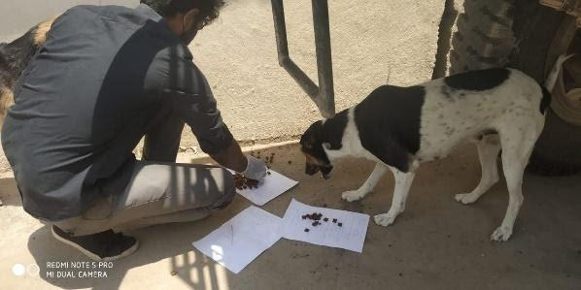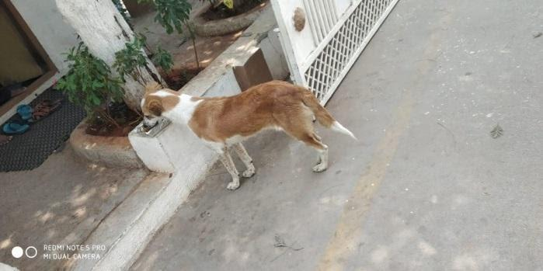

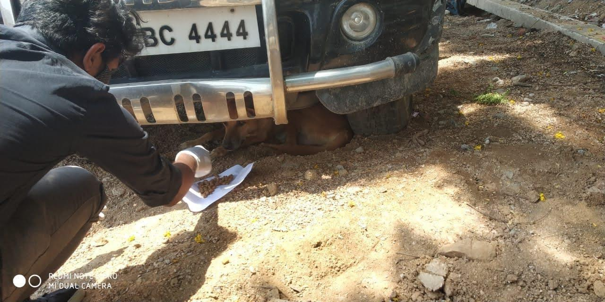

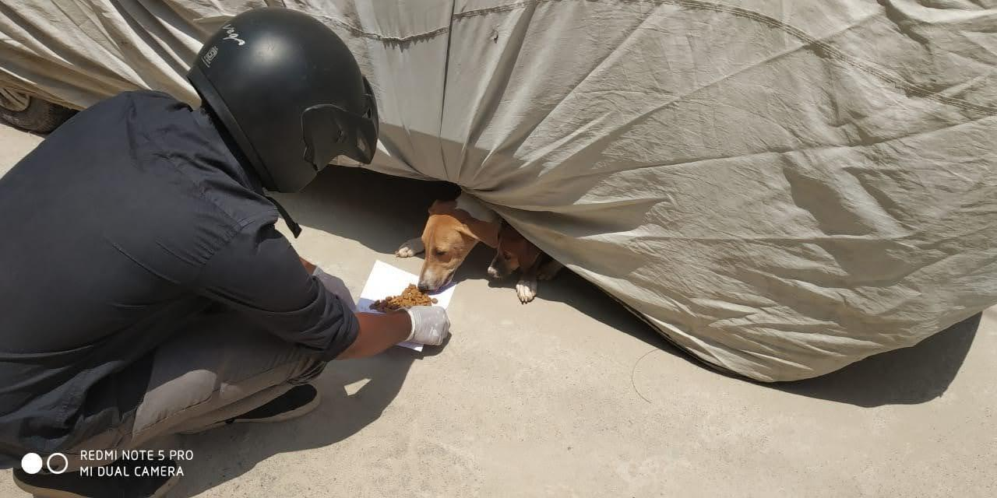

**EVENT-6**

**We have distributed food for around 60 people in WARANGAL on 30th of April 2021. (By SAHANA)**

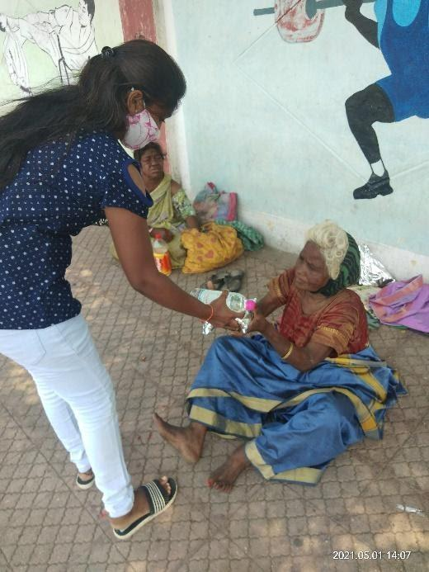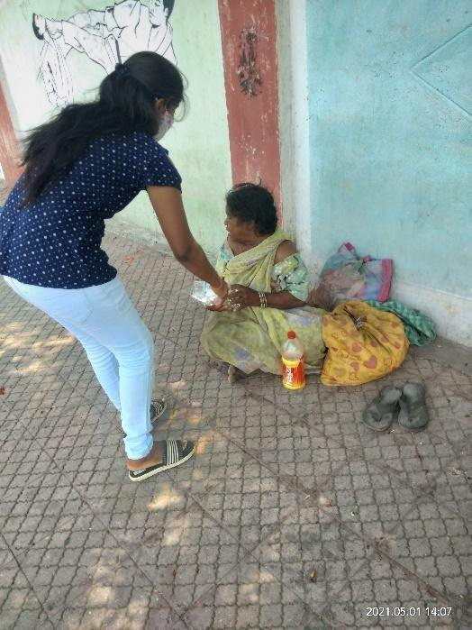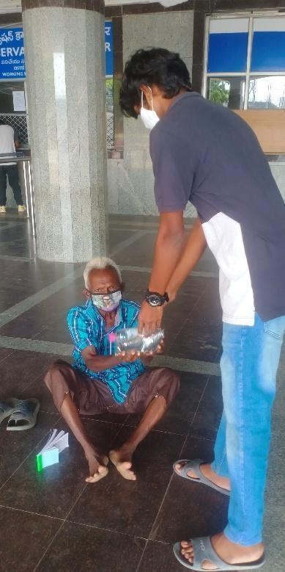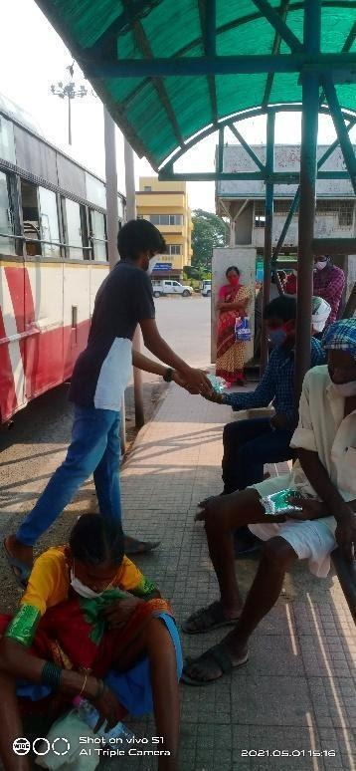

**EVENT-7**

**We have distributed groceries for 10 families in MANUGURU on 29th of May 2021. (By SWATHI)**

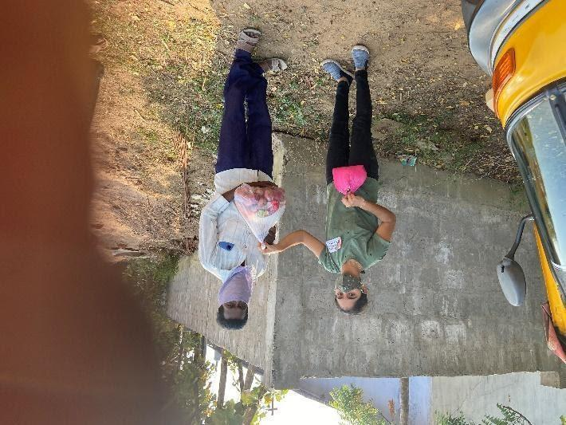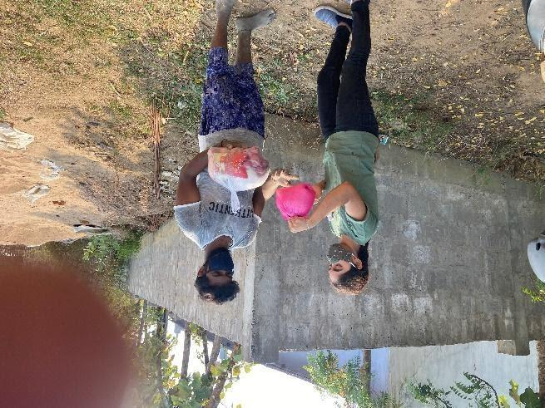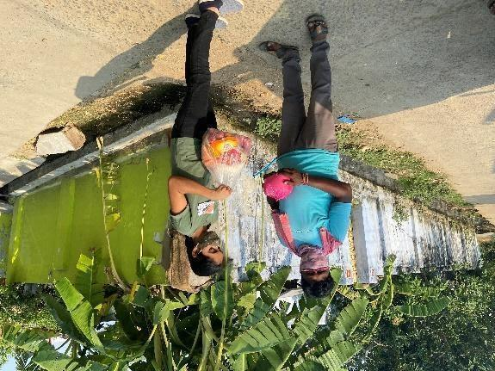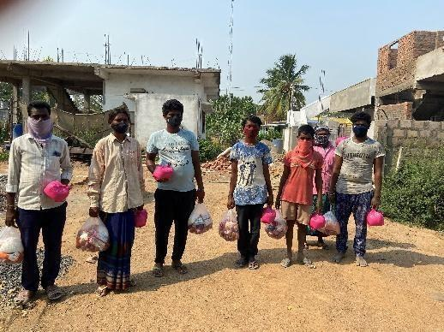

**EVENT-8**

**We have distributed groceries for 10 families in KOTHAGUDEM (rural area)**

**on 2nd of June 2021. (By K. GIRI BHARGAV)**

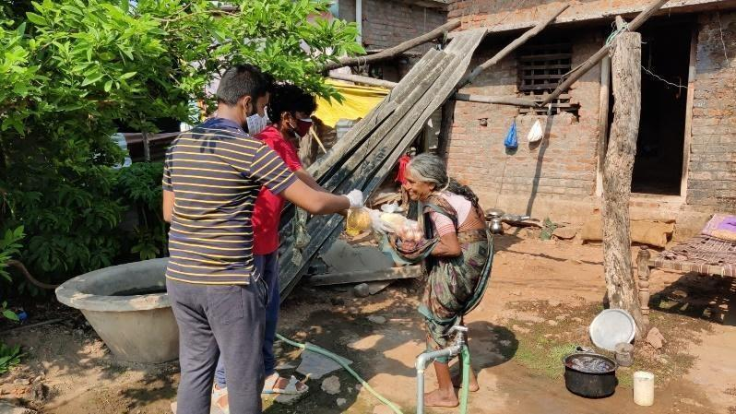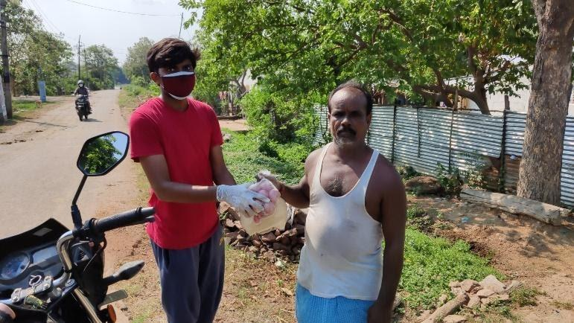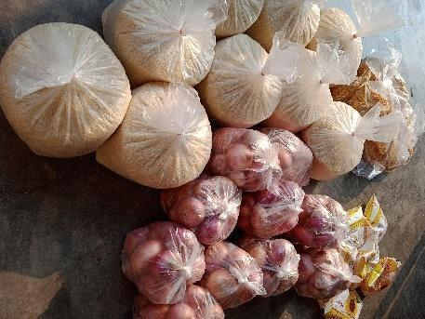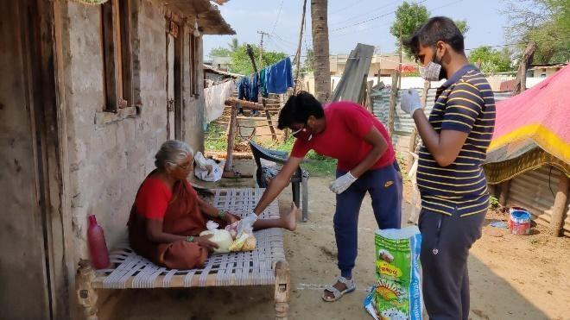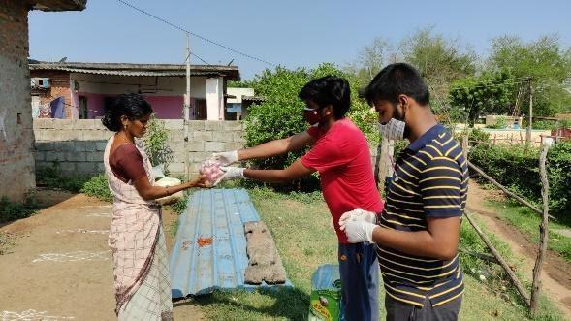

**EVENT-9**

**We have distributed clothes for 20 people in KHAMMAM on 6th of June 2021.**

**(By P. CHANDU)**

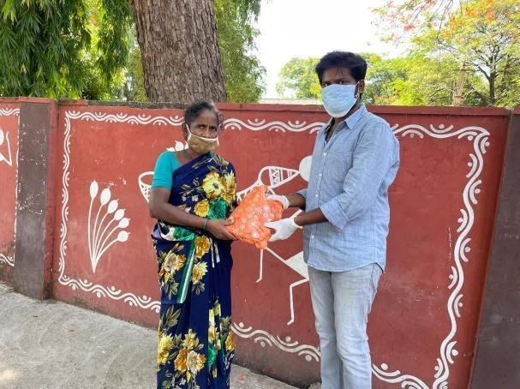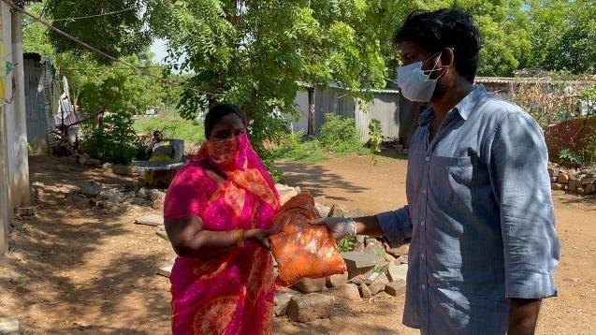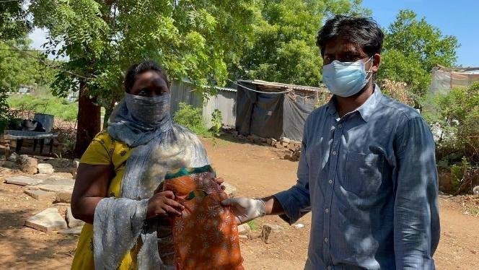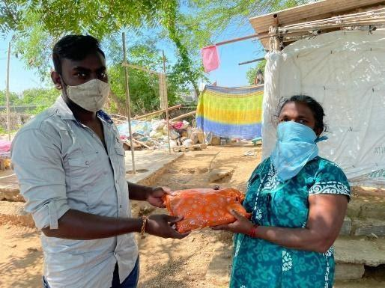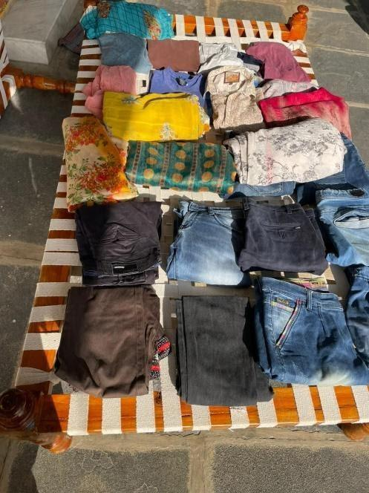

**EVENT-10**

**We have distributed food packets for 50 poor people in KOTHAGUDEM (rural area) on 10th of June 2021. (By M. KALYAN)**

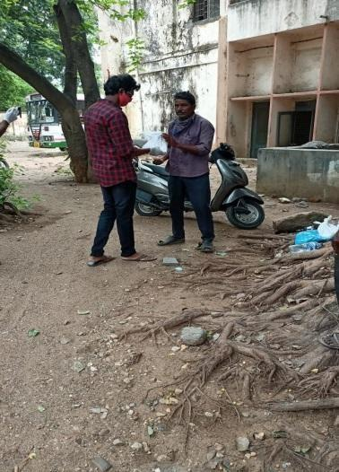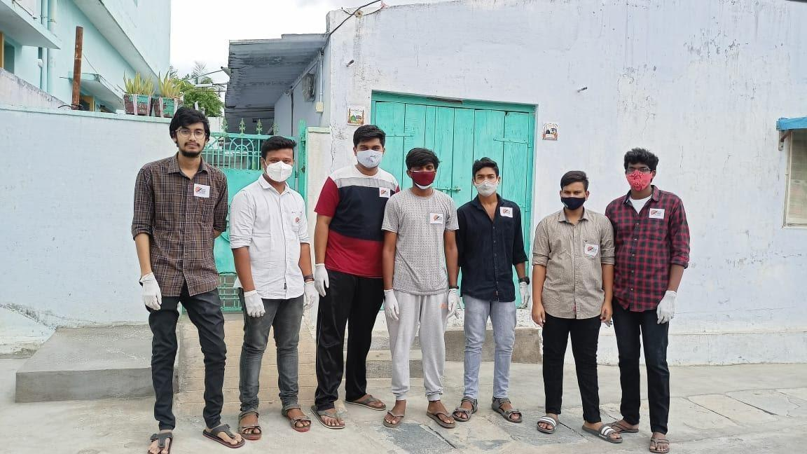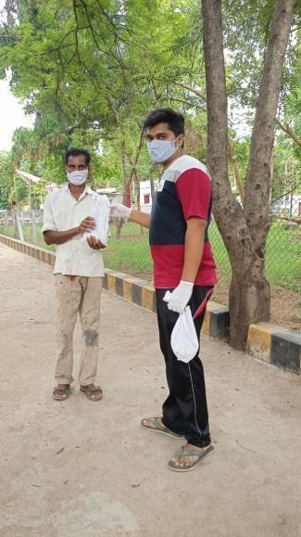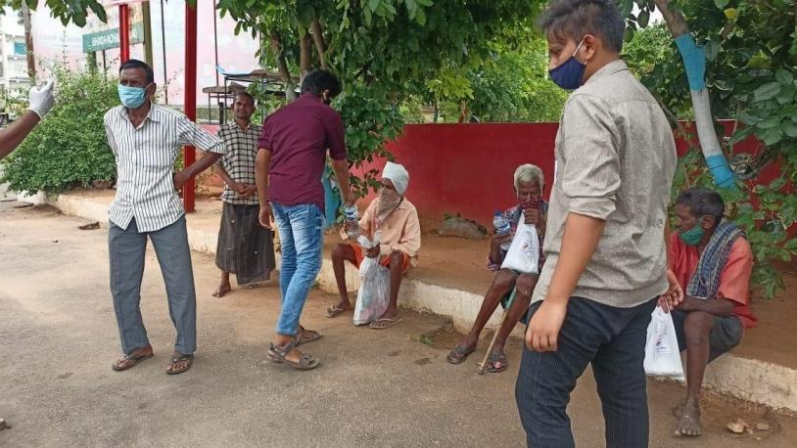

**EVENT-11**

**We have distributed groceries for 10 families in KOTHAGUDEM (rural area) on 13th  of June 2021. (By K. GIRI BHARGAV)**

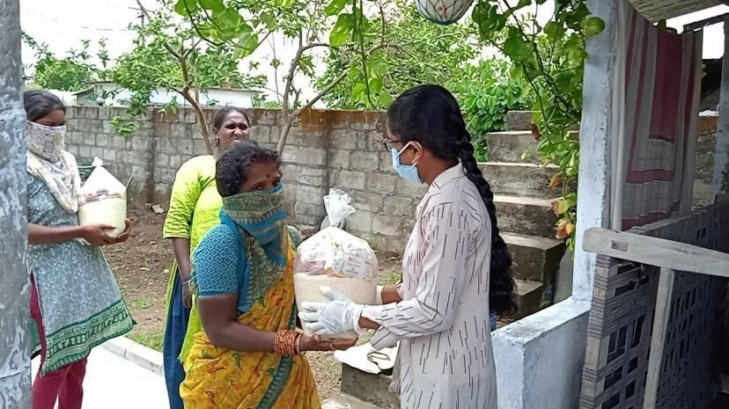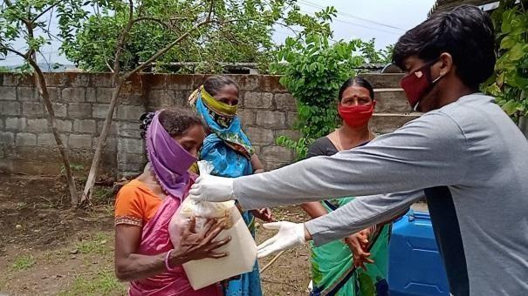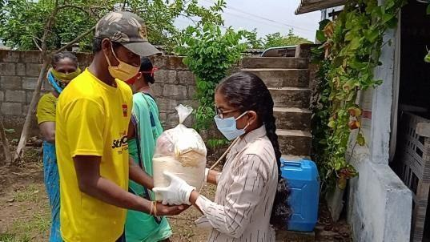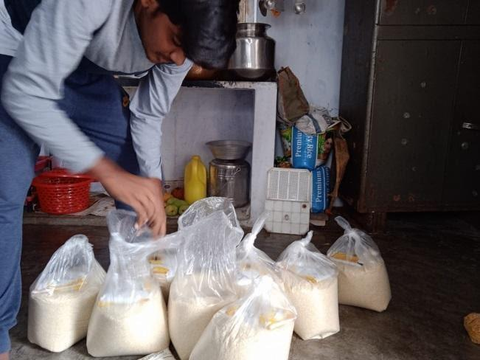**EVENT-12**

**We have distributed groceries for 40 families in KOTHAGUDEM (GANGAMMA COLONY) on 22nd   of June 2021.**

**(By K. GIRI BHARGAV, M KALYAN, YASHWANTH, CH PRUDHVI)**

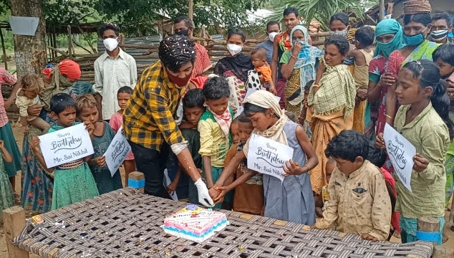**EVENT-13**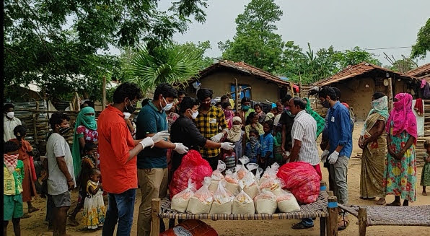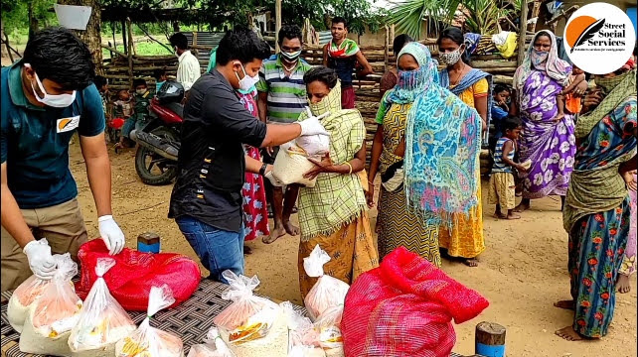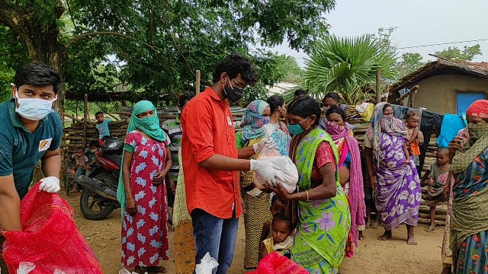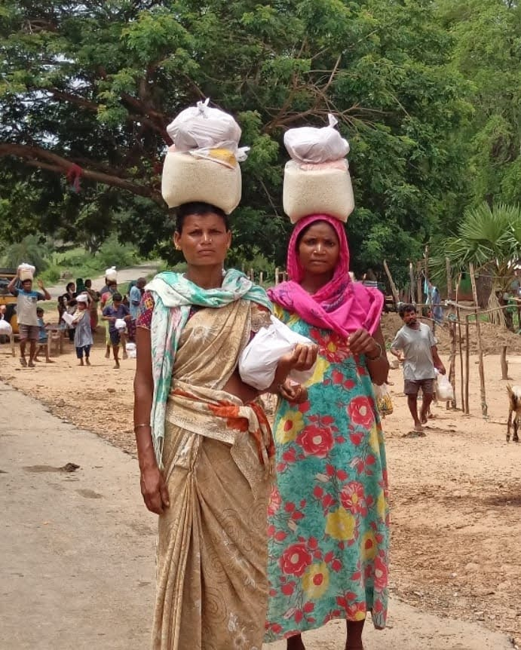

**We have distributed groceries for 30 families in KOTHAGUDEM (KRANTHI NAGAR) on 25th  of June 2021. (By K. GIRI BHARGAV, M KALYAN)**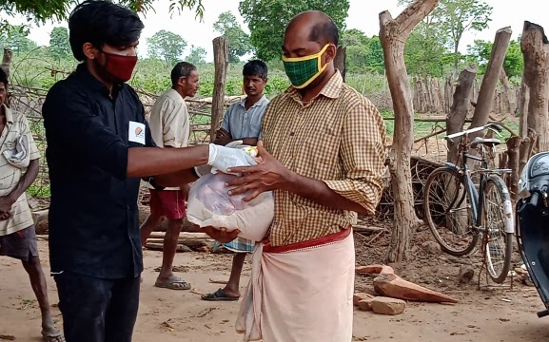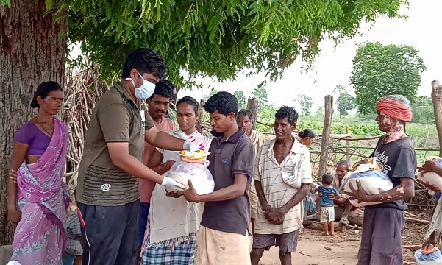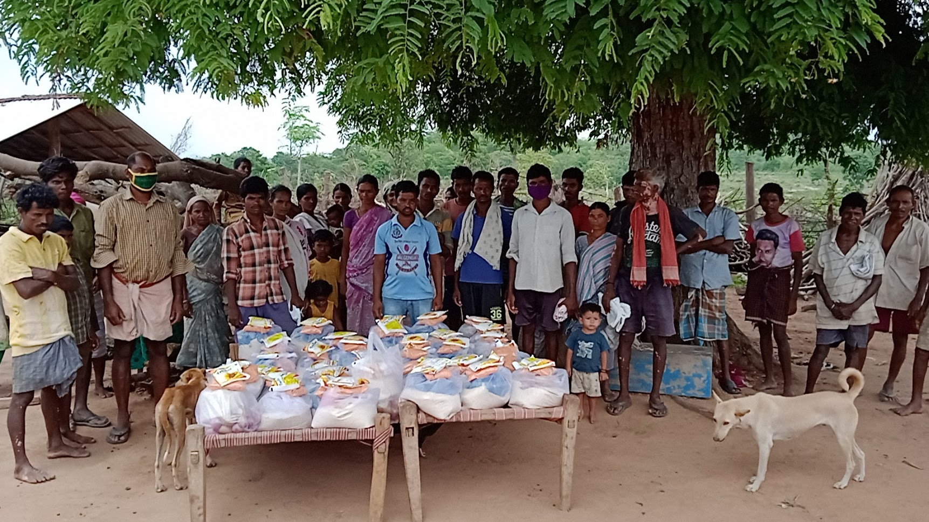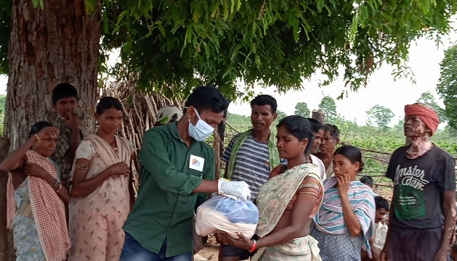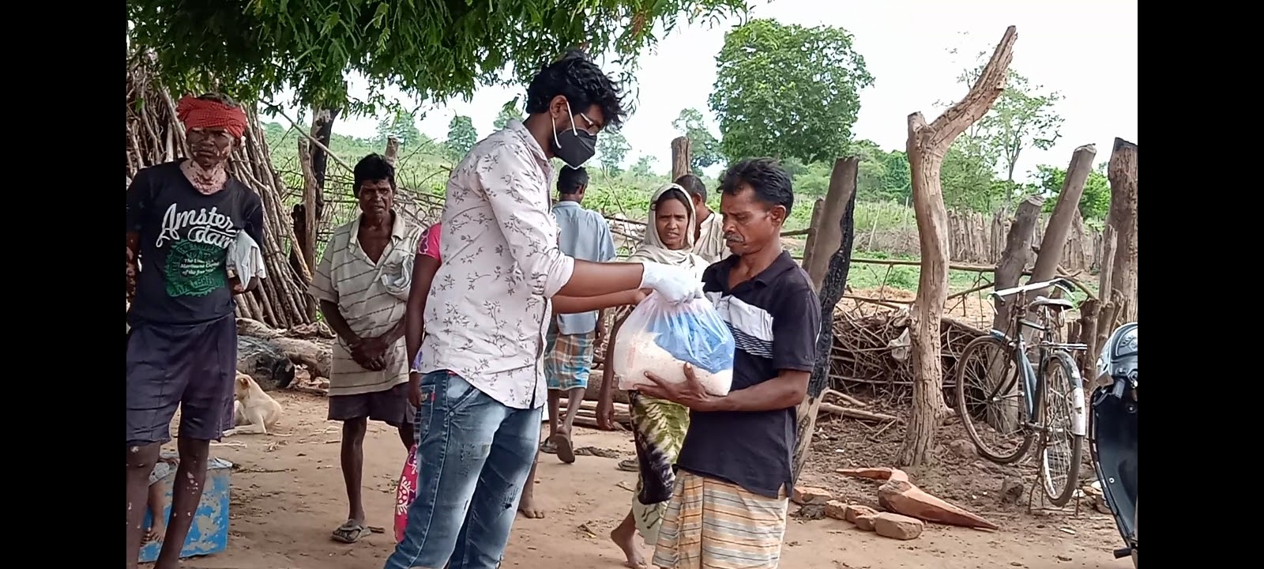

**EVENT-14**

**We have donated food in orphanage (Sri sathya sai samaja seva trust) on the occasion of LASYA’S Birthday**

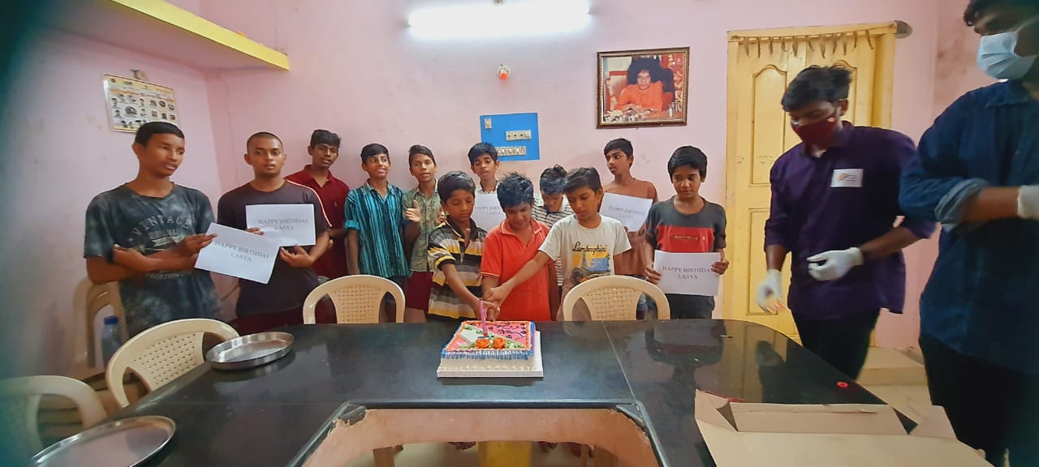

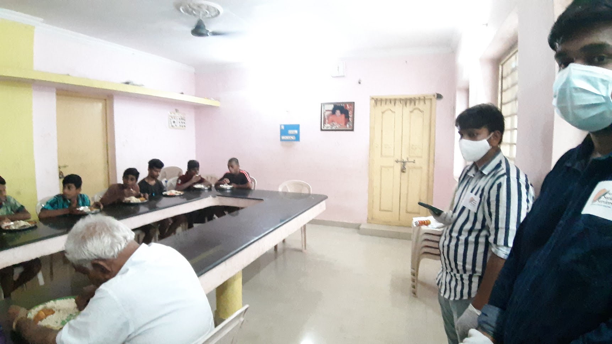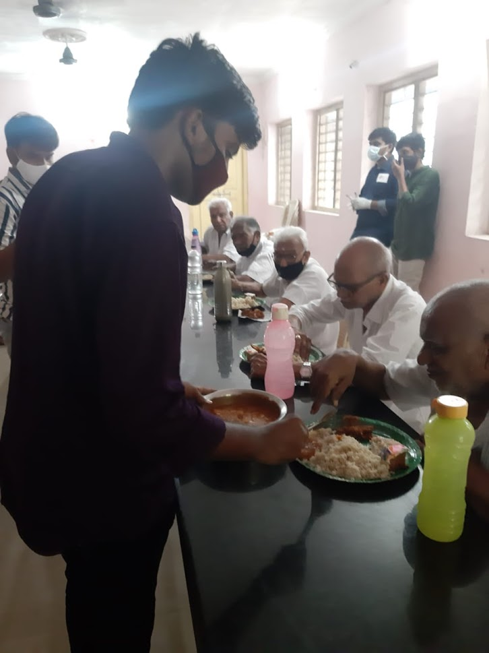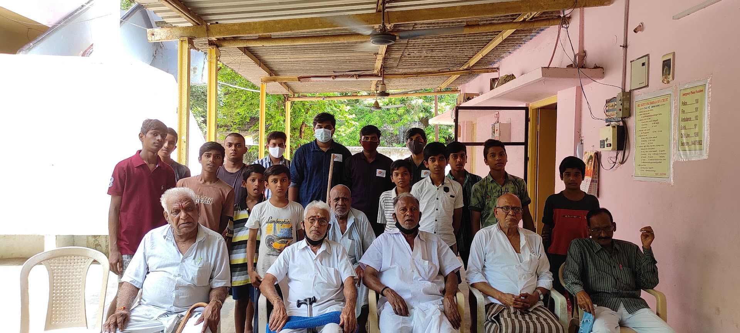

**EVENT-15**

**We have donated food in an orphanage (Sri sathya sai samaja seva trust) on the occasion of RENUKA’S birthday.**

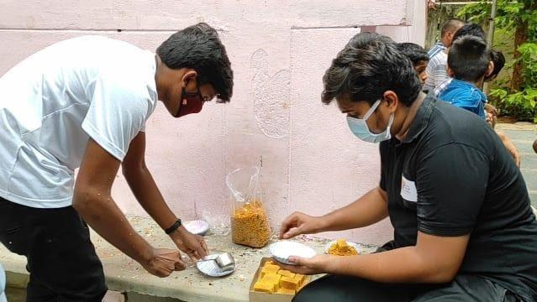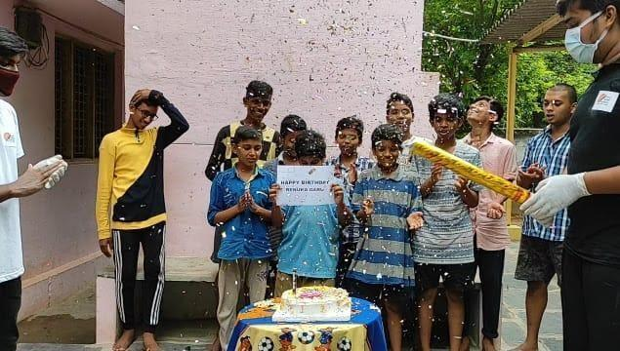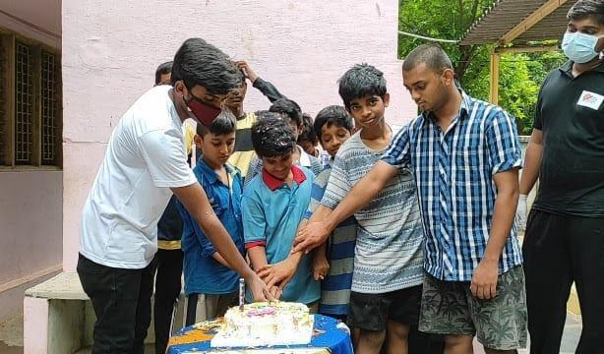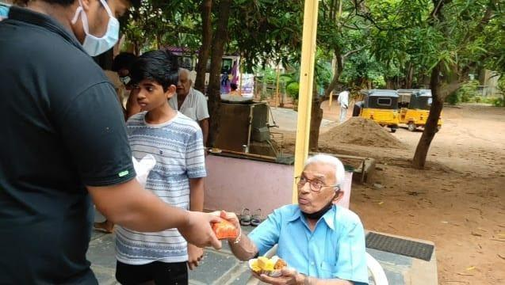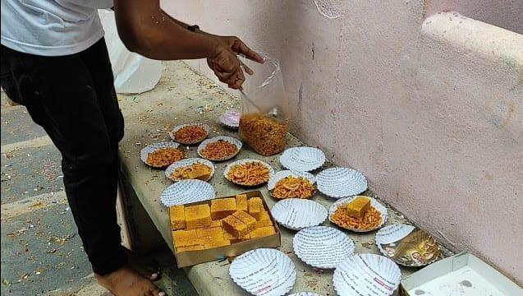

**EVENT-16**

**We have donated food in an orphanage (Sri sathya sai samaja seva trust) on the occasion of  GAYATRI’S birthday.**

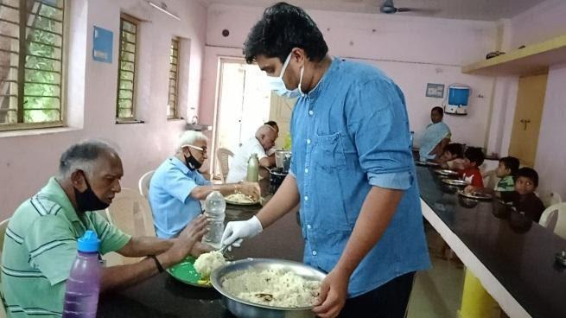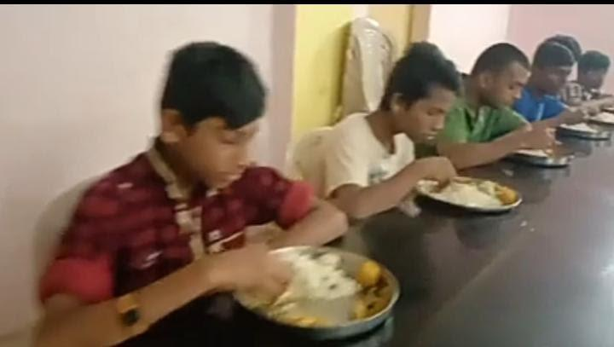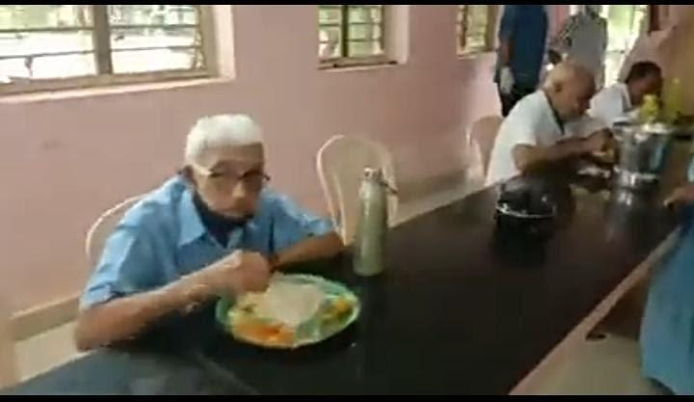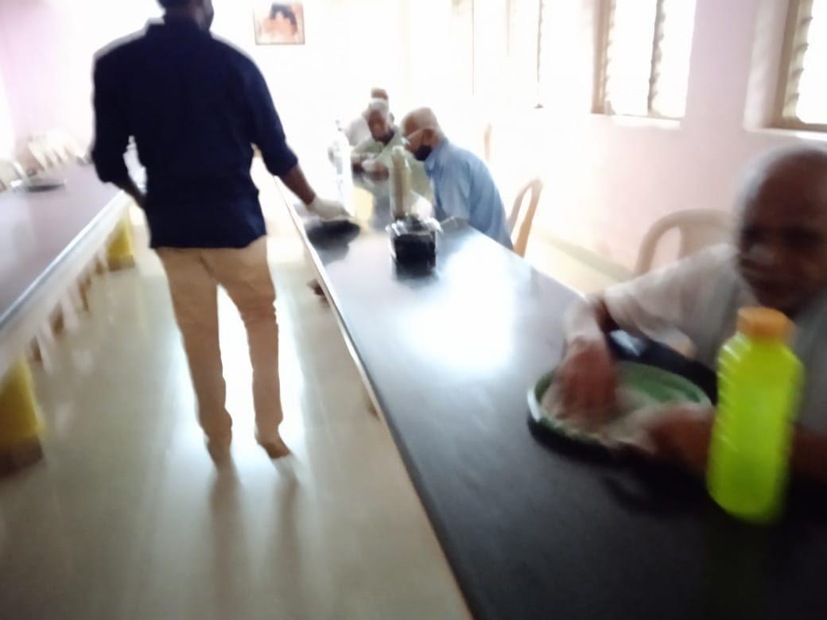

**EVENT-17**

**Full Meals distribution in afternoon session for nearly 30+ people in MEDCHAL surroundings on 19/07/2021 (Hyderabad).**

**This is leftover food from Malla Reddy Engineering College, Mining Department’s farewell party.**

**Done by K. GIRI BHARGAV, M. KALYAN, T. NITHIN SAI, P. CHANDU.**

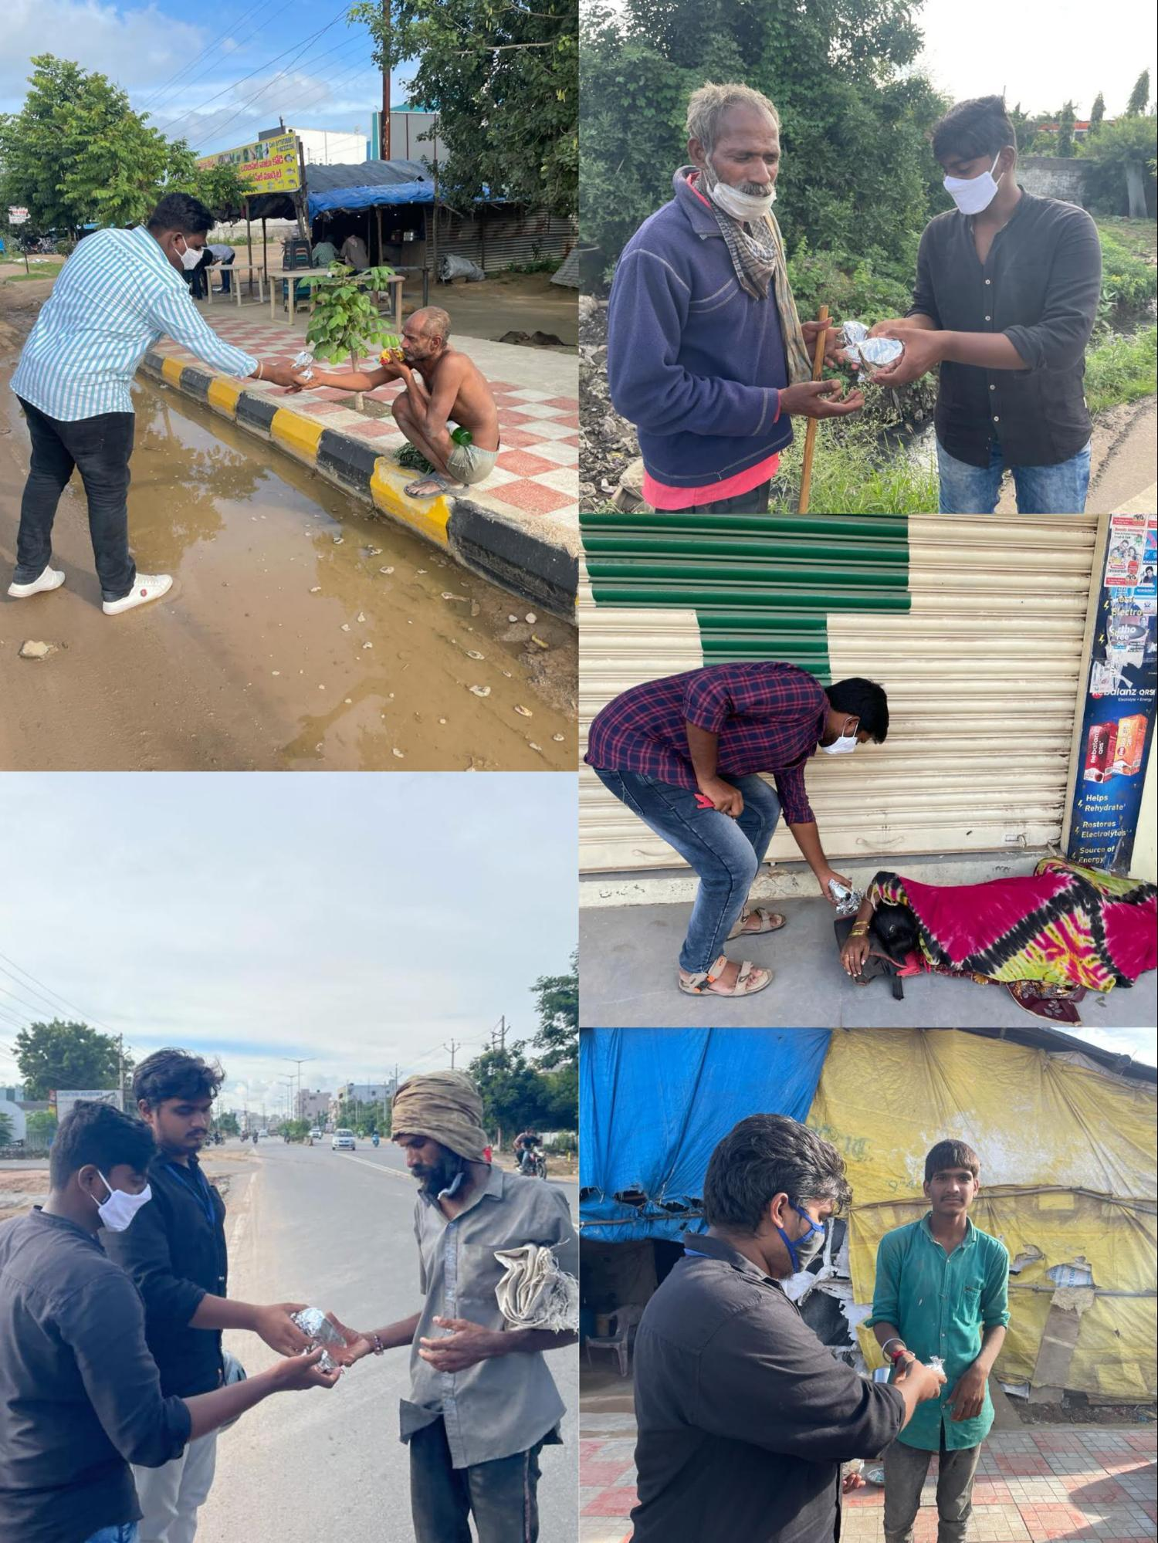

**EVENT-18**

**We have donated Chocolates and biscuits to children in Maisammaguda on the occasion of INDEPENDENCE DAY.**

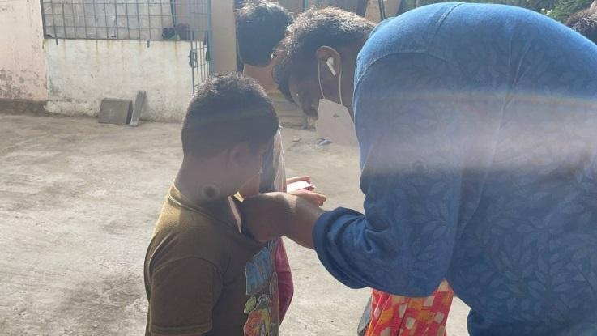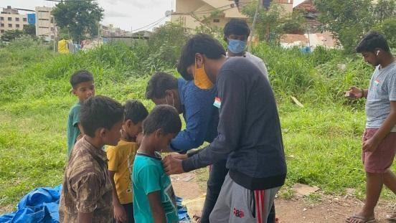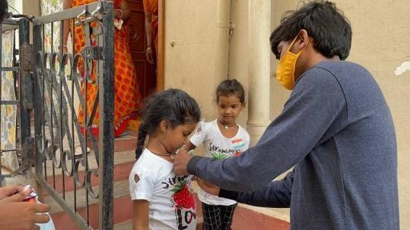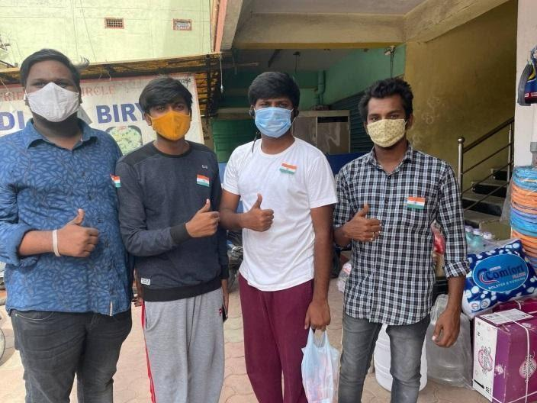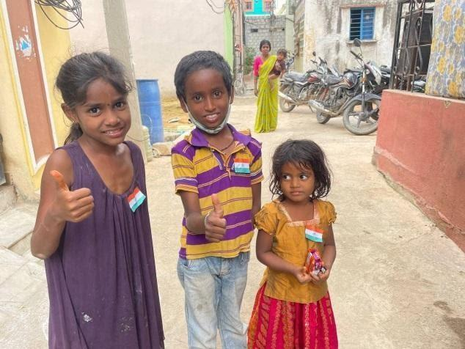

**EVENT-19**

**We have donated food in an orphanage (JASMINE GIRLS HOME) on the occasion of PRANITHA’S birthday on SEP 14th** 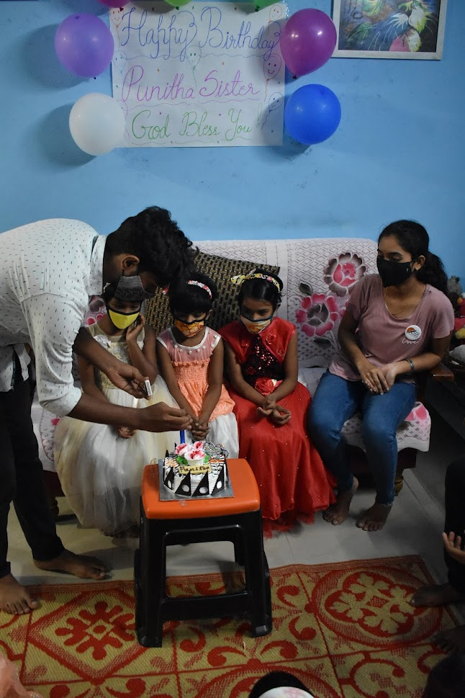

**.**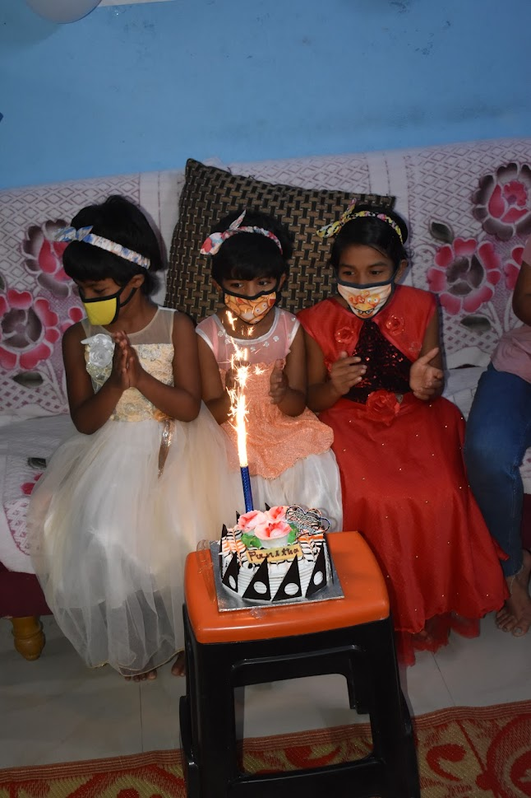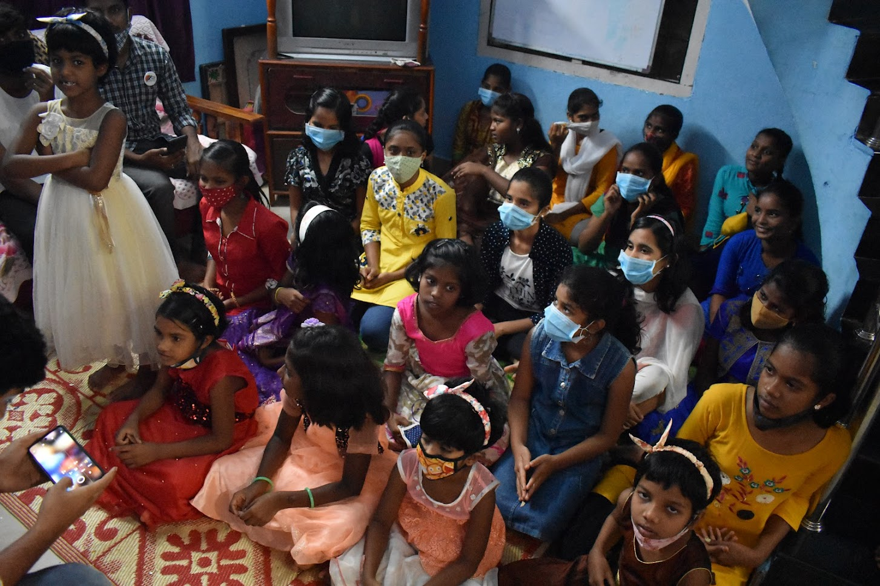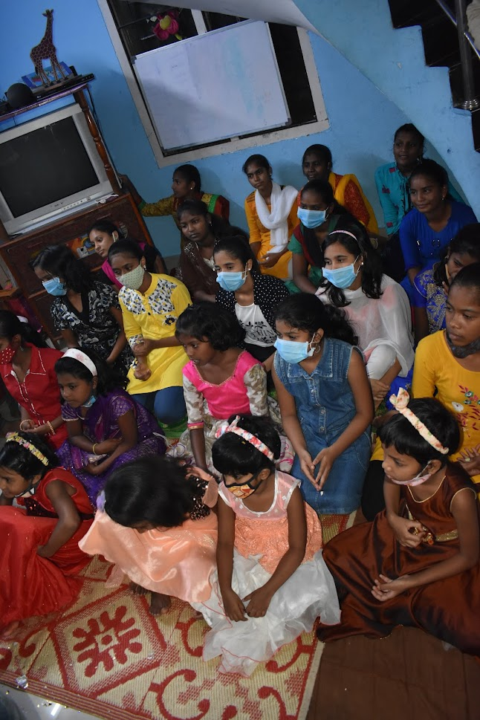

**EVENT-20 & 21**

**We have distributed BLANKETS to 100 poor people in Secunderabad on 1st, 5th of Dec 2021. Done by M. Kalyan, P. Chandu,K. Giri Bhargav, V. Manoj Kumar, P.** **Vishal, B. Naveen, K. Sai Teja, Rohit, K. Naveen, T. Nitin Sai, Thirupathi.**

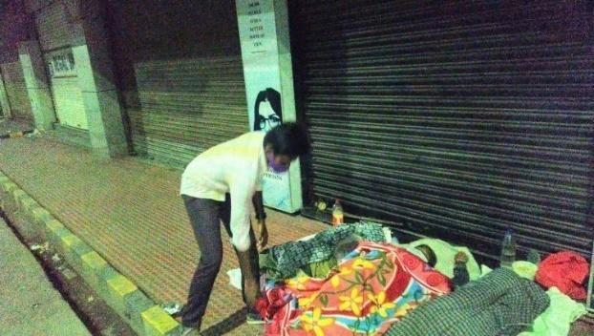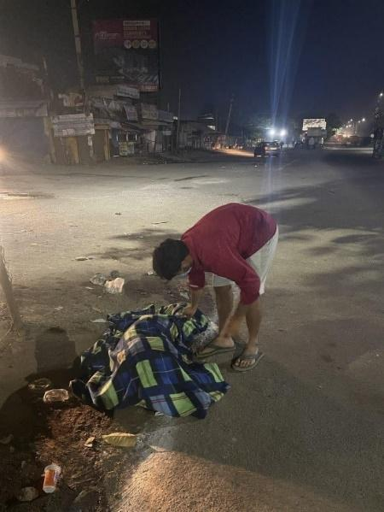

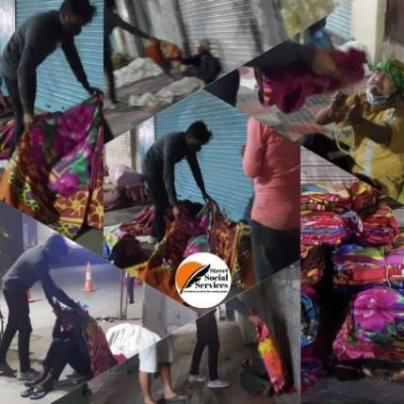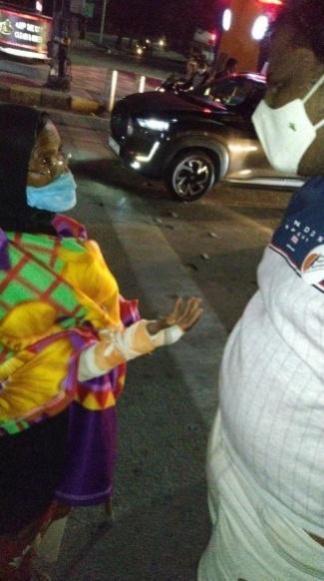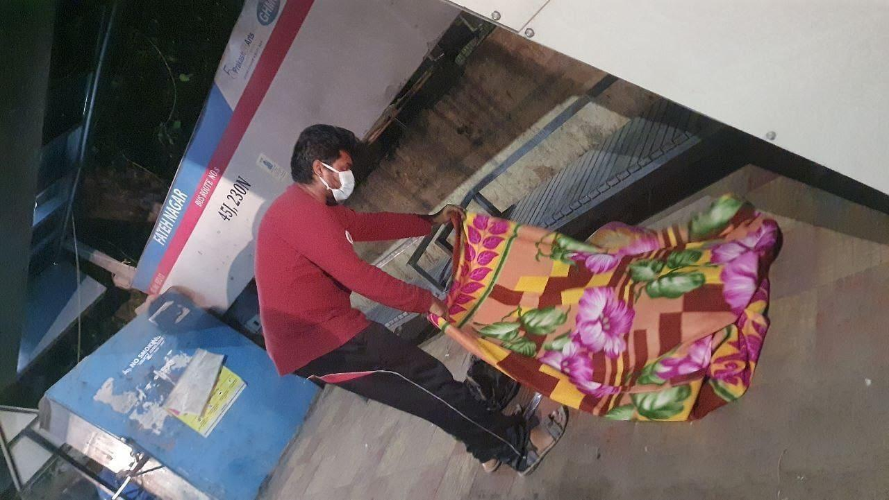

**EVENT-22**

We have decided to plan a vaccination camp in MREC and executed successfully on December 7th and the camp lasted up to 9th of December. It is one of the biggest EVENTS as well as one of the biggest achievements of SSS. We have vaccinated more than 900 people. The event was held in Malla Reddy Engineering College (MREC), Hyderabad. Our special Thanks to this event were Uday Bhaskar sir and Chitti Babu sir and the entire College management for the permission to conduct such a big camp. The initiate of vaccination camp took by Ajay Kumar (Executive member of SSS)

The Event all together done by **K.** **Giri Bhargav** (President), **M. Kalyan** (Vice President), **T. Nithin Sai** (General Secretary), **P. Chandu** (Joint Secretary), **G. Sai Ram** (Treasurer), **P. Vishal (**Event organizer**)** **A. Swathi** (Executive Member), **K. Sai Teja** (Executive Member), **Ajay Kumar** (Executive Member), **K. Naveen** (Executive Member), **Sahana** (SSS member), **Rushmitha** (SSS member), **T. Vasanth** (SSS member), **V. Manoj Kumar** (SSS member), **Sanjana Reddy** (SSS member), **Ravi Kiran Reddy**, **Sk.Nagur Babu**, **Indrasena Reddy**, **Jeevesh**, **Surya**, **Karthik**, **Khaja pasha**.

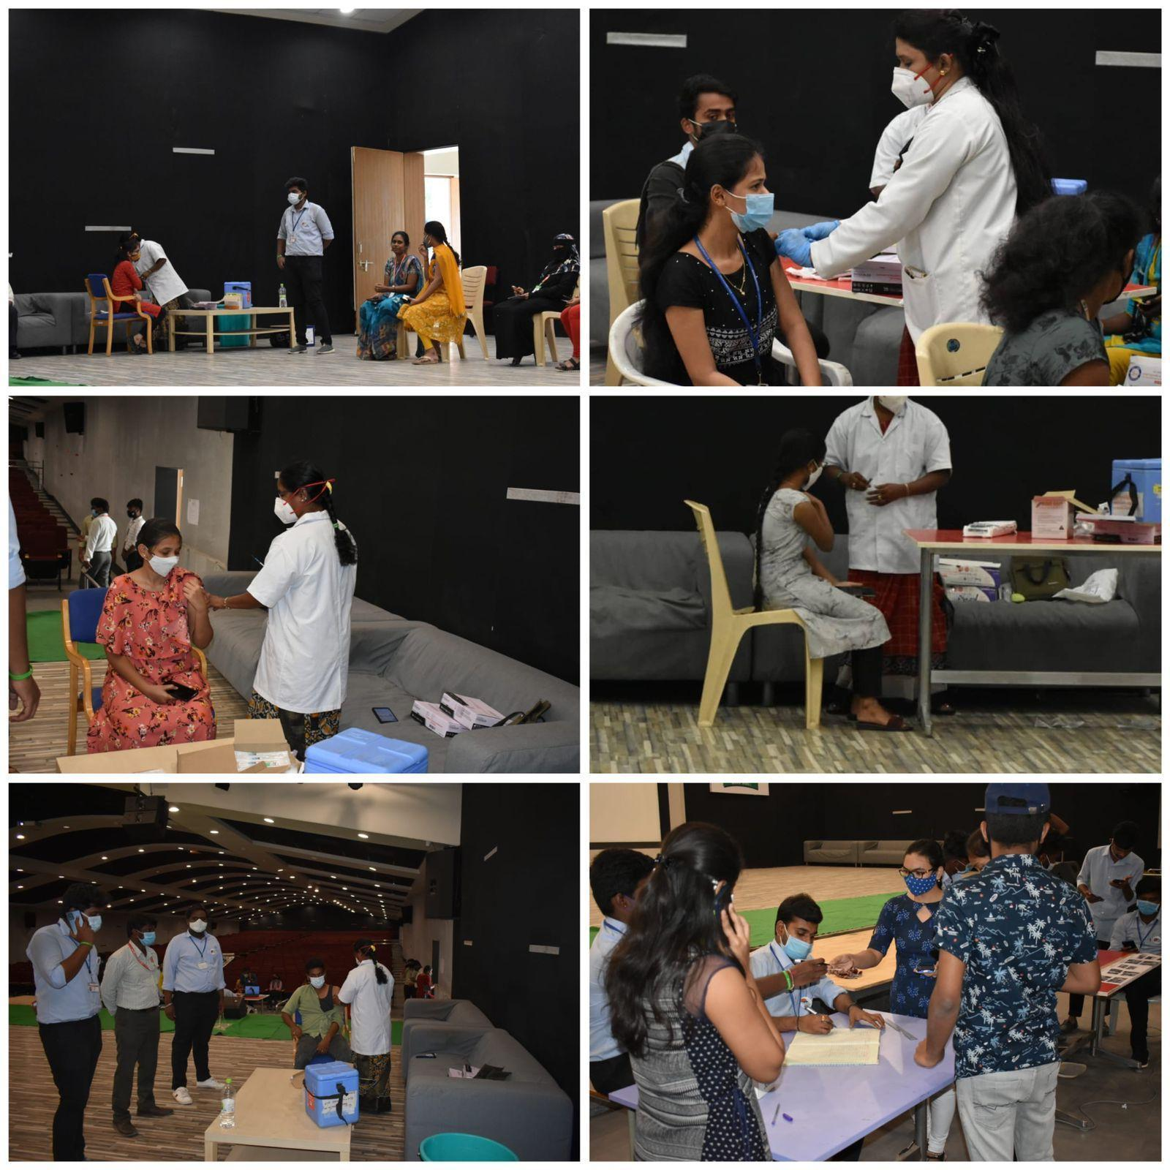

**EVENT-23**

**BLANKETS distribution in night timings for nearly 40 people in MGBS and KOTI areas (Hyderabad) on 16th DEC.**

**The event was done by Thirupathi.**

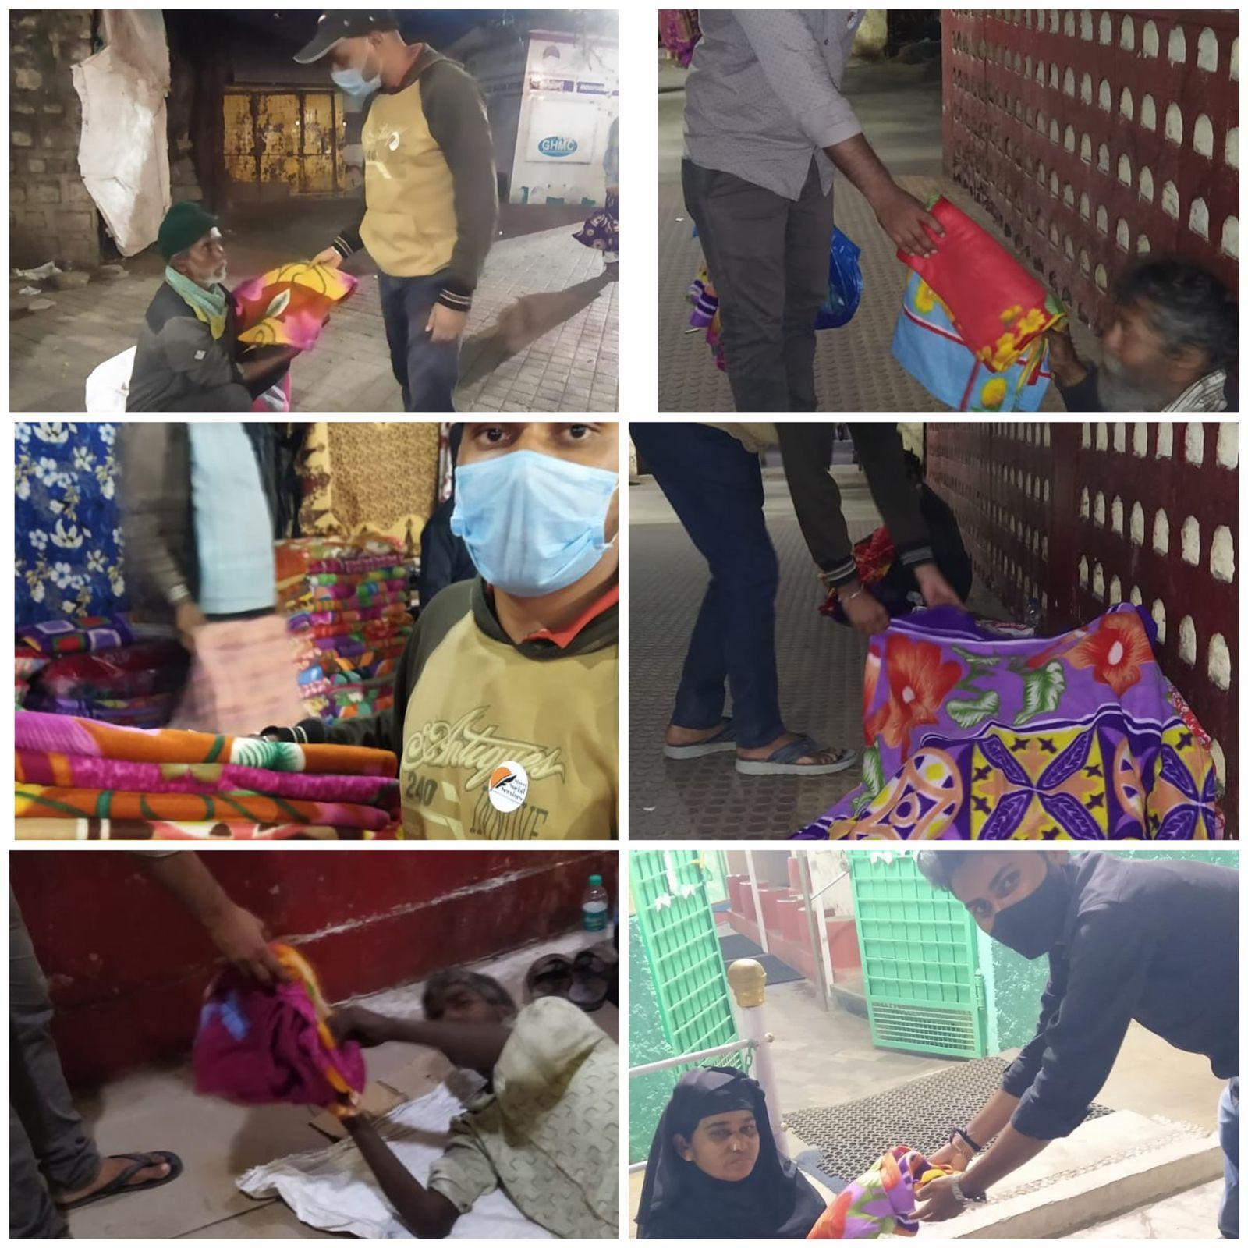

**EVENT-24**

We have conducted **ARTS COMPETITION** on the occasion of **REPUBLIC DAY** (Jan 26th) in online mode. It was a great success for **TEAM SSS**. Total 22 students of **MREC** are participated in this competition. They have drawn arts whole heartedly and presented. Judges analysed and took all the responsibility of giving a perfect and genuine results.

Judges are:

1. Shashikanth Sir (Asst. Prof mining dept.)
2. Prasanna Kumar Sir (Asst. Prof mining dept.)

The results are announced on jan 26th in social media (Instagram).

The winners are:

**#1 VENNELA IMMADI**

**#2 VYSHNAVI**

**#2 BHAVANI PRASAD**

**#3 BHANU TEJA**

**Event conducted by M. KALYAN, K. GIRI BHARGAV, T. NITHIN SAI.**

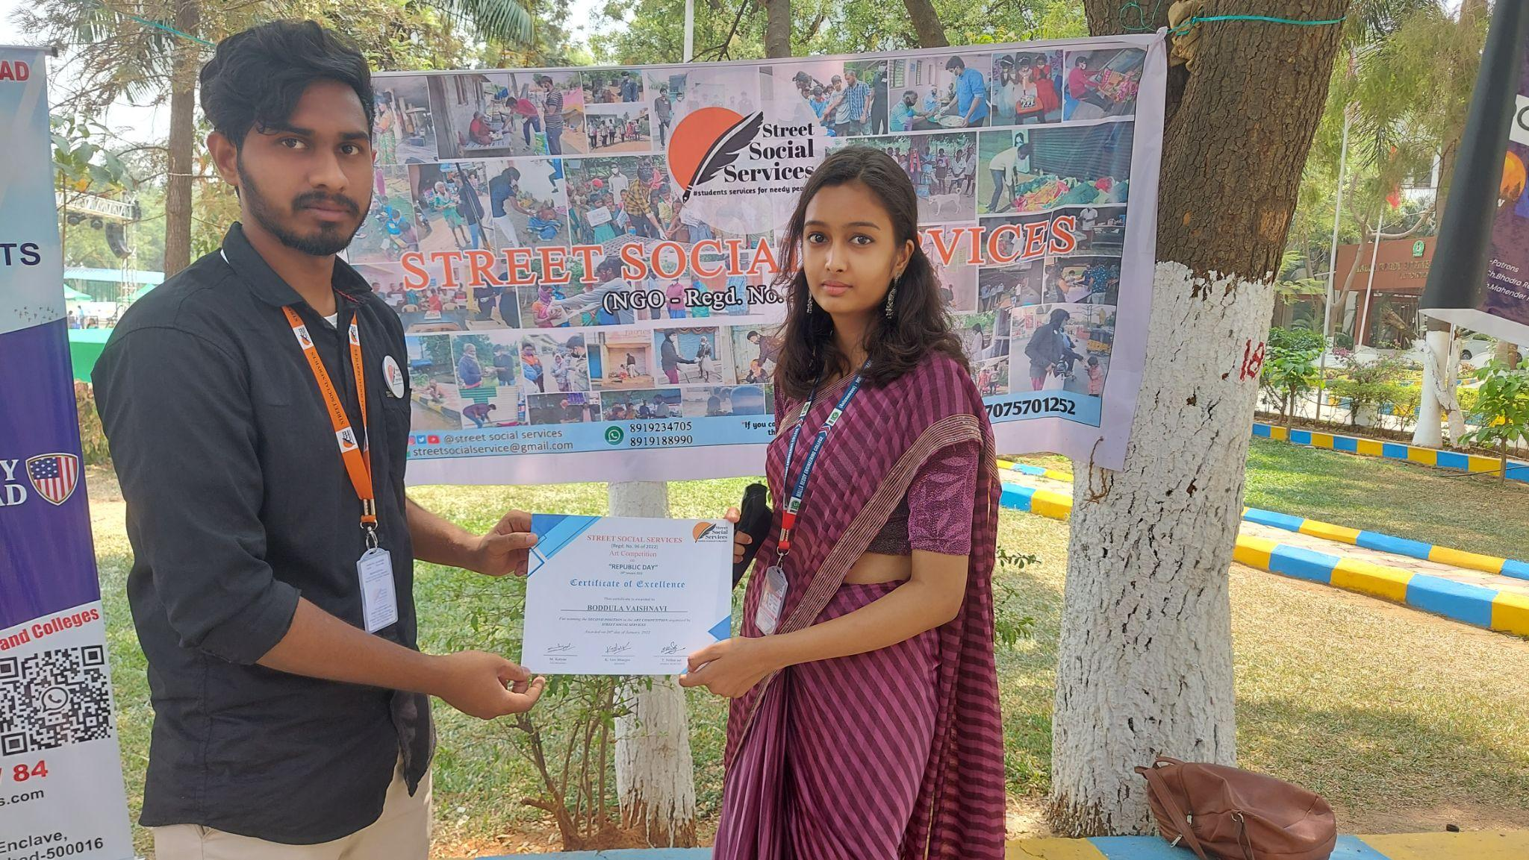

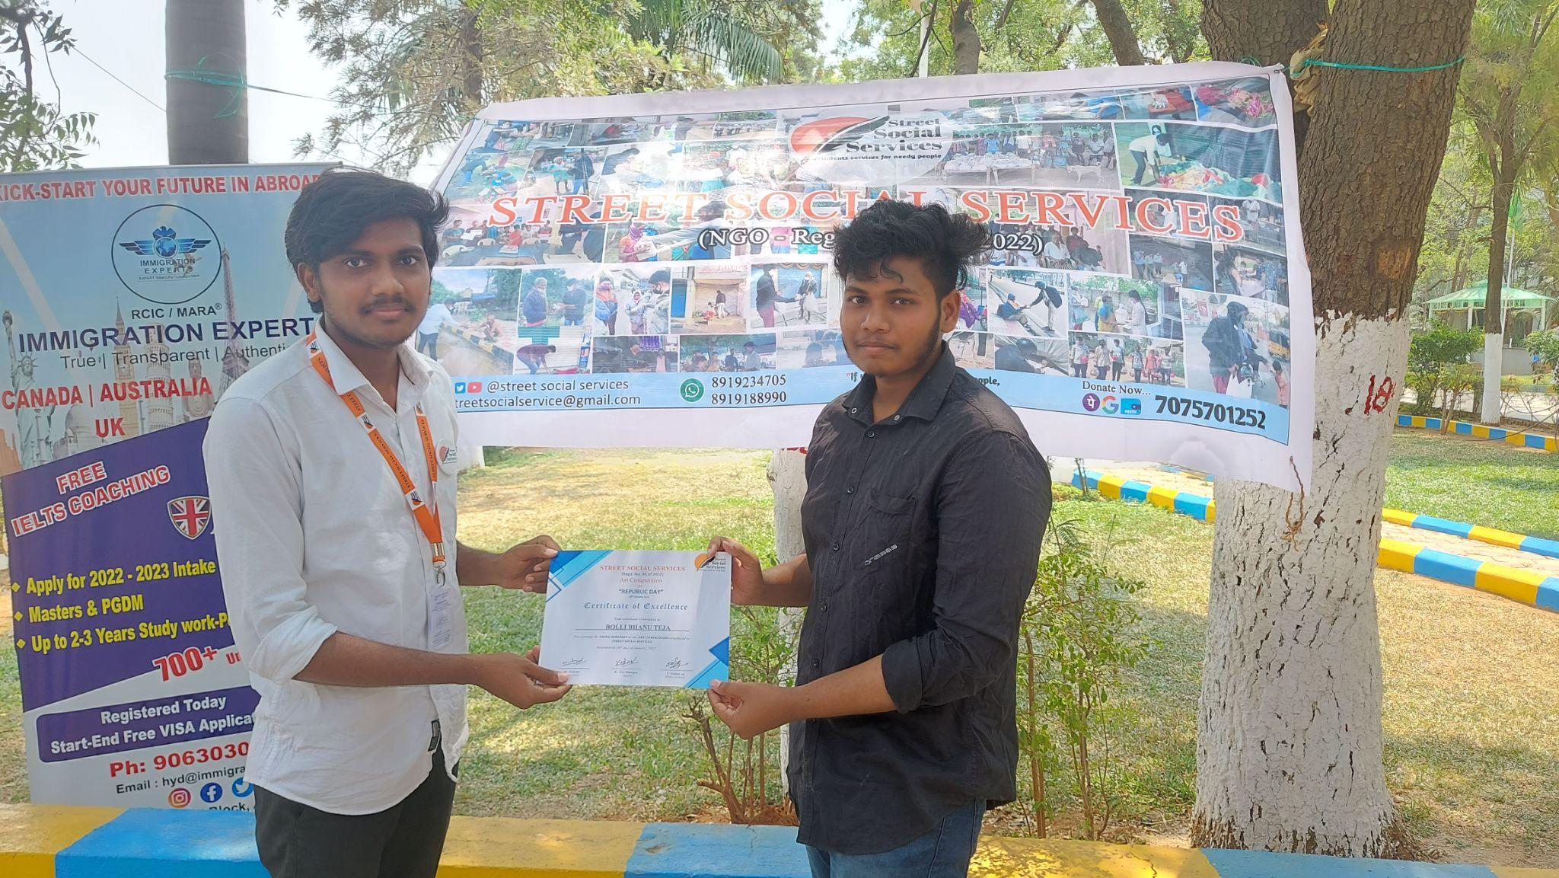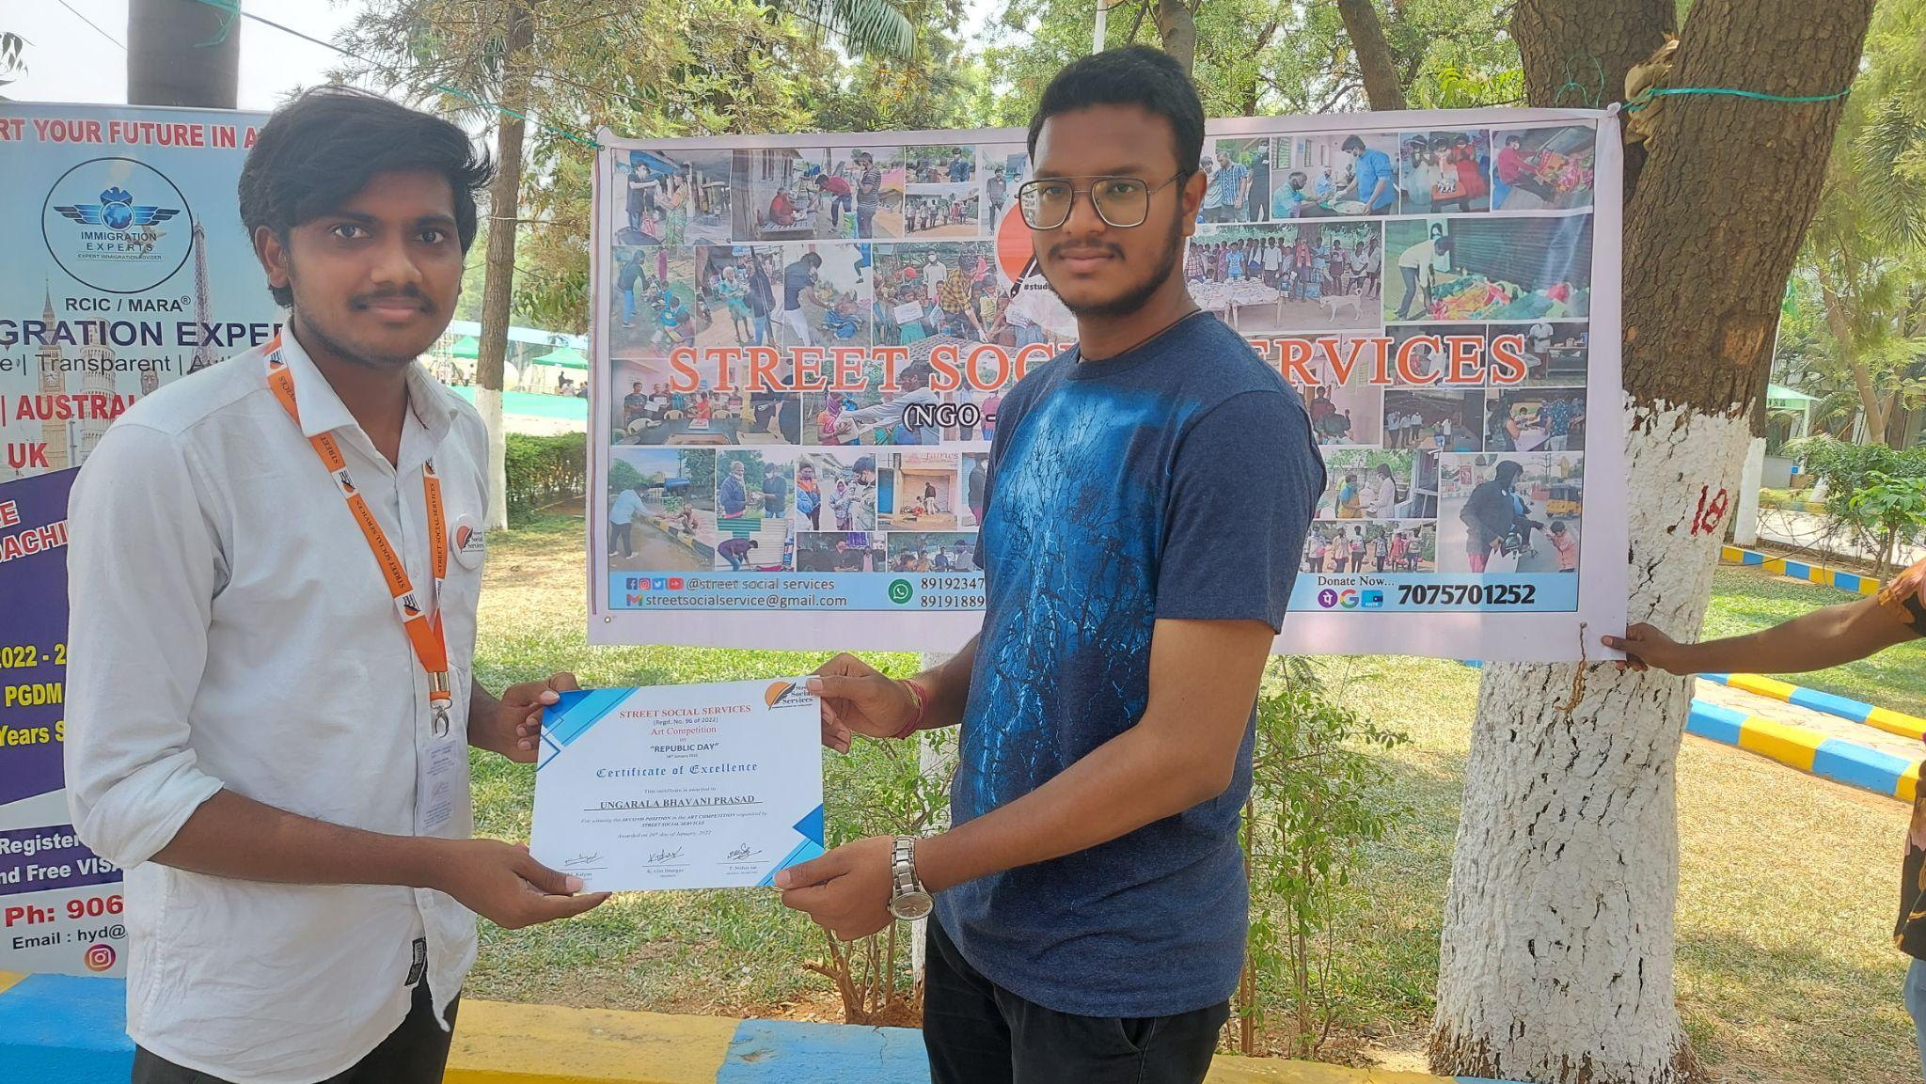

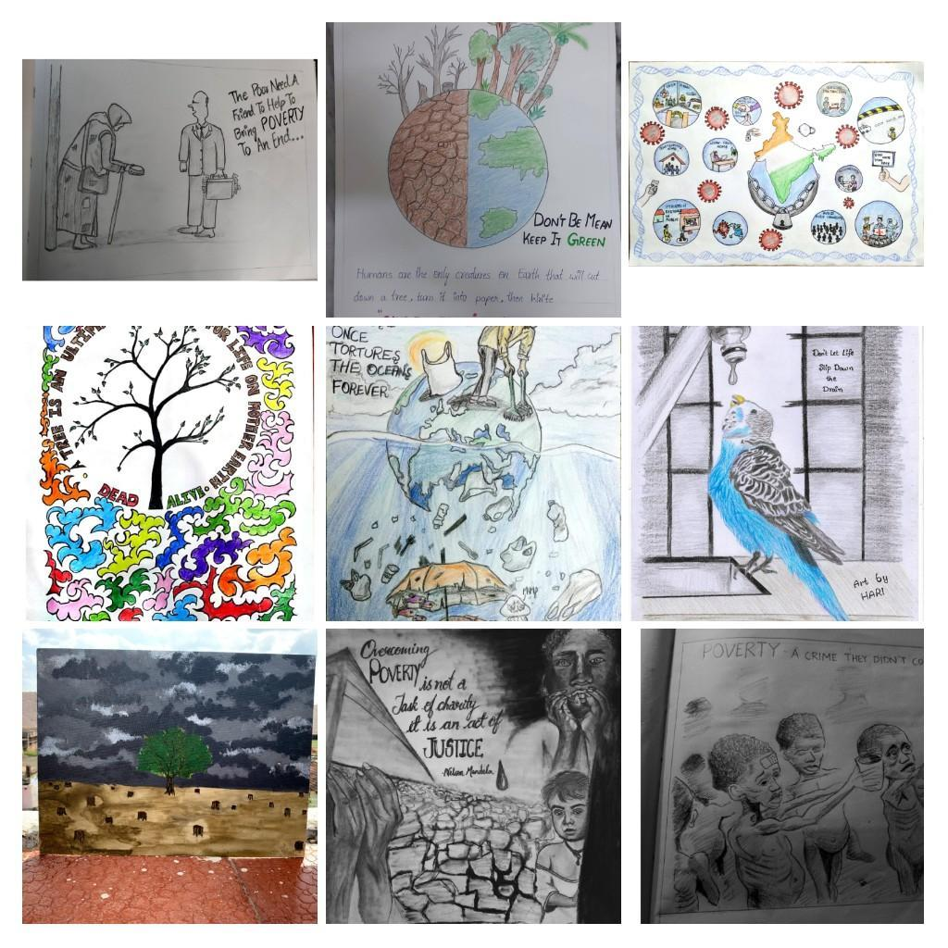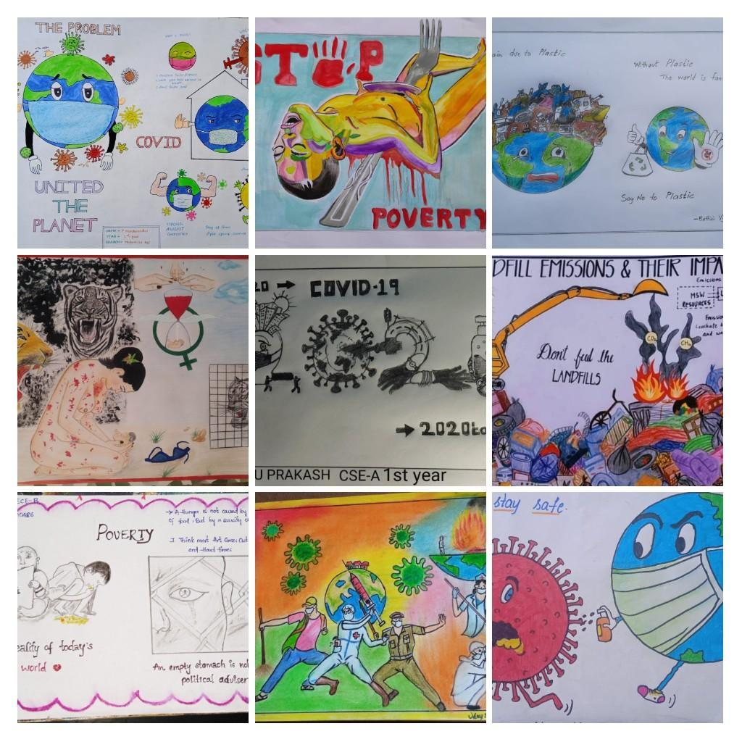

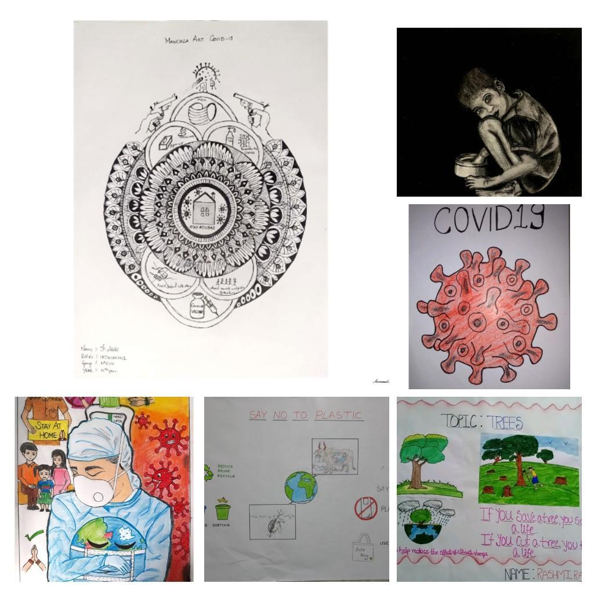**EVENT-25**

**BREAKFAST distribution in morning session for nearly 50+ people in SECUNDERABAD on 13/02/2022 (Hyderabad).**

**Done by K. GIRI BHARGAV, M. KALYAN, T. NITHIN SAI, P. CHANDU, SK. NAGUR, P. VISHAL, MANISH.**

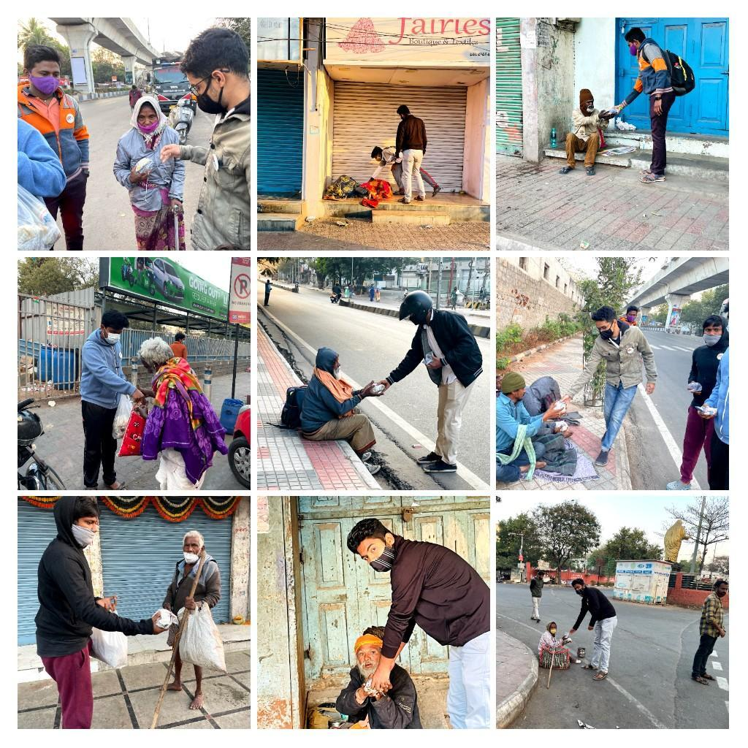

**VOLUNTEERING EVENT-1**

We have conducted a volunteering event on 25-02-2022, on the occasion of ENTREPRENEURSHIP AWARENESS PROGRAMME with Focus on Entrepreneurship for Youth/Prospective Entrepreneurs and Startups, organised by MSME-DI Hyd at Malla Reddy Engineering College.

Done by M. KALYAN, T. NITHIN SAI, P. CHANDU, P.VISHAL,S.SAHANA, SK.NAGUR,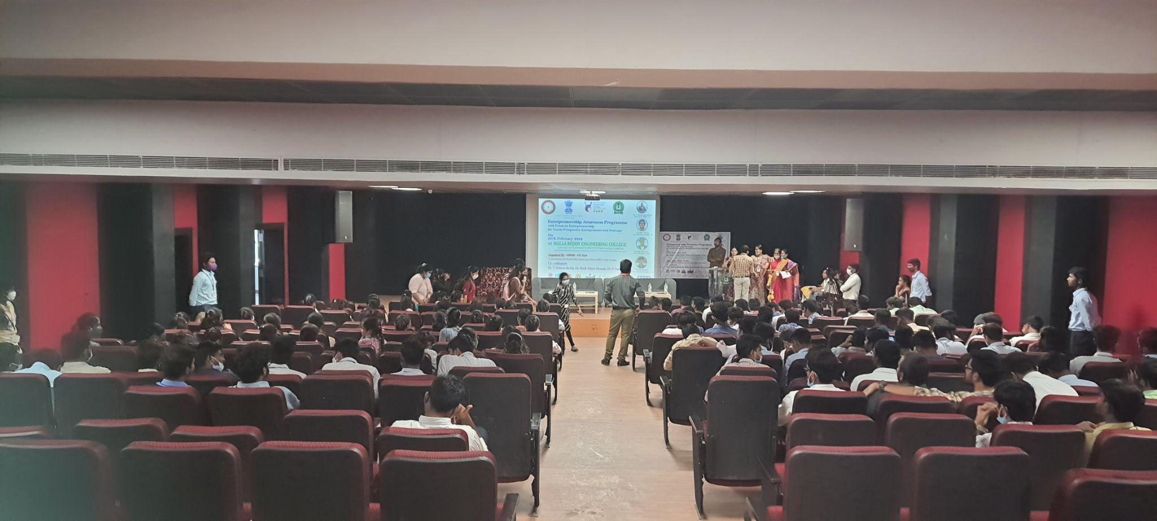

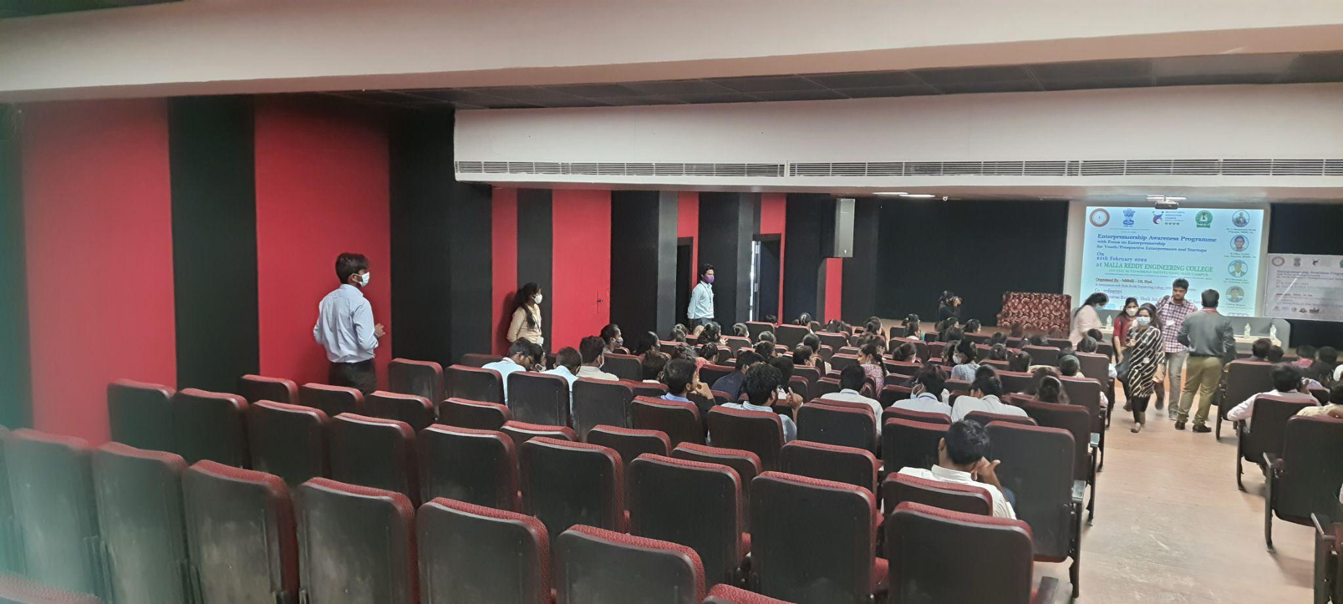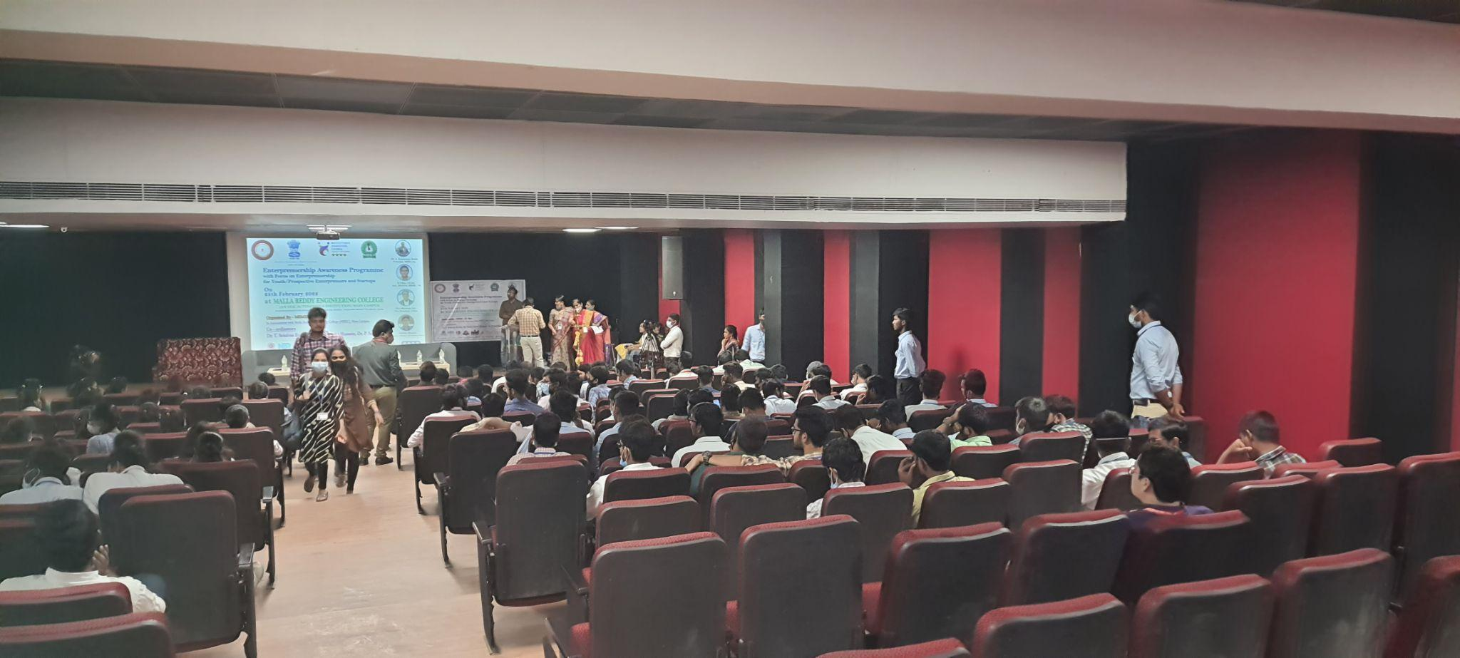

**EVENT-26**

We have conducted **TECHNICAL QUIZ COMPETITION** on 26-02-2022, on the occasion of **NATIONAL SCIENCE DAY** (i.e; Feb 28th) in our campus. It was a great success for **TEAM SSS**. Total 130 students of **MREC participated** in this competition. They have written the exam to answer MCQ type of questions under our volunteer’s strict supervision & invigilation. Judges analysed and took all the responsibility of giving perfect and genuine results.

The winners are; 1.GAVINOLLA SHASHANK REDDY

2.MOHAMMED TAQIUDDIN 3.MANTRI PAVITHRA

**Done by K. GIRI BHARGAV, M. KALYAN, T. NITHIN SAI, P. CHANDU,G.SAIRAM, P.VISHAL, K.NAVEEN, S.SAHANA, V.MANOJ, SK.NAGUR, T.VASANTH, G.AJAY, NAGARAJU, POOJWALA, ASHRITA,**

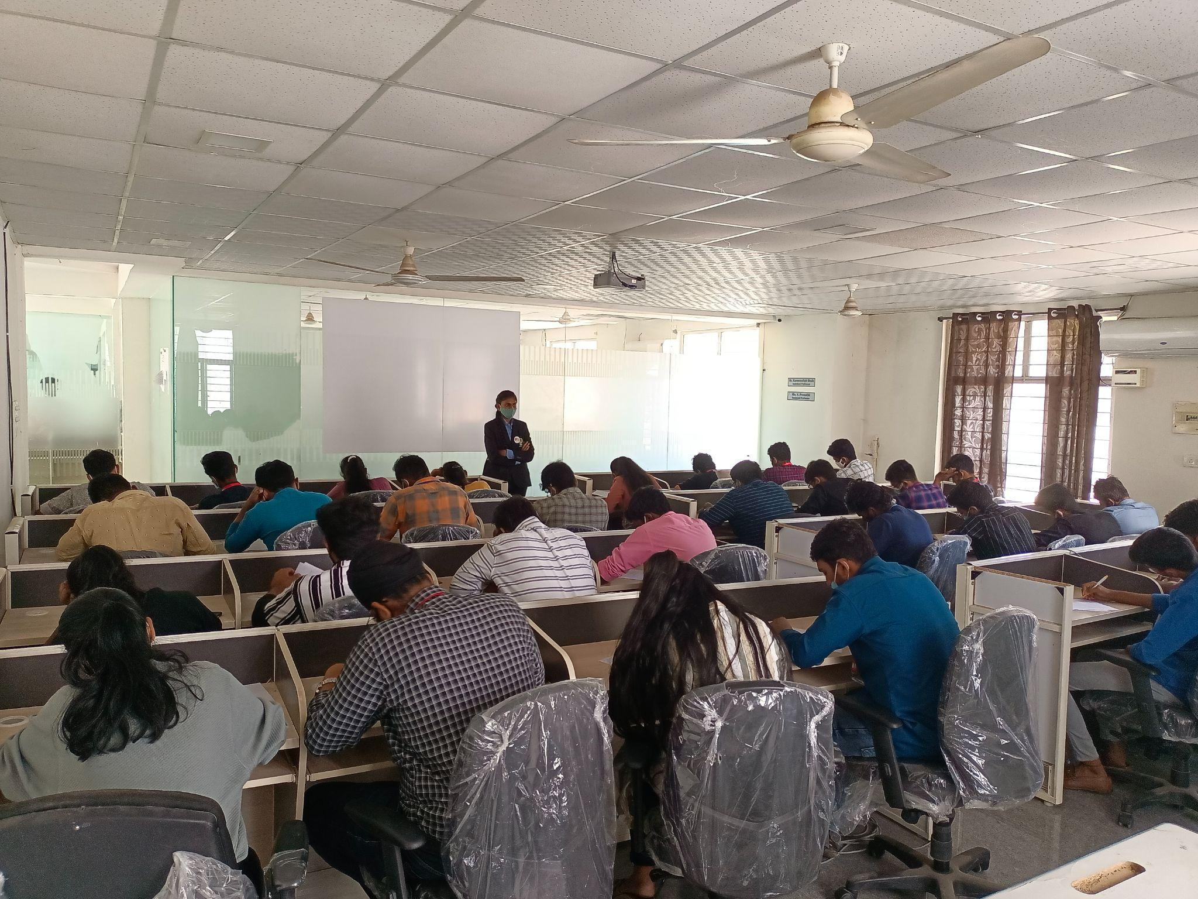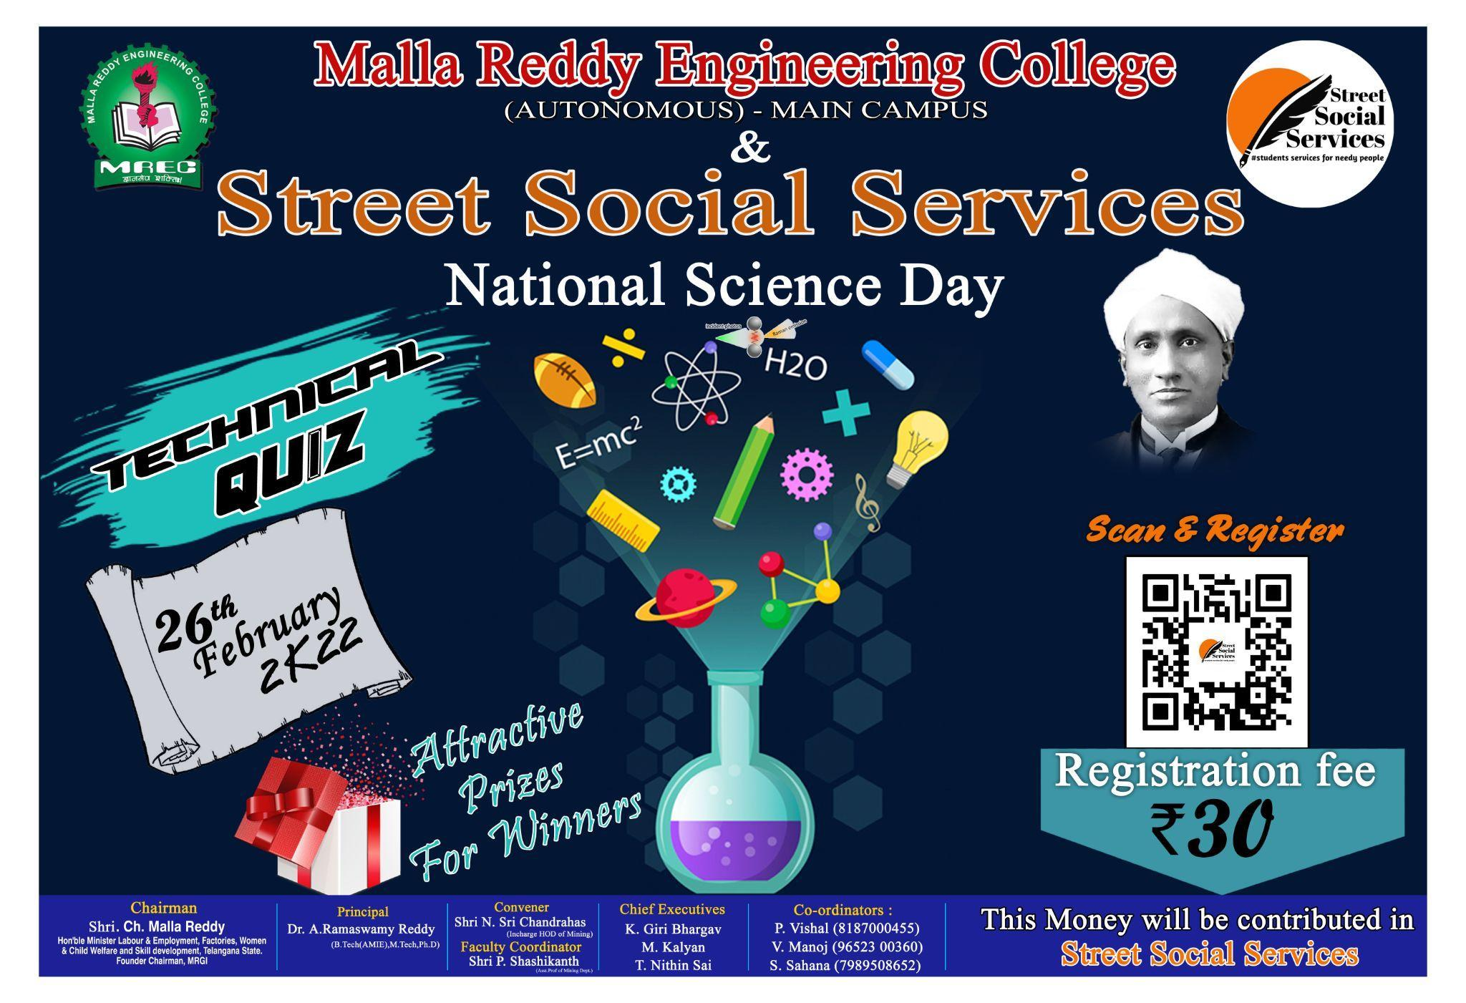

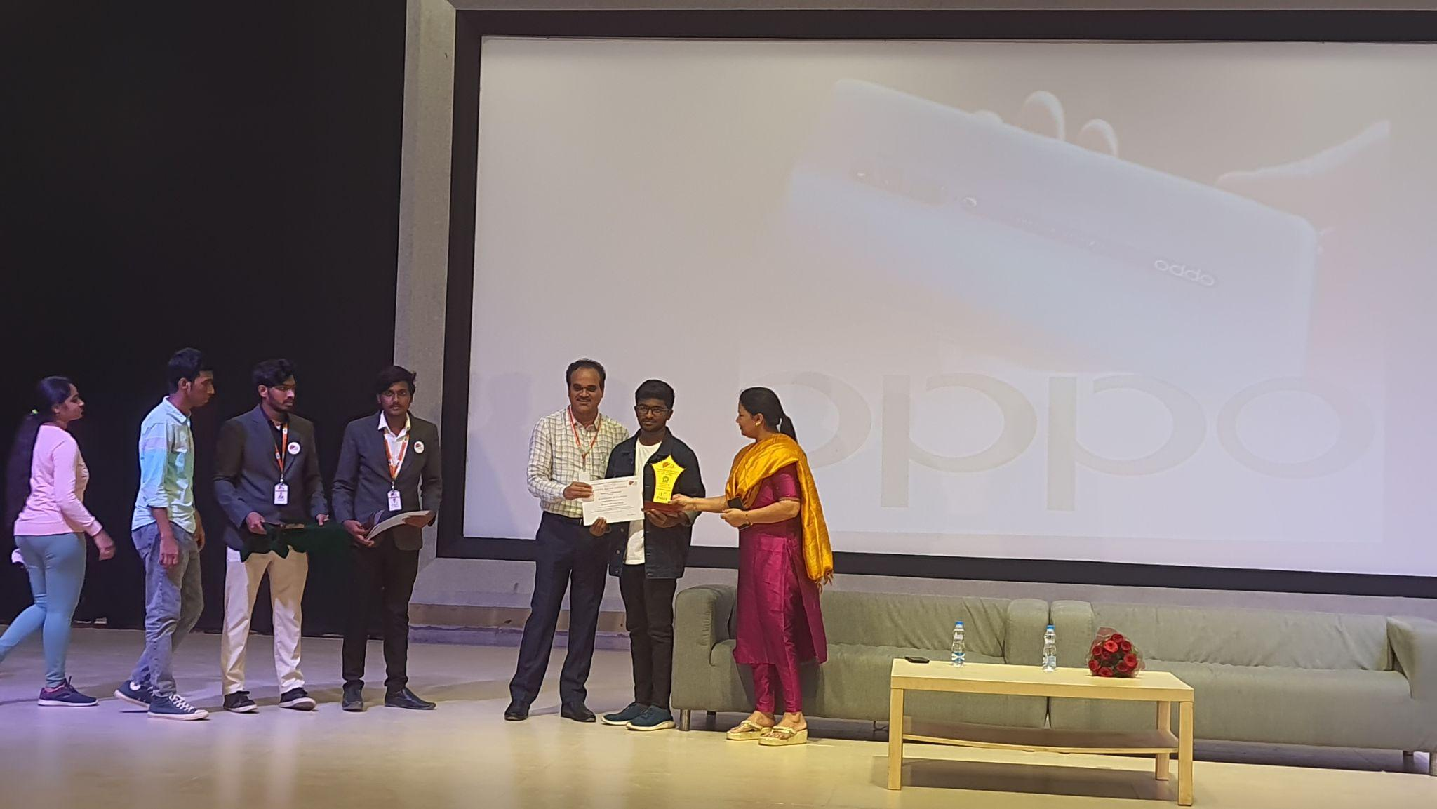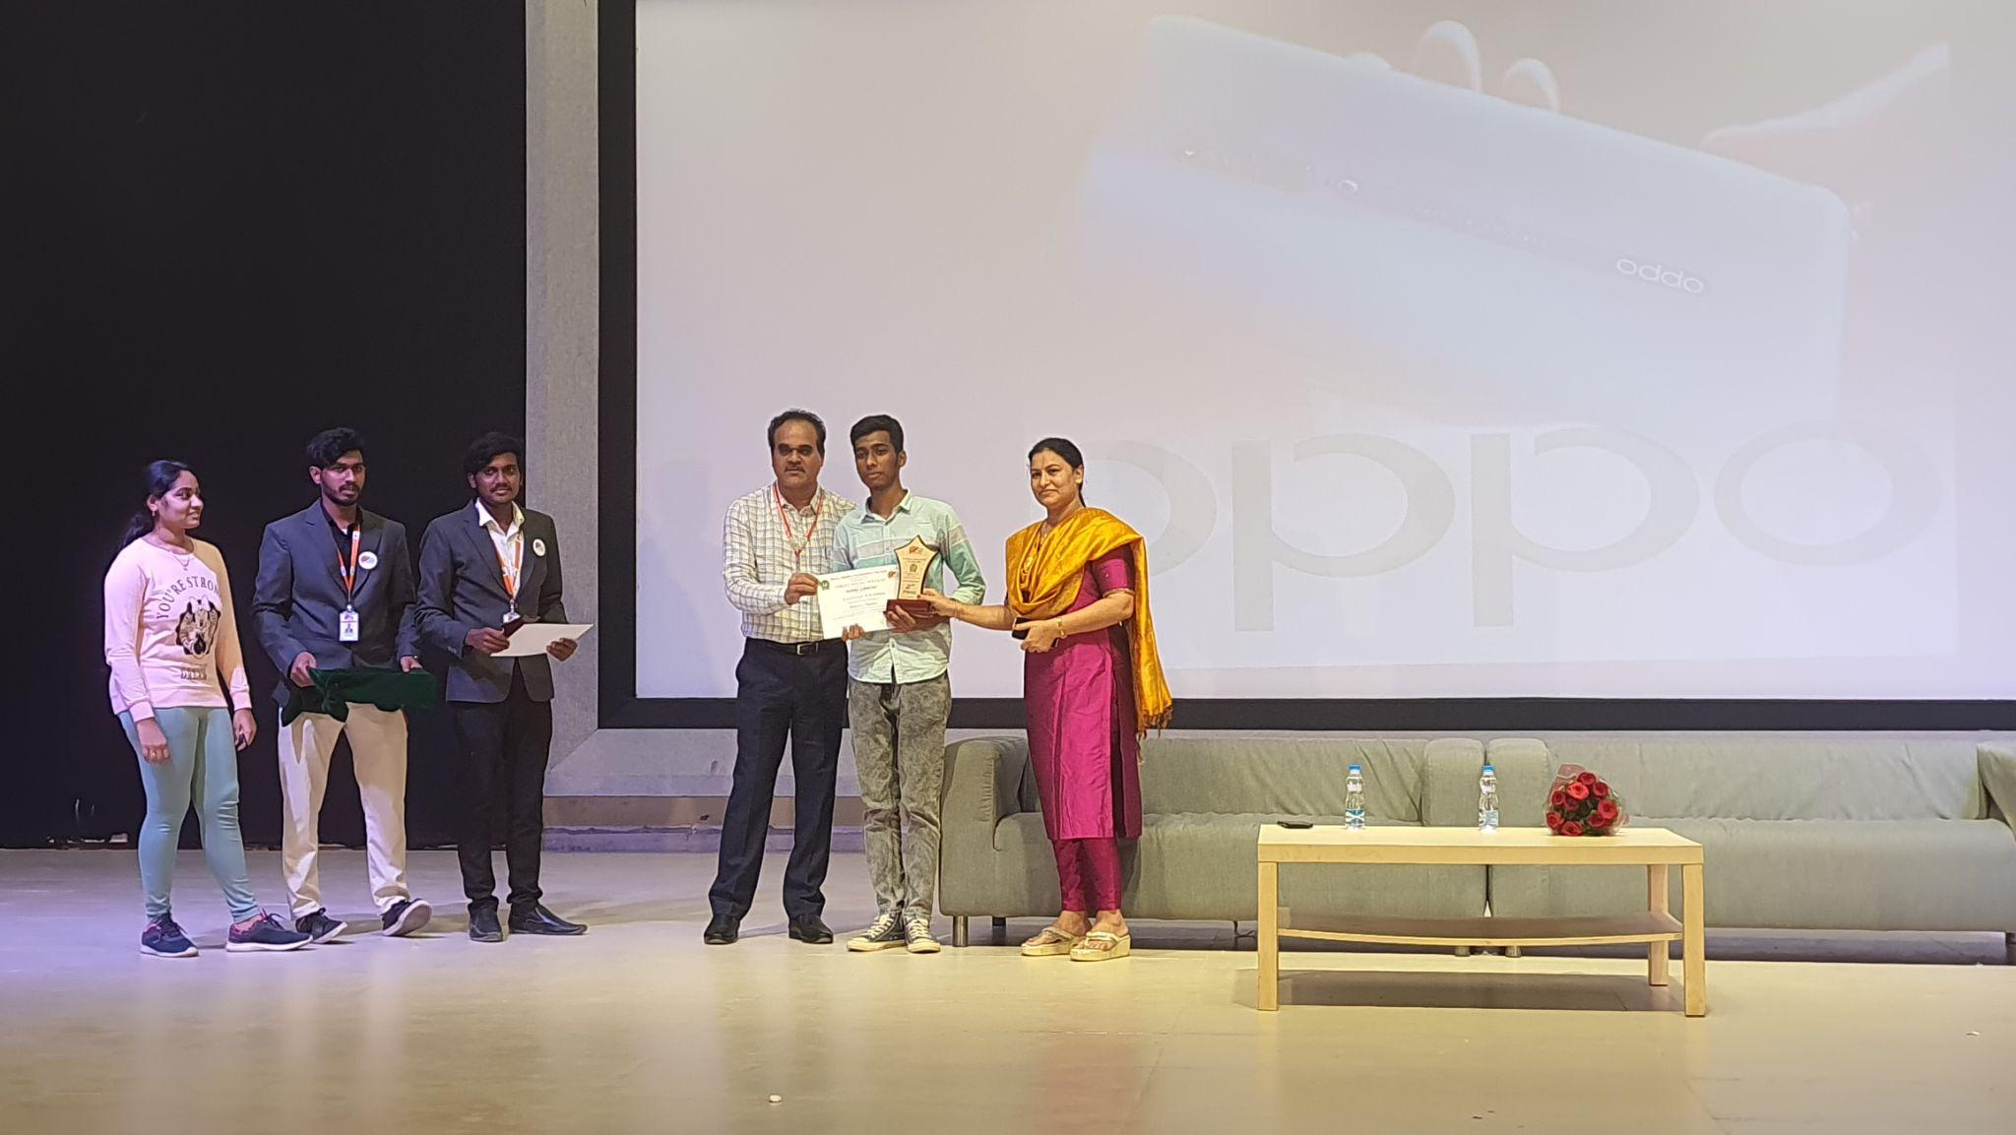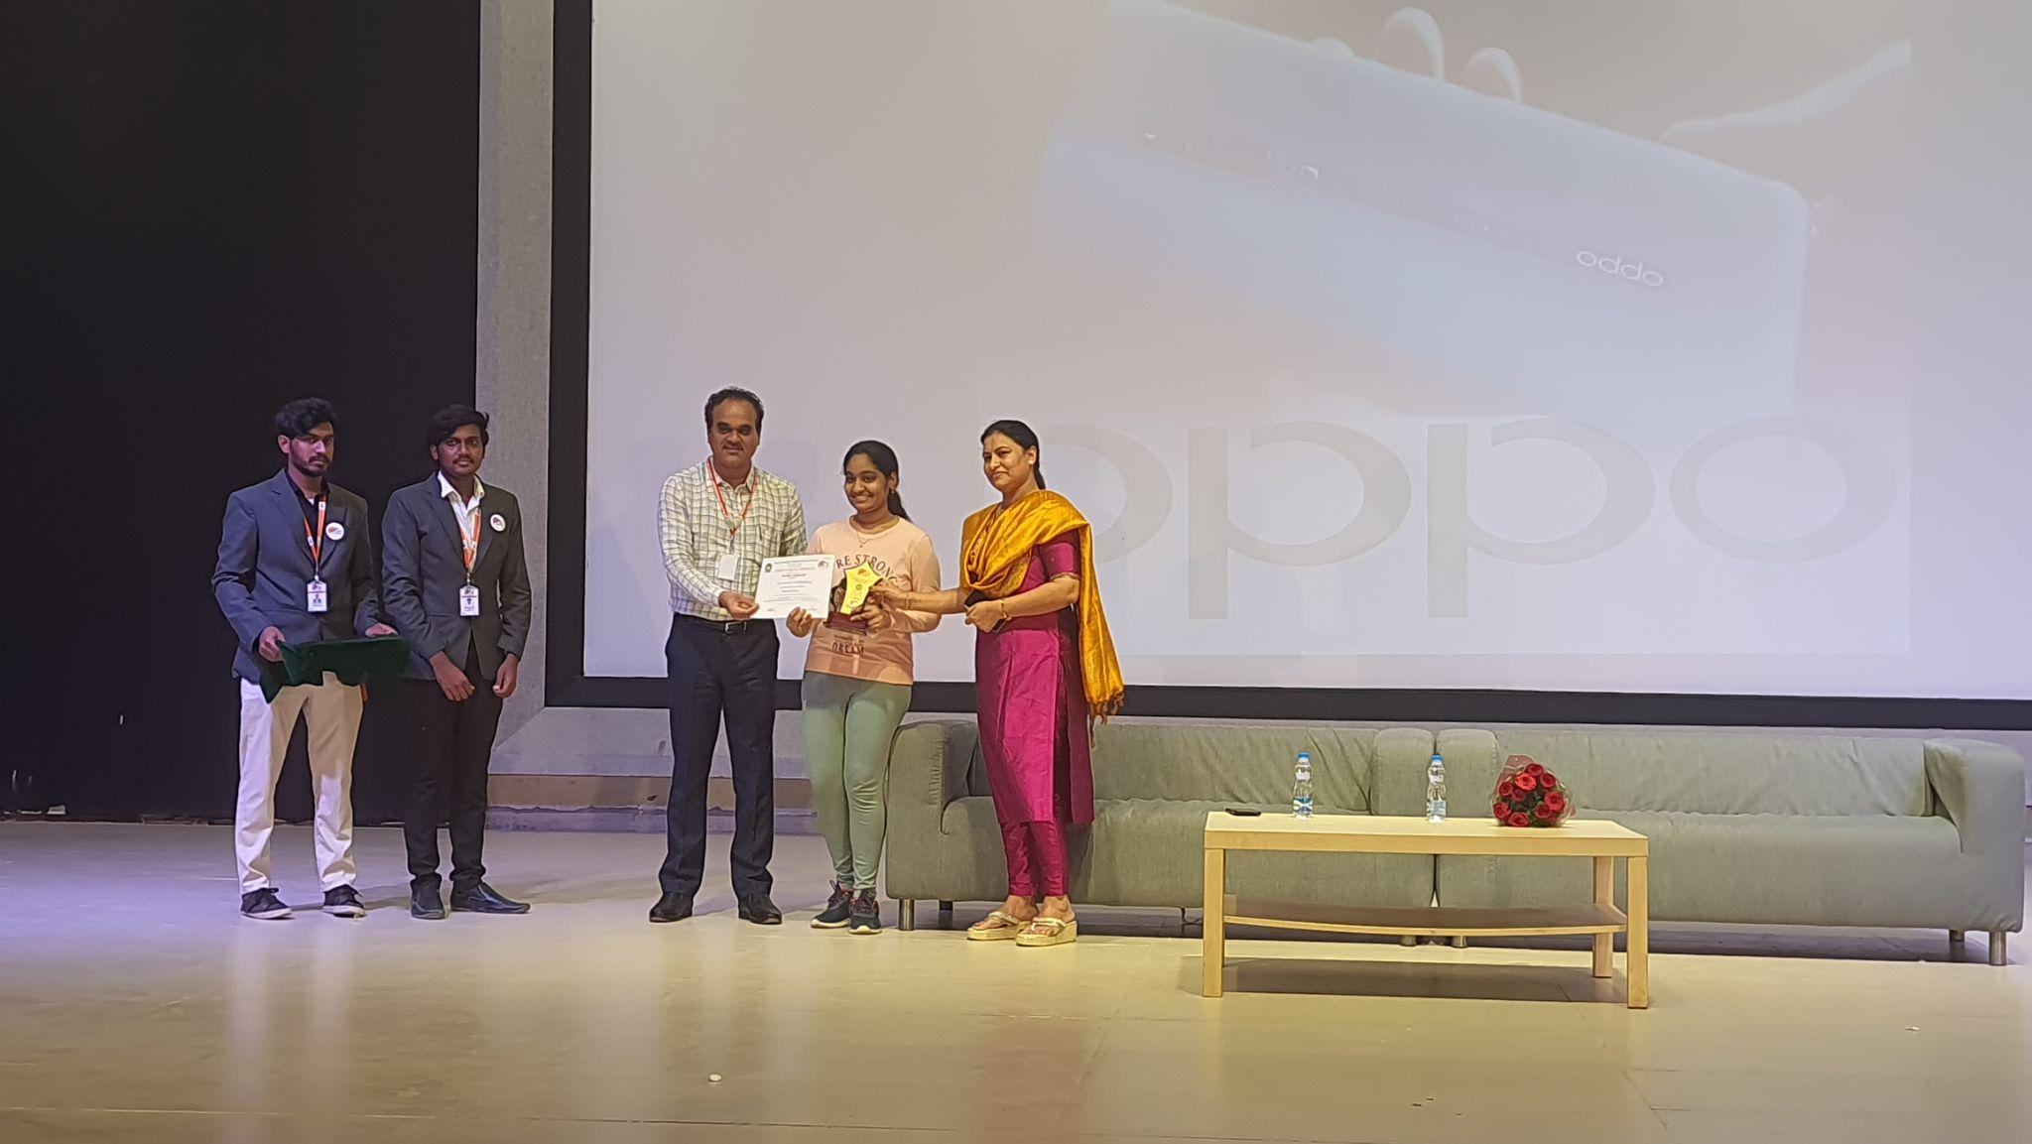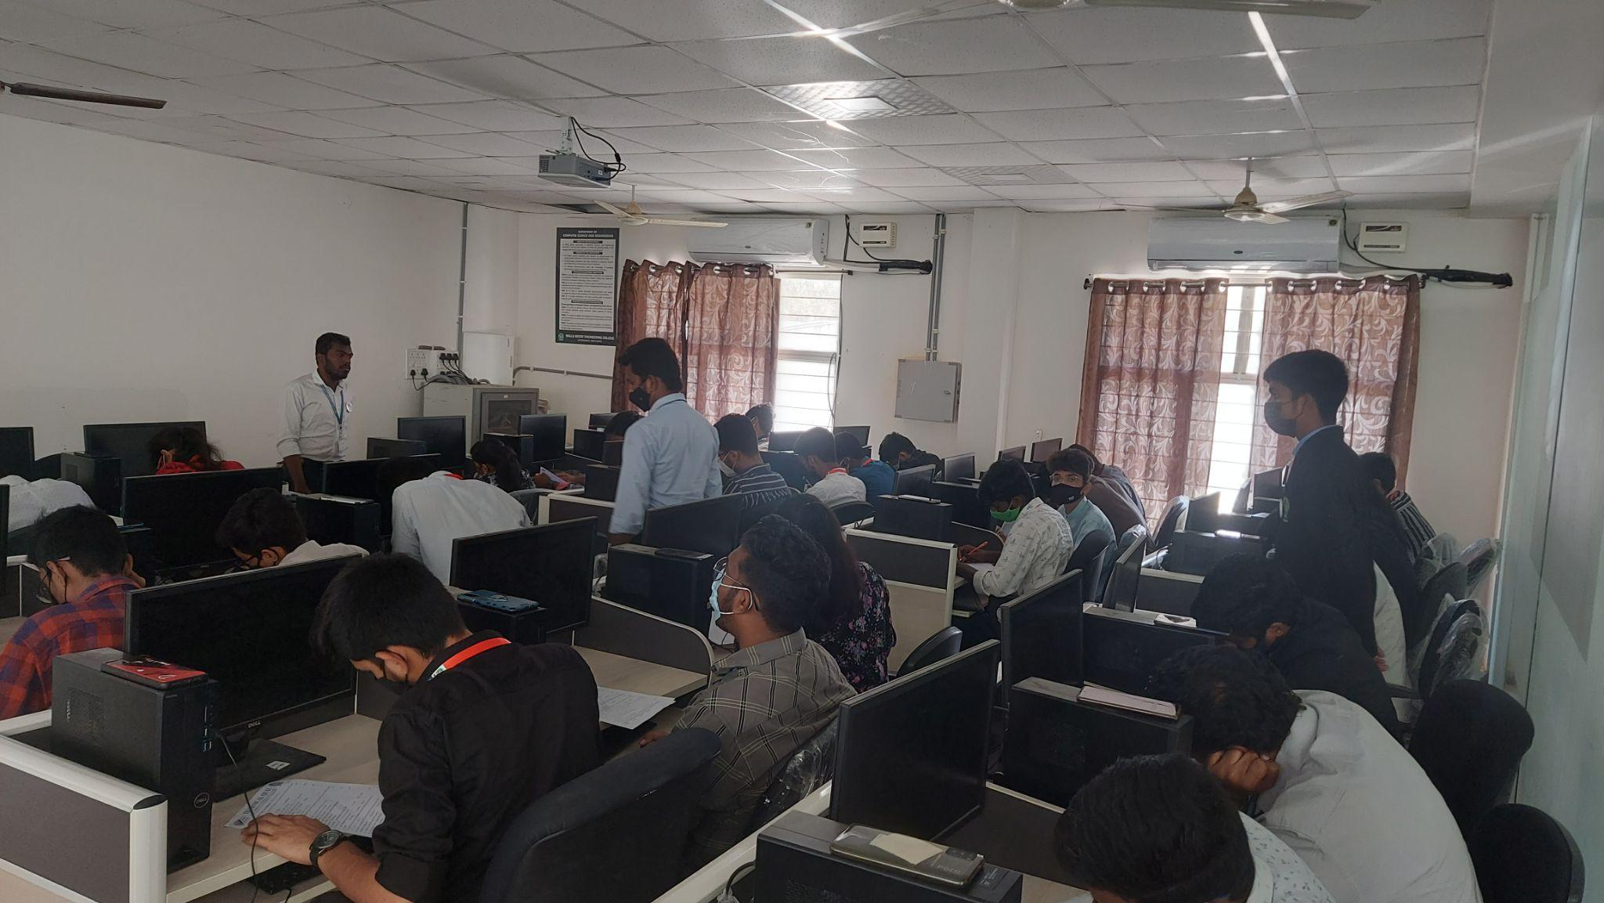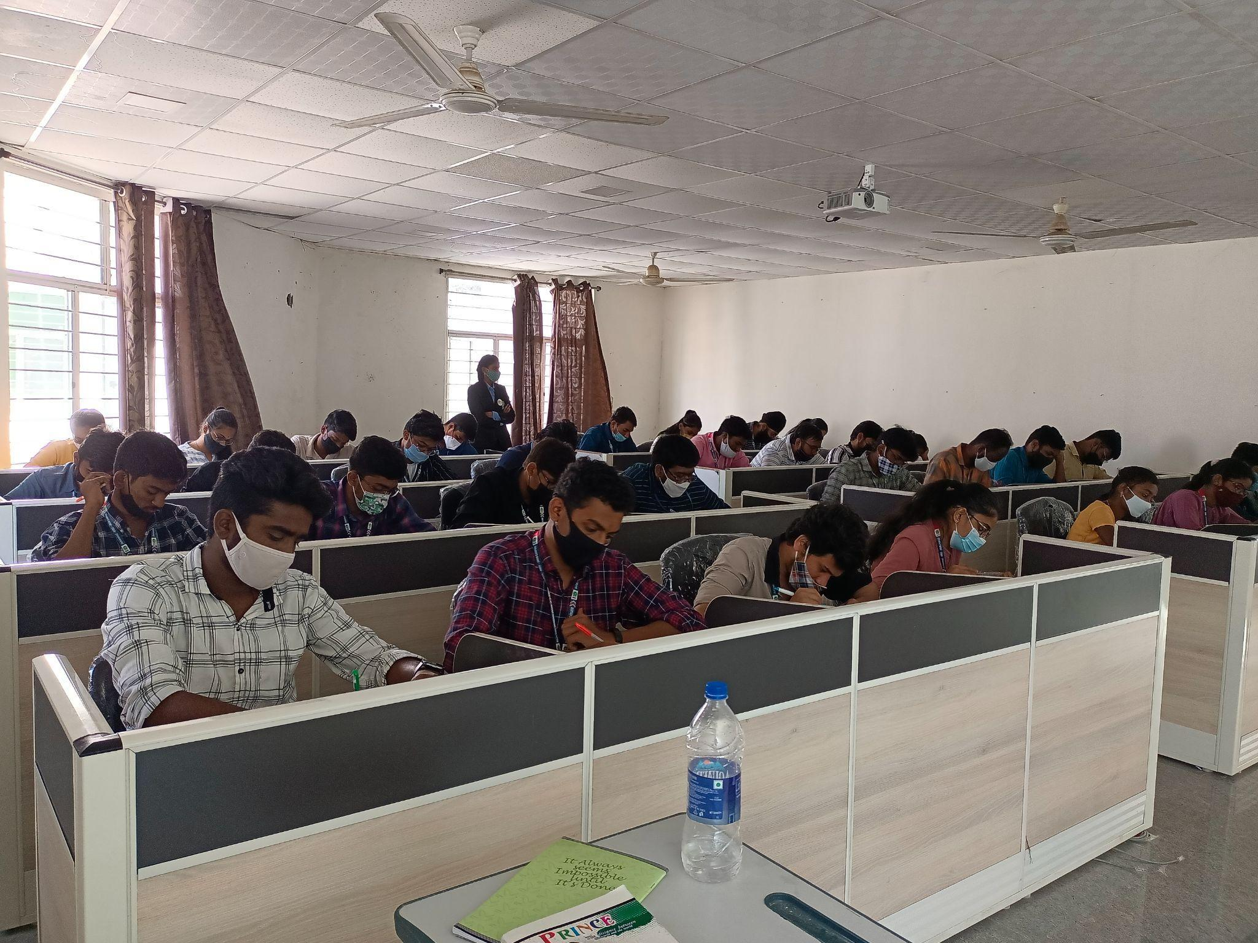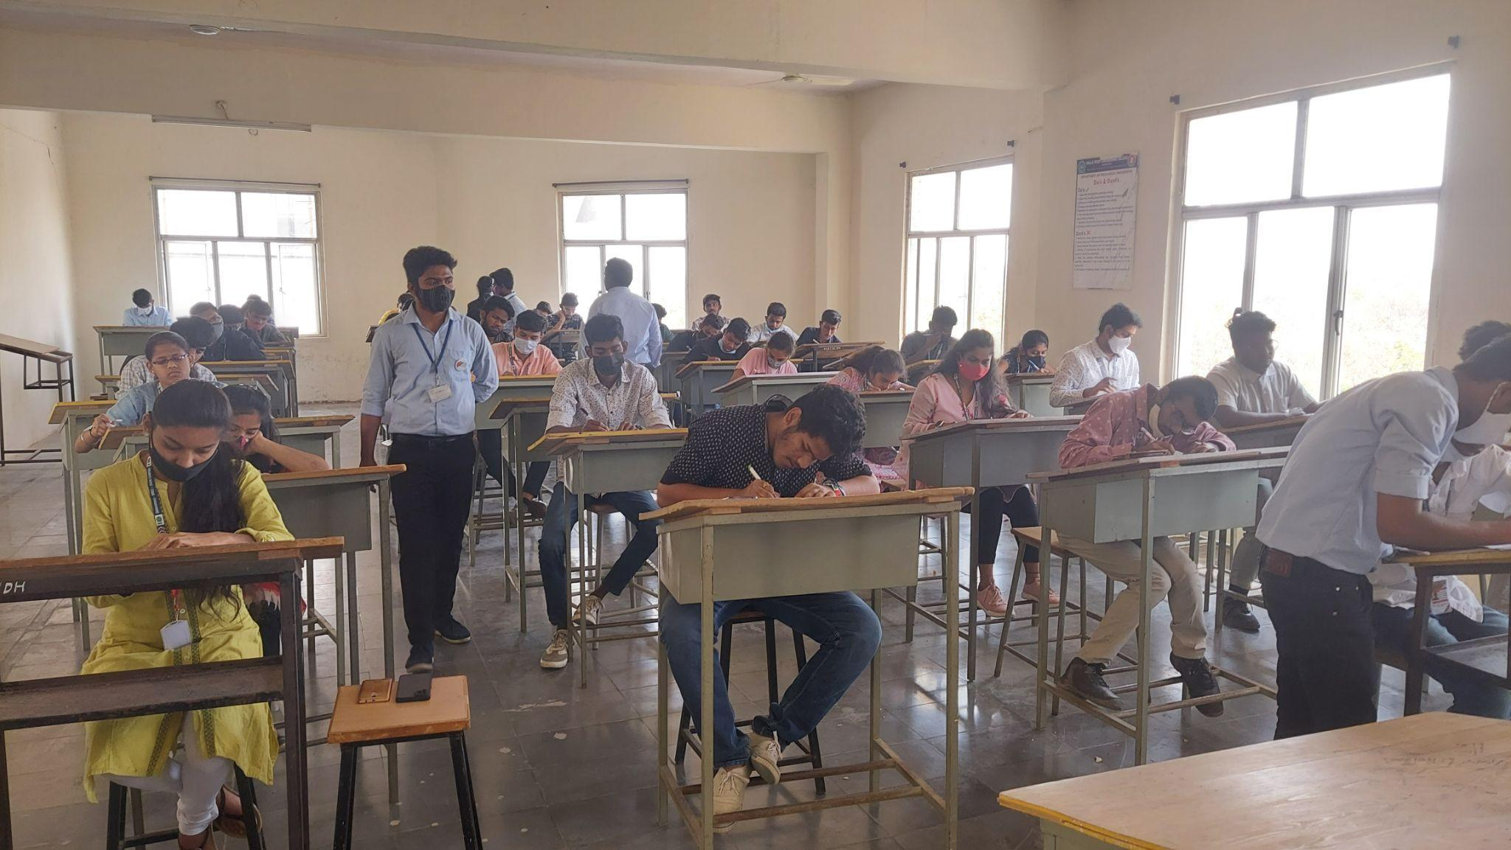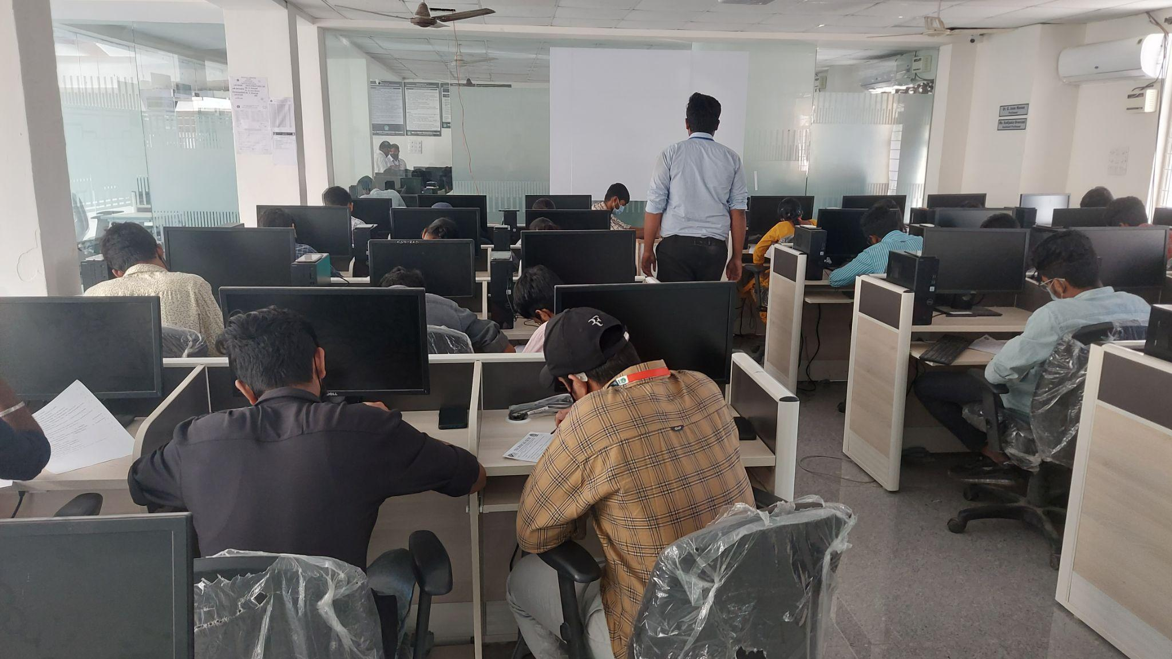

**VOLUNTEERING EVENT-2**

We have conducted a volunteering event on 03-03-2022, on the occasion of CULTURAL PROGRAMME for welcoming NAAC PEER TEAM at Malla Reddy Engineering College.

Done by M. KALYAN, T. NITHIN SAI, P. CHANDU, P.VISHAL,K.NAVEEN, SK.NAGUR, T.VASANTH, SANJANA, PAVAN KUMAR, NAGATEJA, RISHITH,

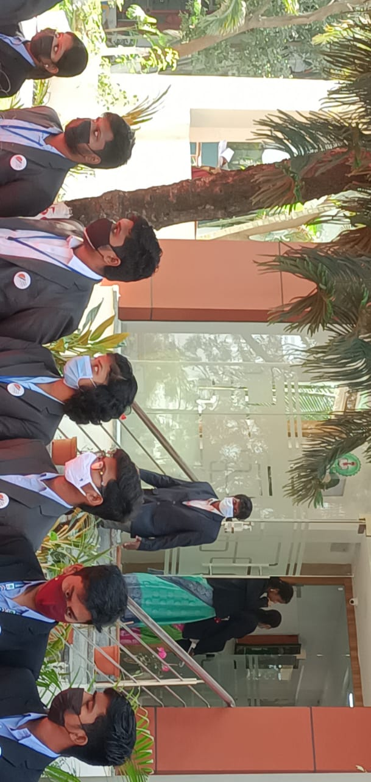

**EVENT-27**

We have distributed 400+ CHAPATIS to 100 people in the Hyderabad city on the occasion of WORLD WOMENS DAY i.e; 08-03-2022. We felt great because these chapathies were not only distributed but also made by our volunteers.

Done by M. KALYAN, T. NITHIN SAI, P. CHANDU, P.VISHAL,K.NAVEEN, SK.NAGUR,K.AJAY, PAVAN KUMAR, NAGATEJA, DATHA PRASAD, T.ARAVIND.

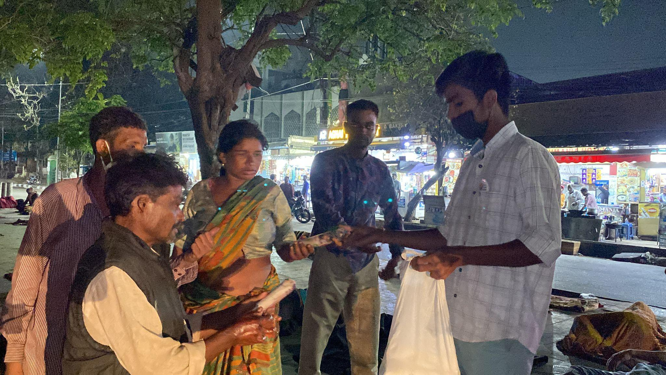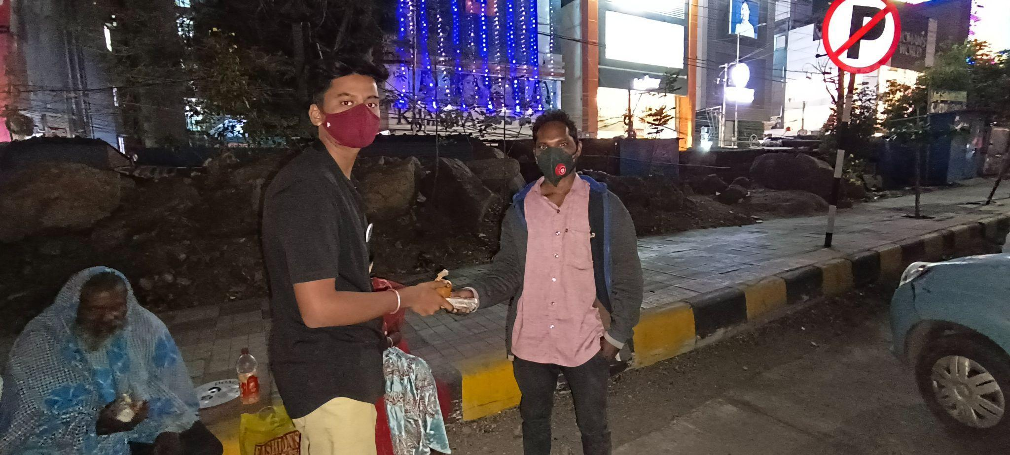

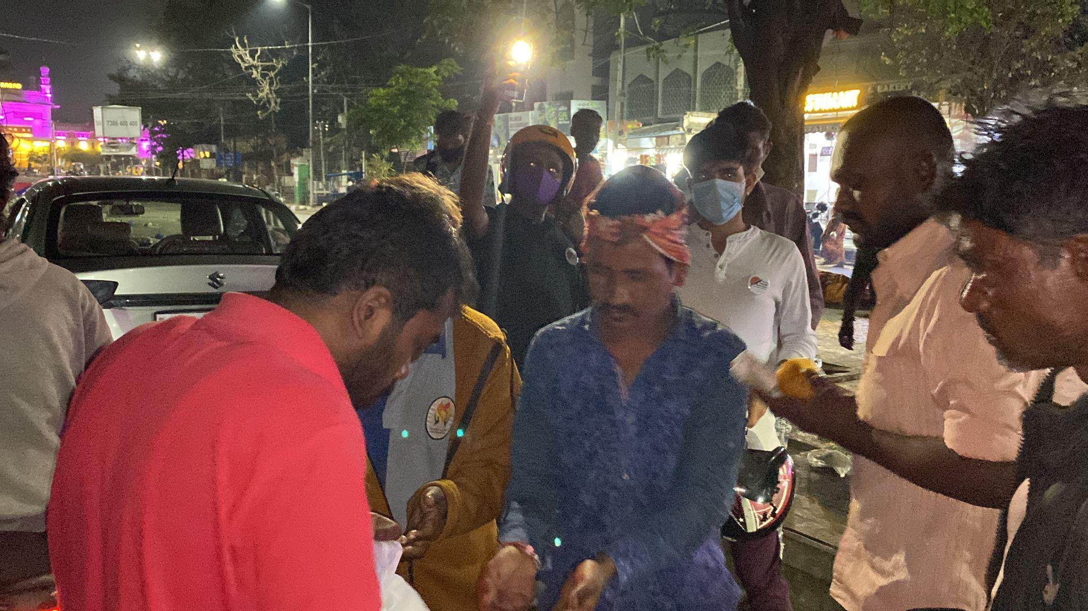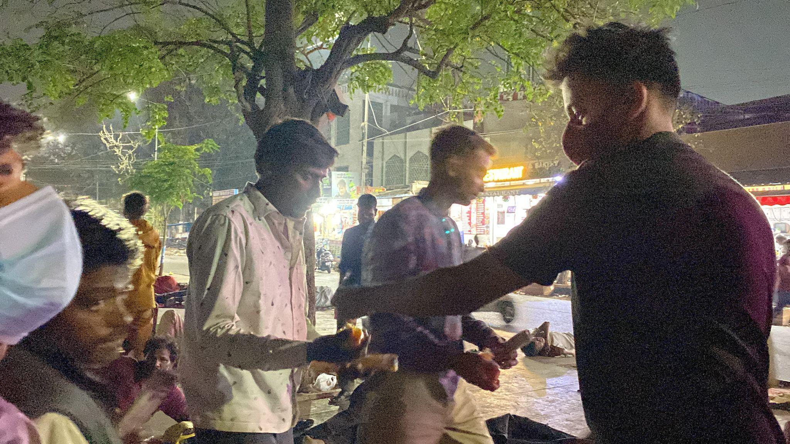

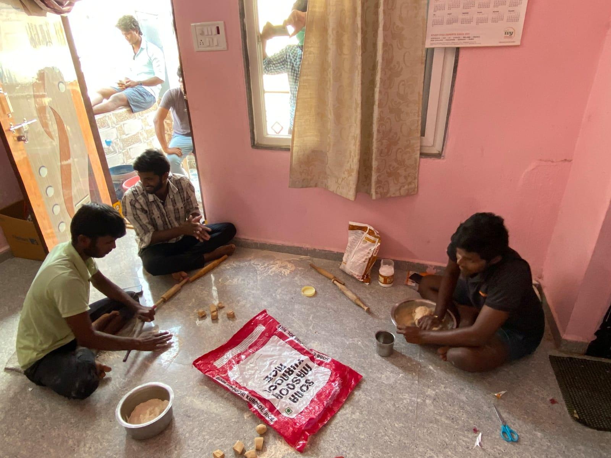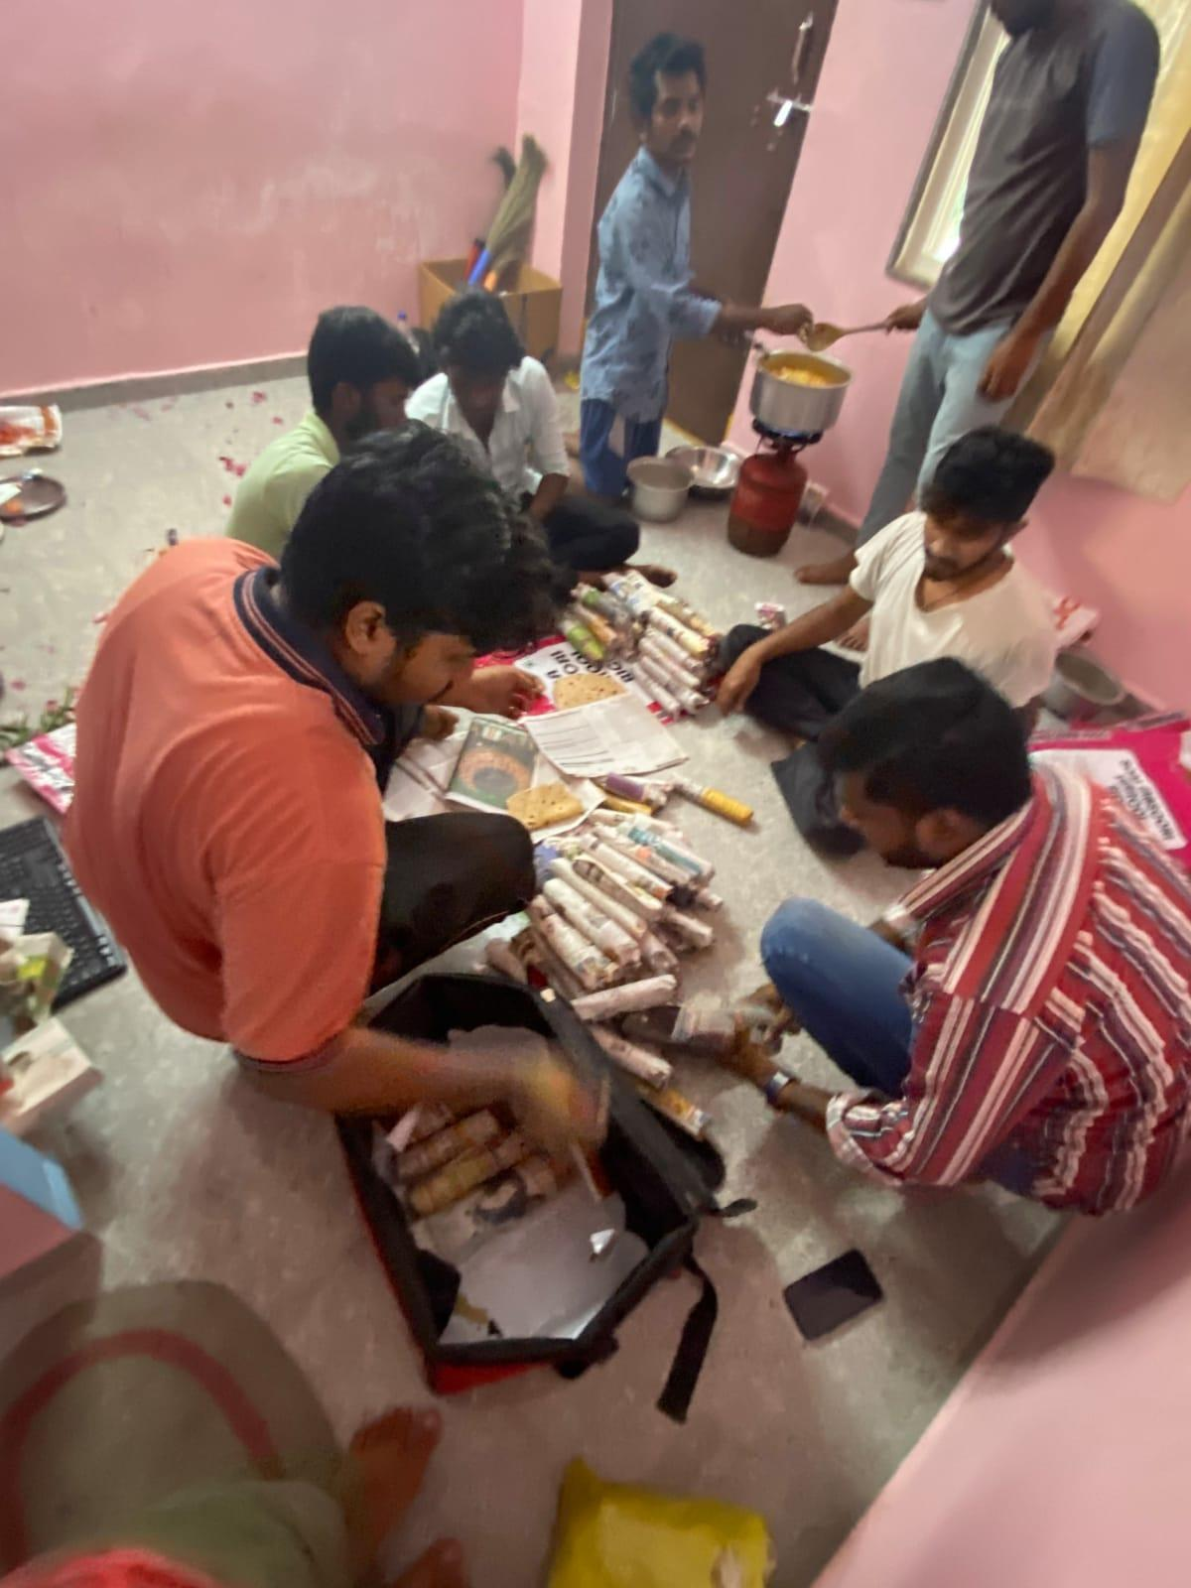

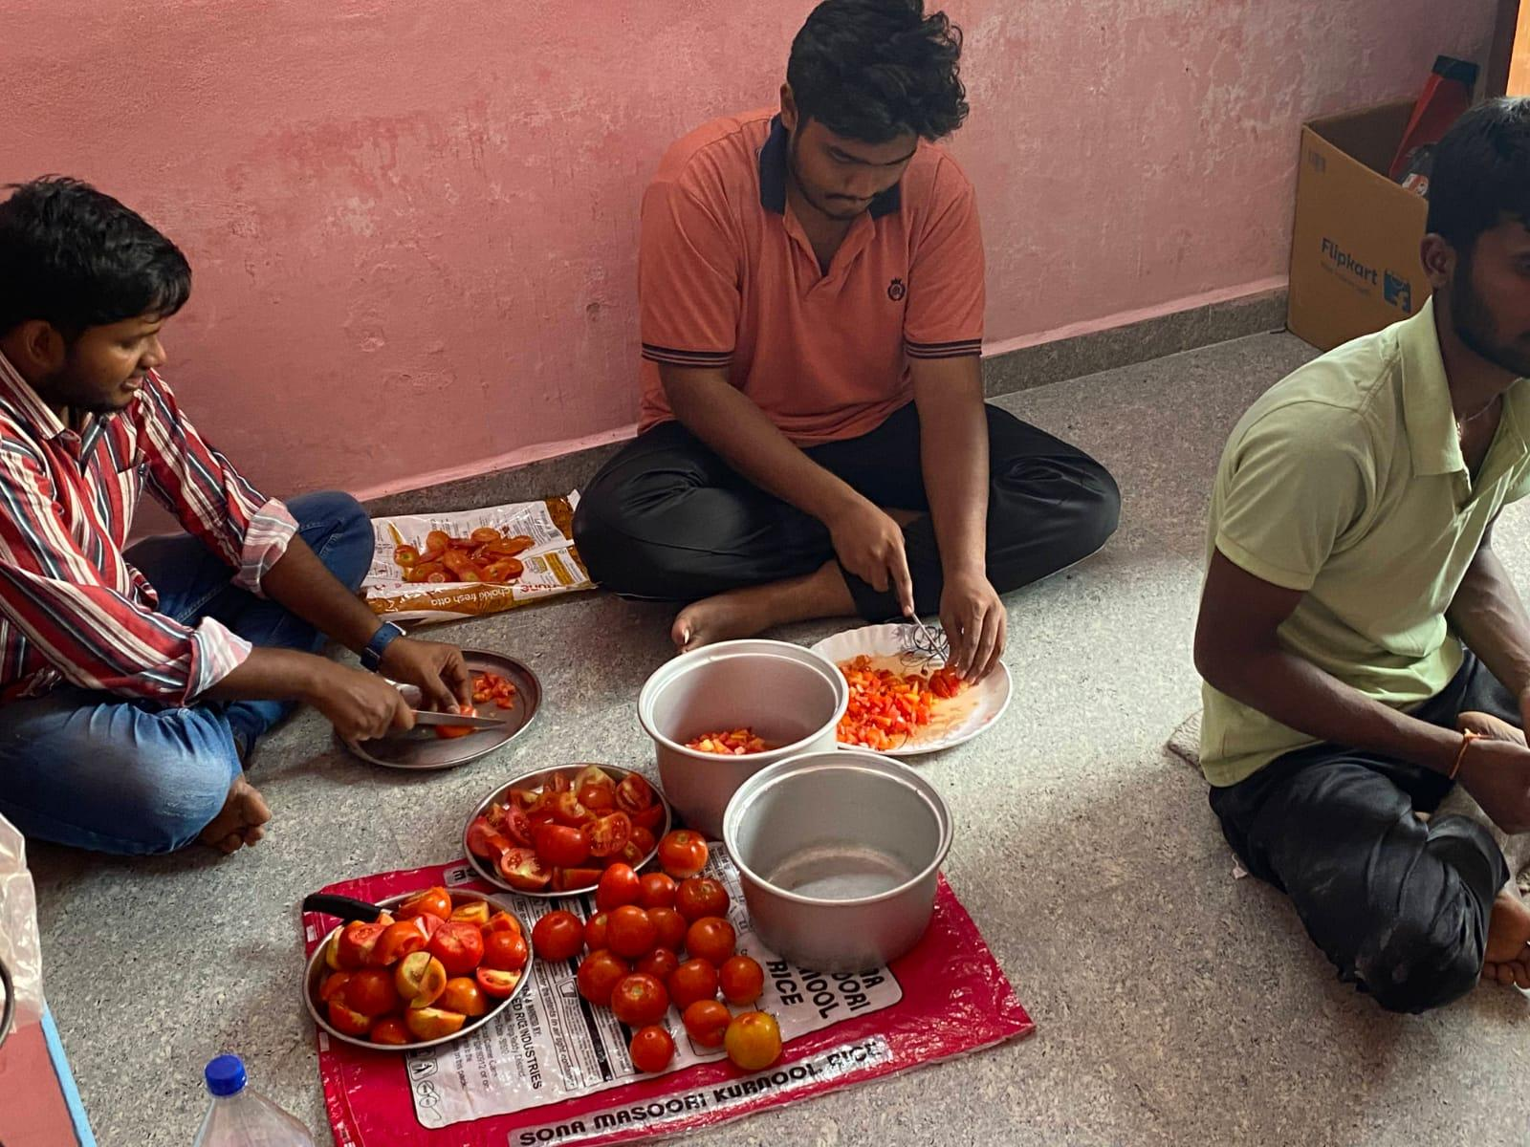

**EVENT-28**

We have distributed 100 Glasses of FRUIT SALAD Juice to 100 people in the Hyderabad city on 20-03-2022. Distribution made by our volunteers.

Done by K.GIRI BHARGAV, T. NITHIN SAI, P.VISHAL,K.NAVEEN, G.SAIRAM, A.SWATHI, K.SAITEJA, PAVAN KUMAR, NAGATEJA

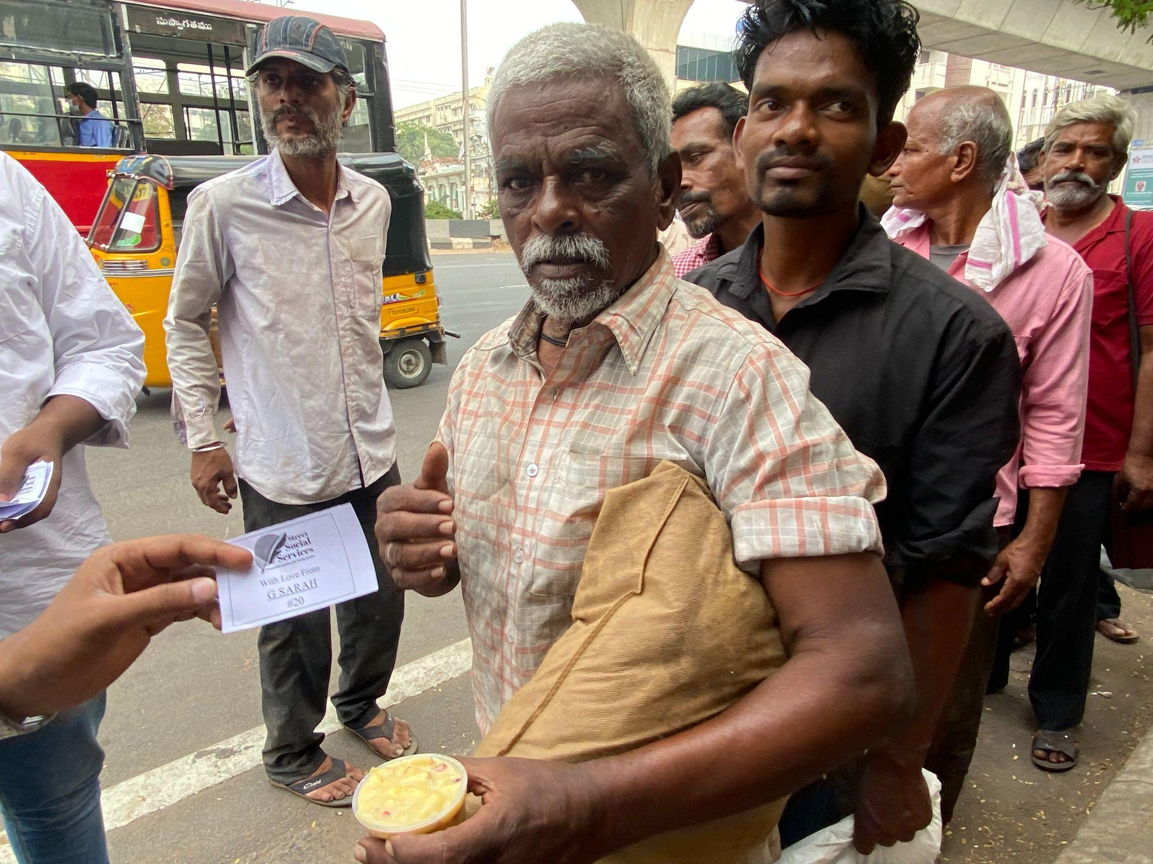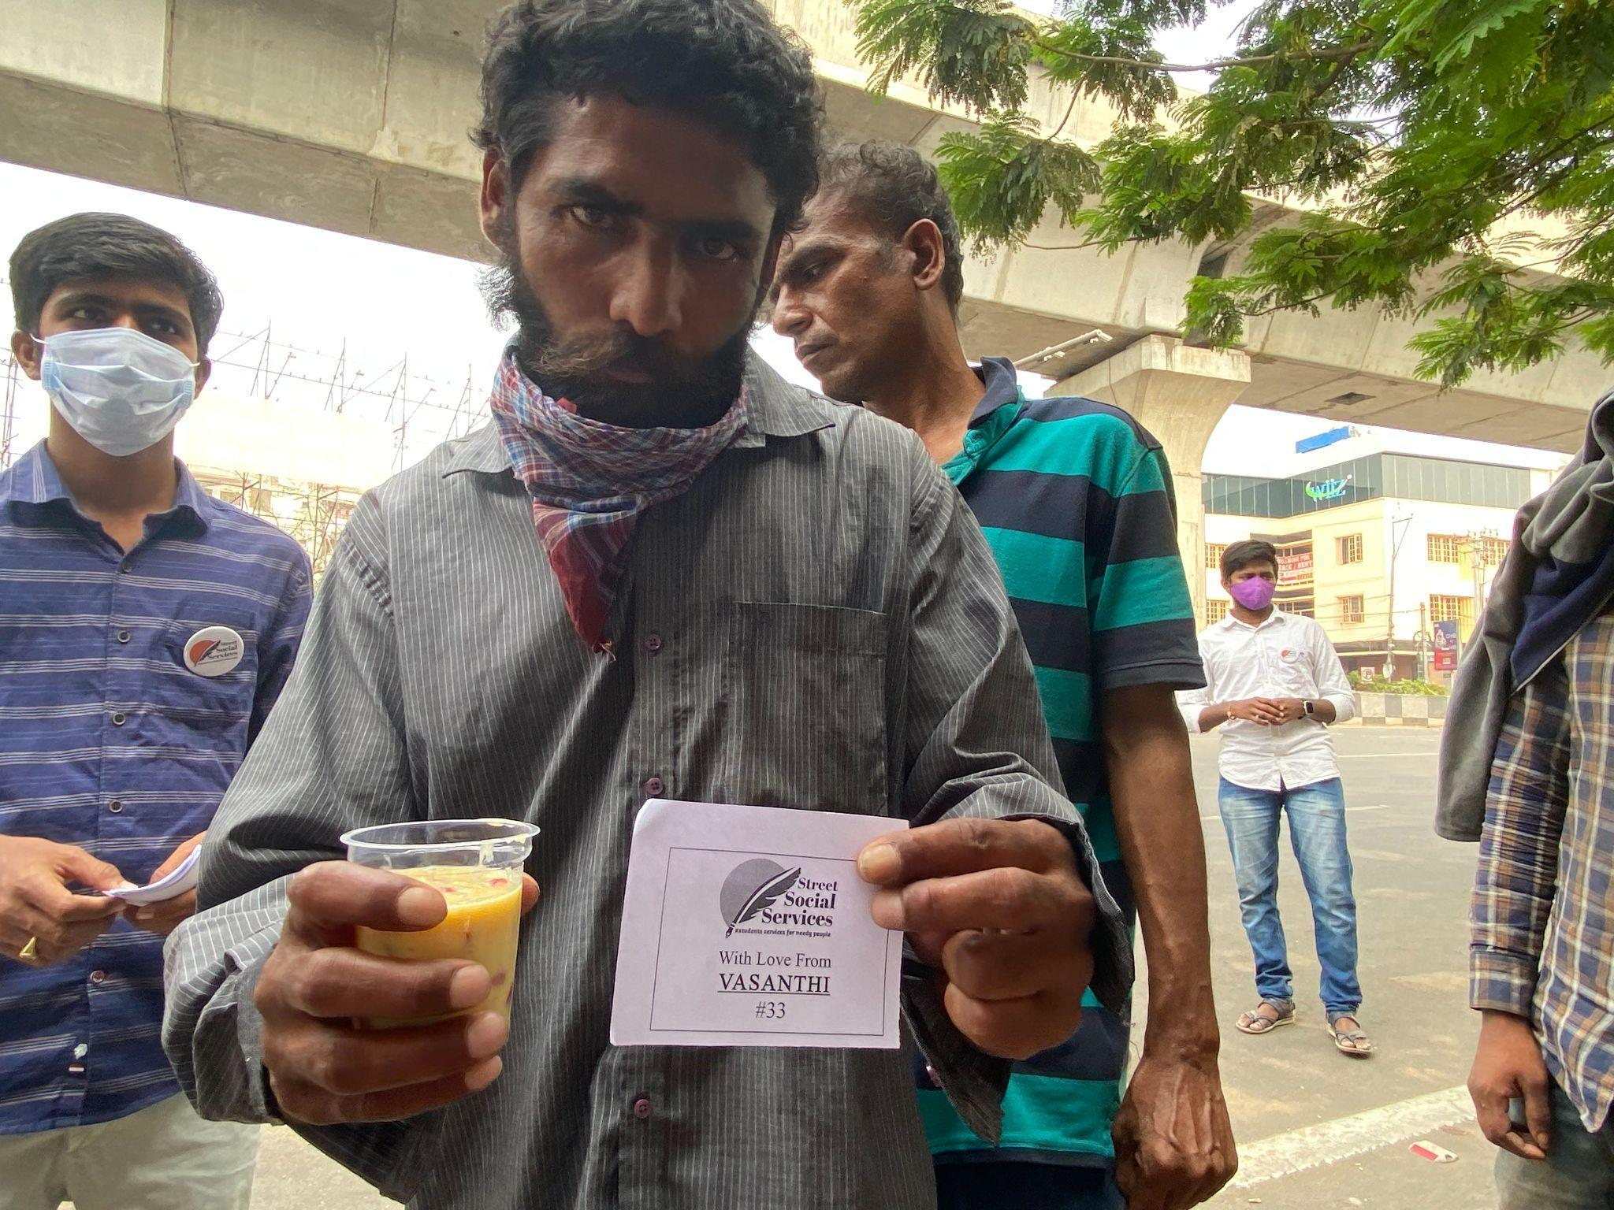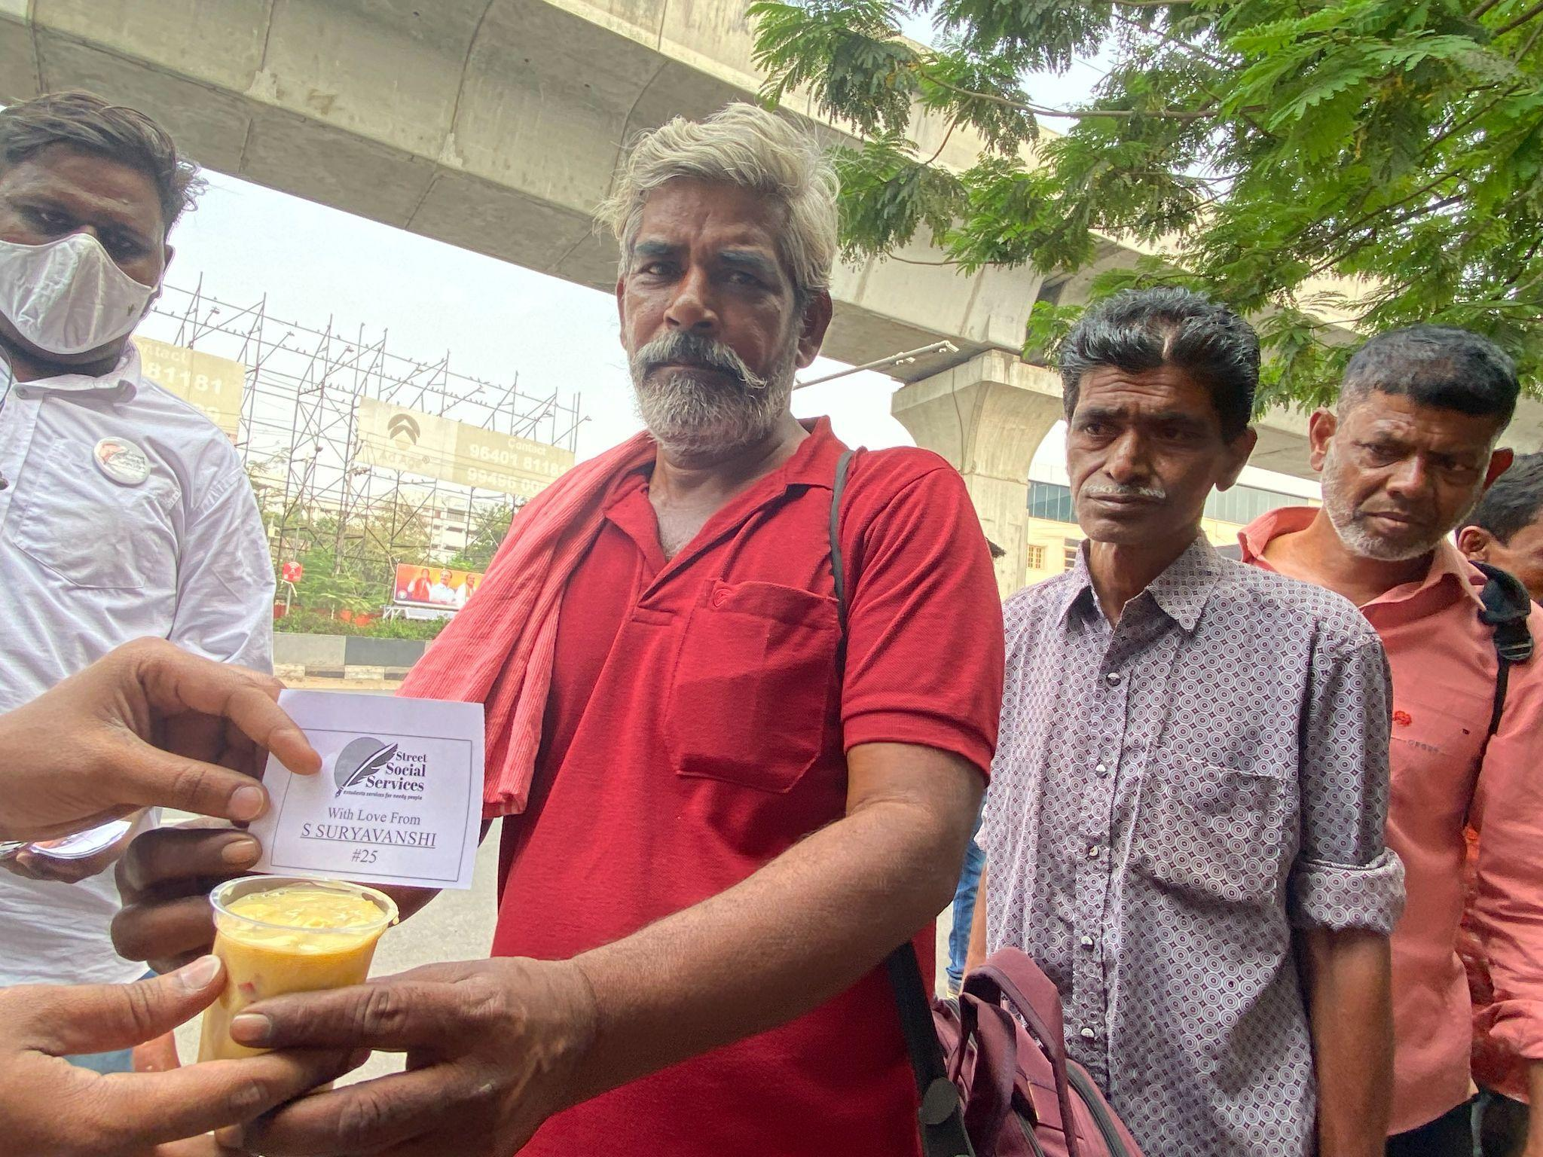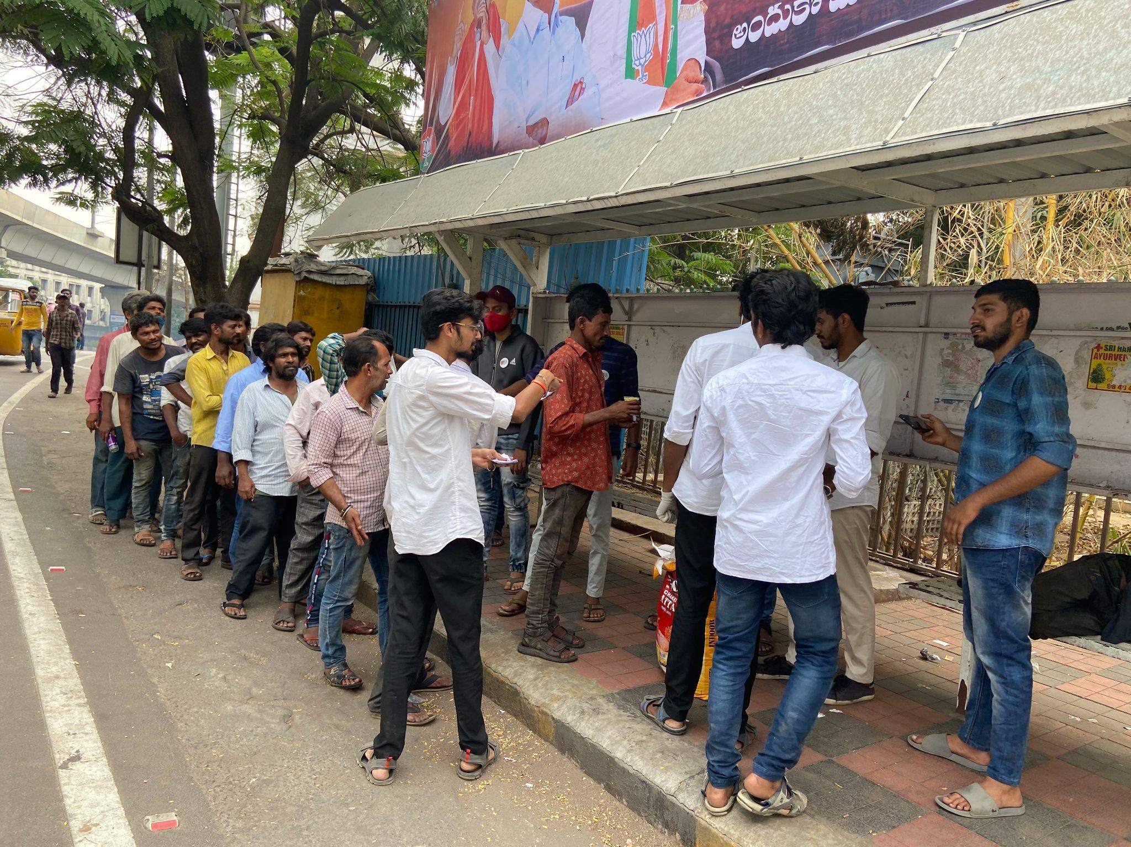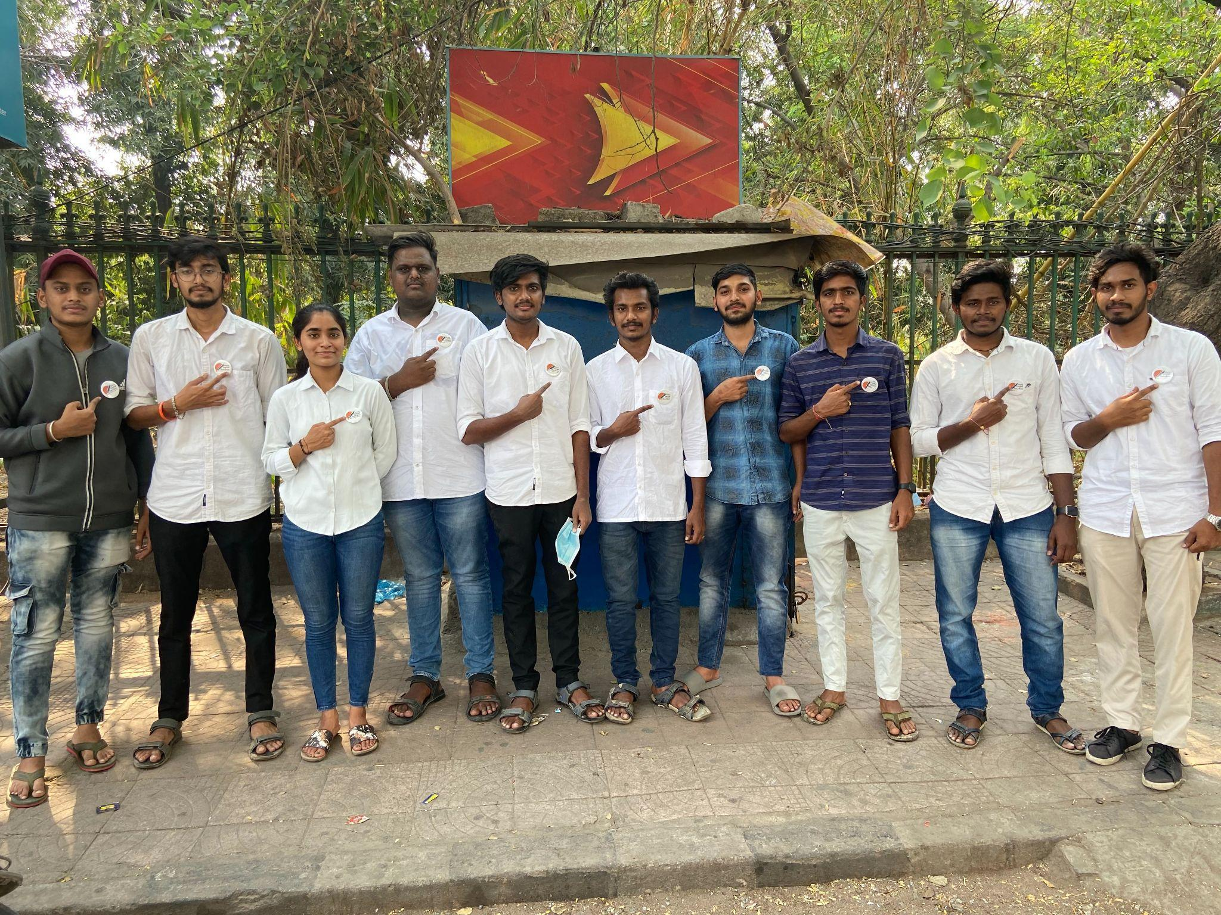

**FUNDRAISING EVENT-1**

We had conducted FLASH MOB as a fundraising event at AMB MALL in Hyderabad. All the dancers are students of MREC, (i.e; nearly 40 students participated in this flash mob performance ).

Done by; T.NITHIN SAI, K.GIRI BHARGAV, K.NAVEEN, PRUDHVI, SAIRAM, VISHAL. 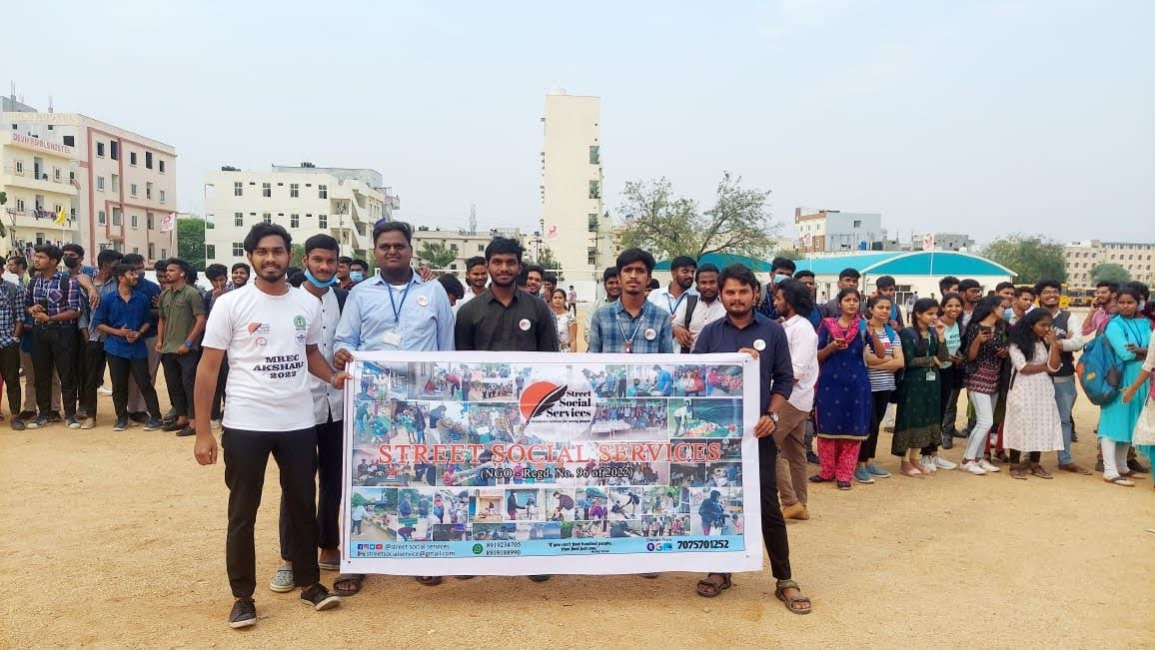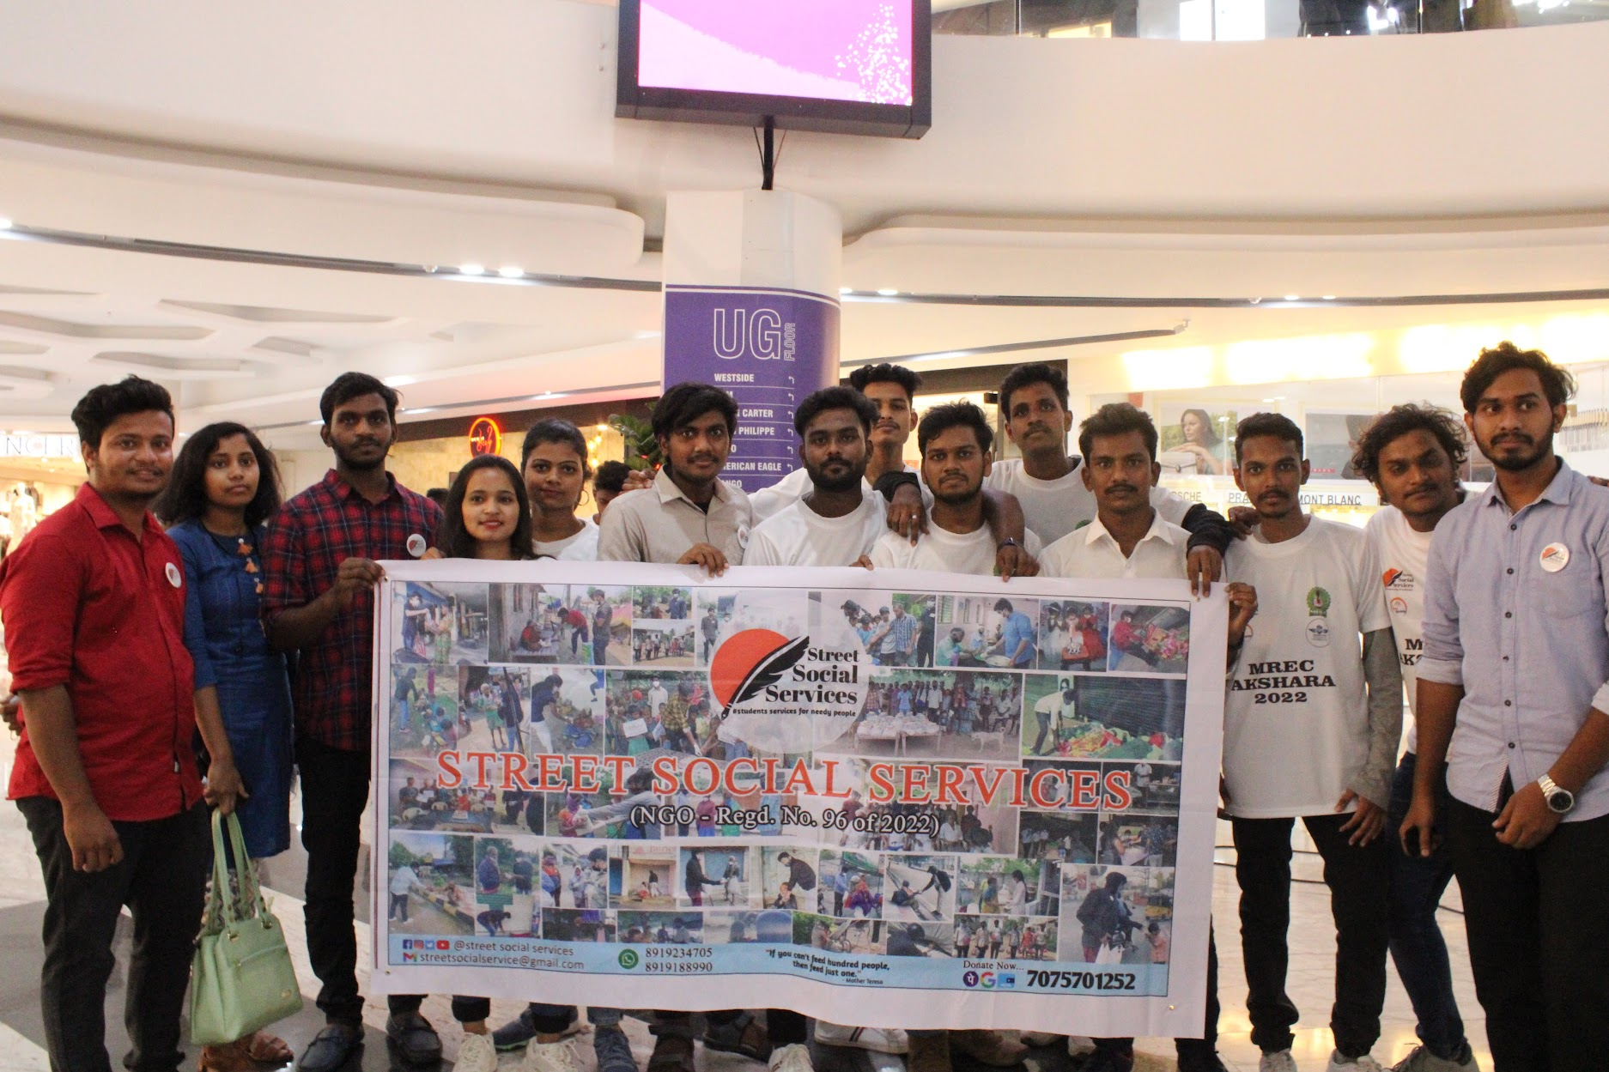

Dancers team coordinators; RAHUL & VISHALAKSHI.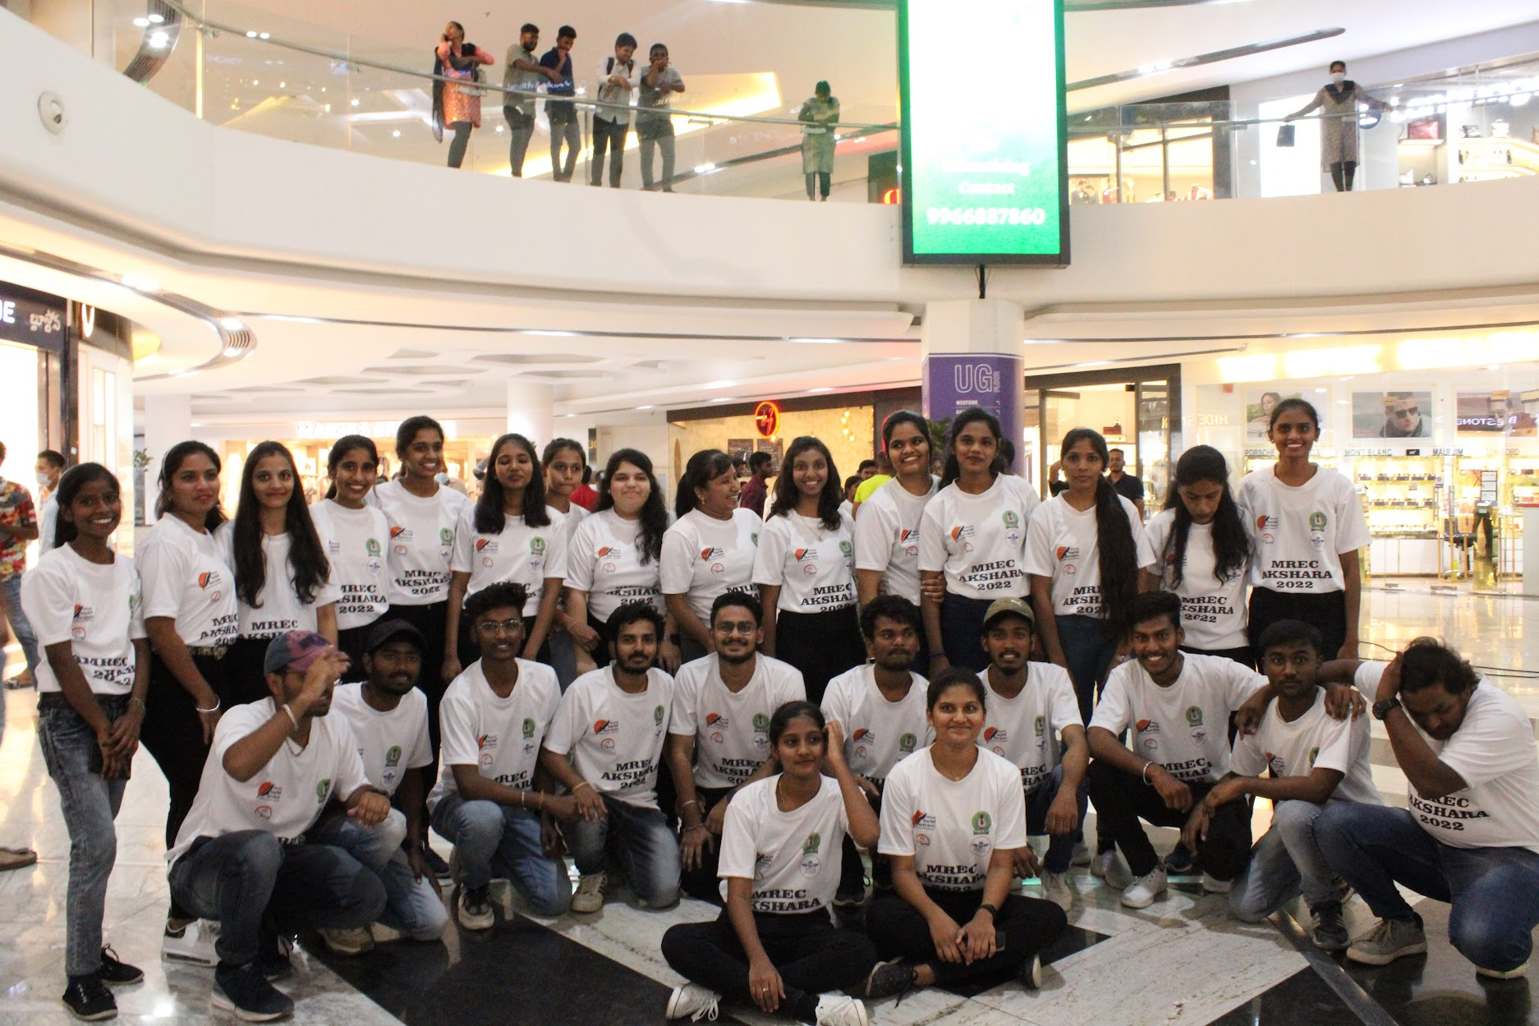

**EVENT-29**

We have donated food in an orphanage ( Trailblazers Jasmine Girls Home, Kompally, Secunderabad ) on 25-03-2022. We collected this food from a Biryani stall of MERC's AKSHARA-2k22 Fest, which is left over as excess at them.

Done by; V.MANOJ, PAVAN, SANTHOSH, HARISH, OBUL REDDY, SRINIVAS.

Thank you REKHA MAMIDI Garu ( owner of the stall ).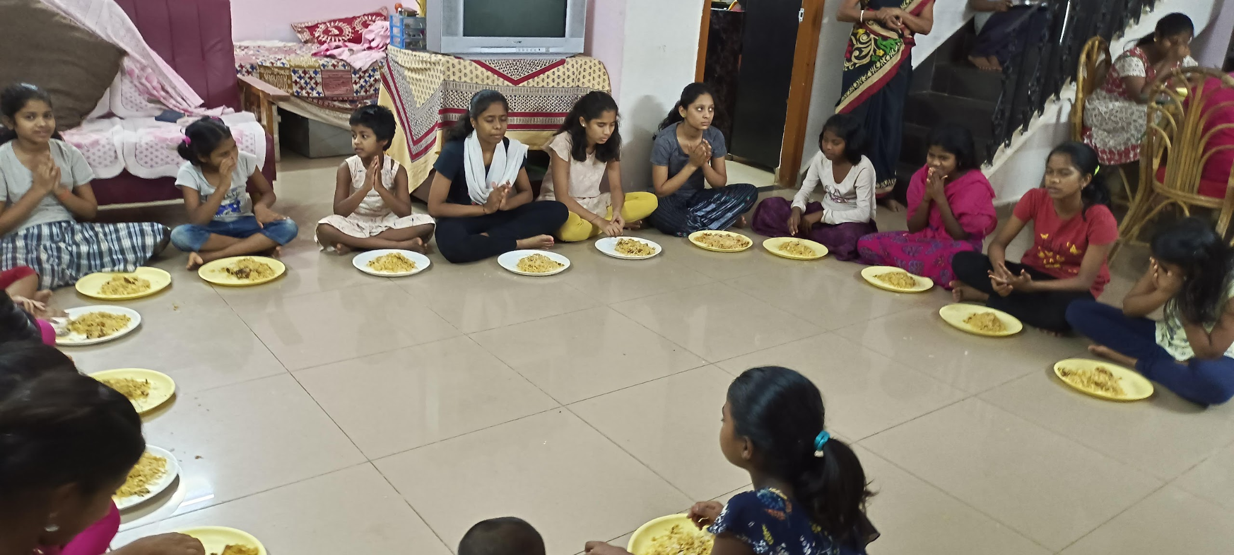

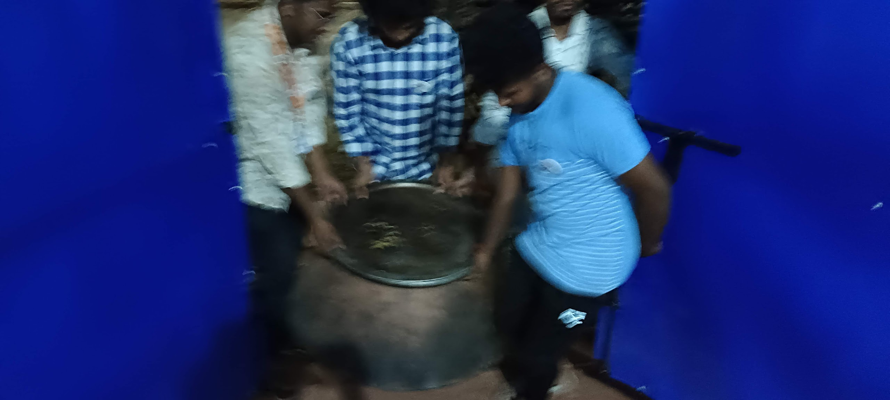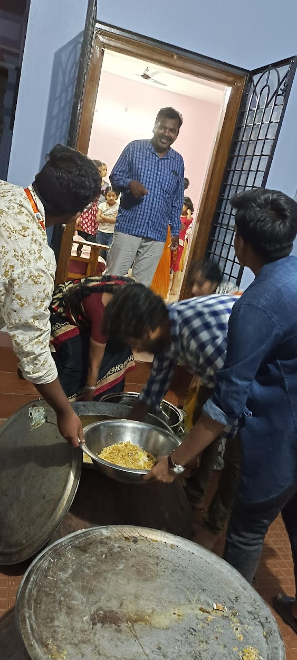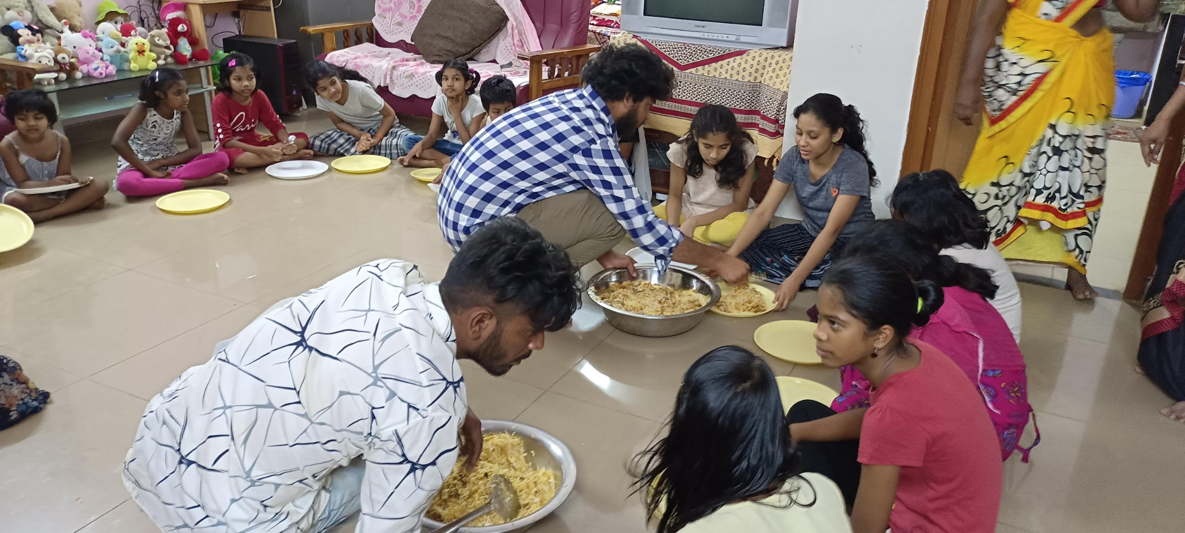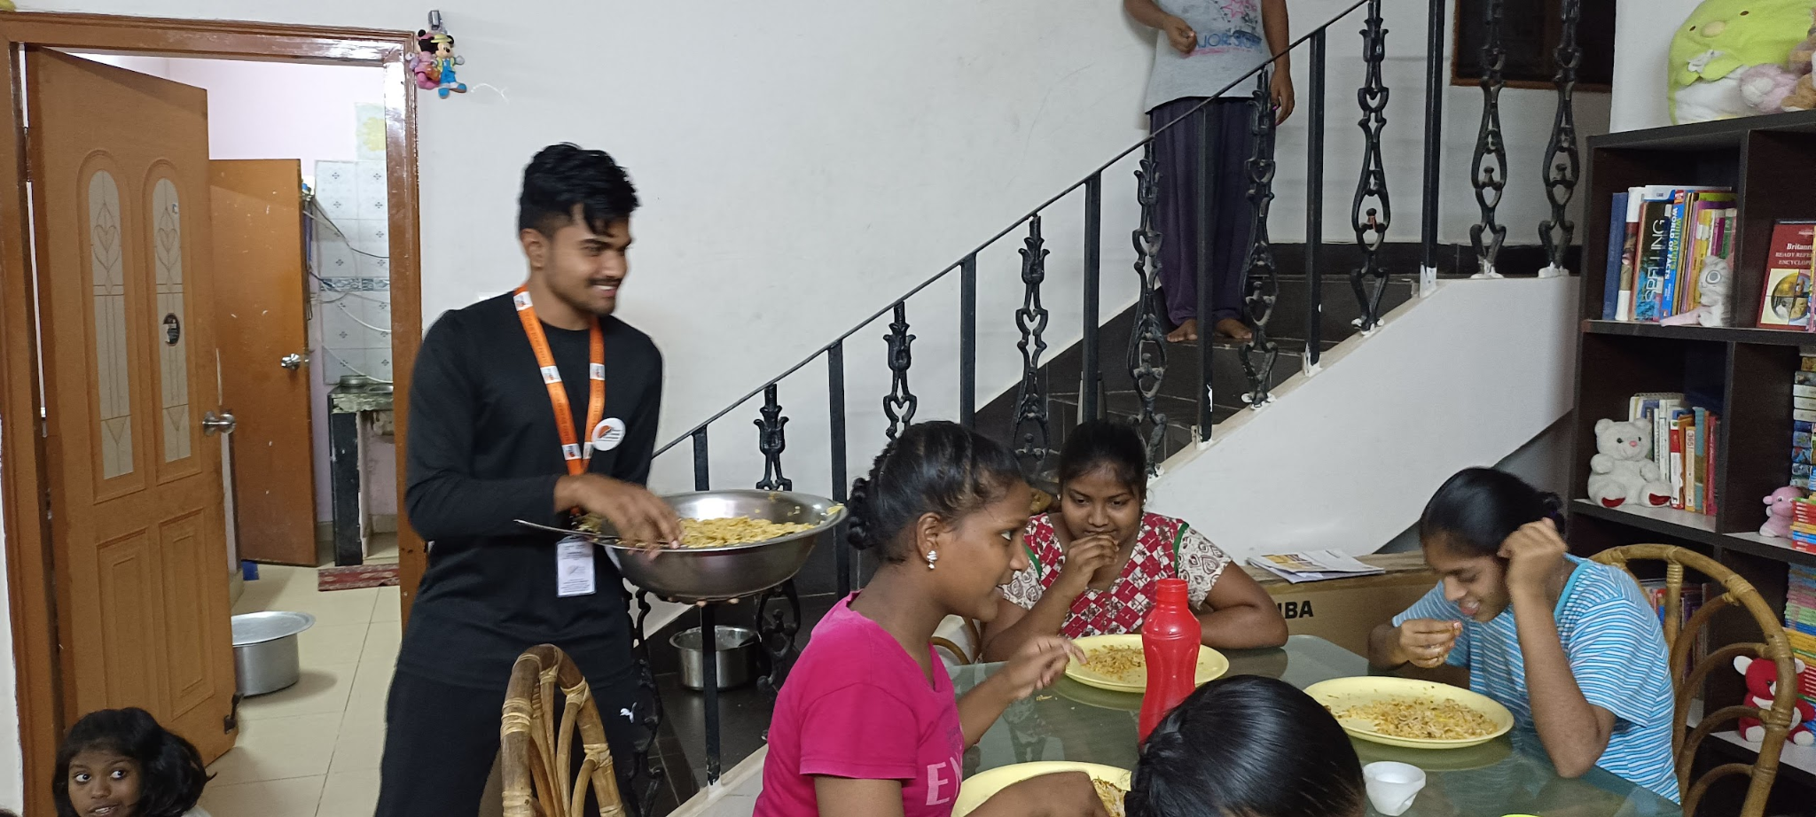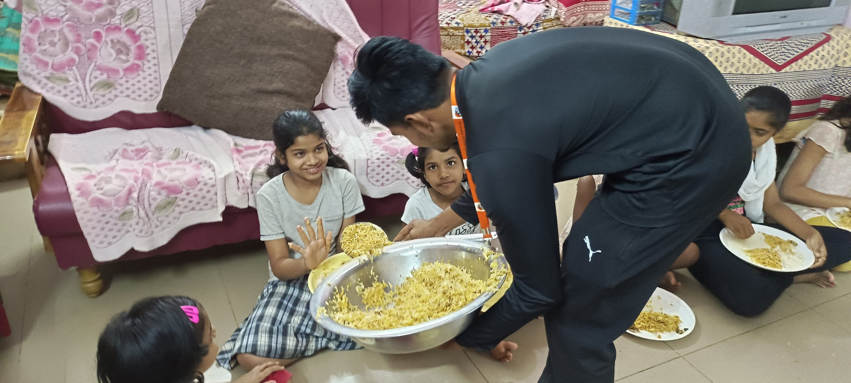

**FUNDRAISING EVENT-2**

We had conducted a Fundraising event as collecting Donations in MREC AKSHARA-2k22 College Fest ( i.e; on 25-03-2022 and 26-03-2022 )

Done by; K.GIRI BHARGAV, T.NITHIN SAI, M.KALYAN, G.SAIRAM, P.VISHAL, K.NAVEEN, POOJWALA, PAVAN, NAGATEJA, RISHITH, ADITYA TEJA.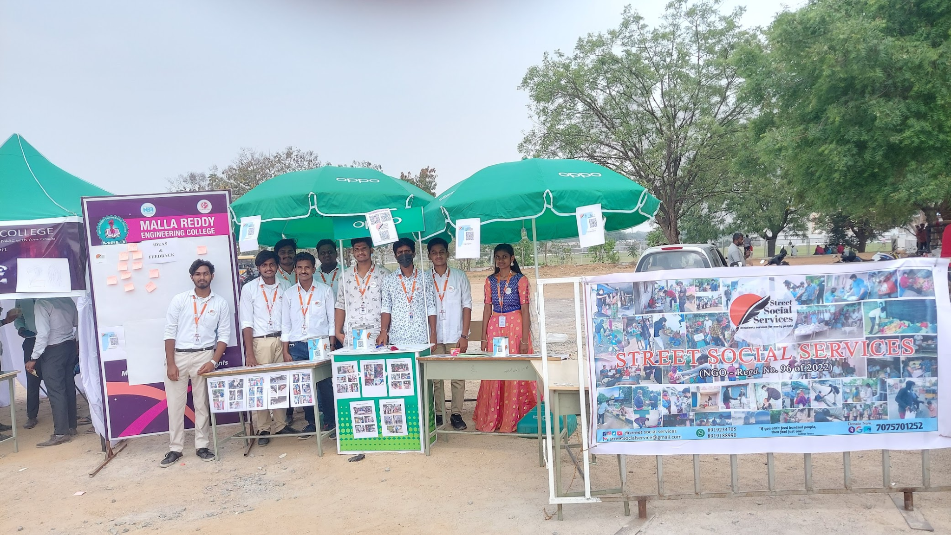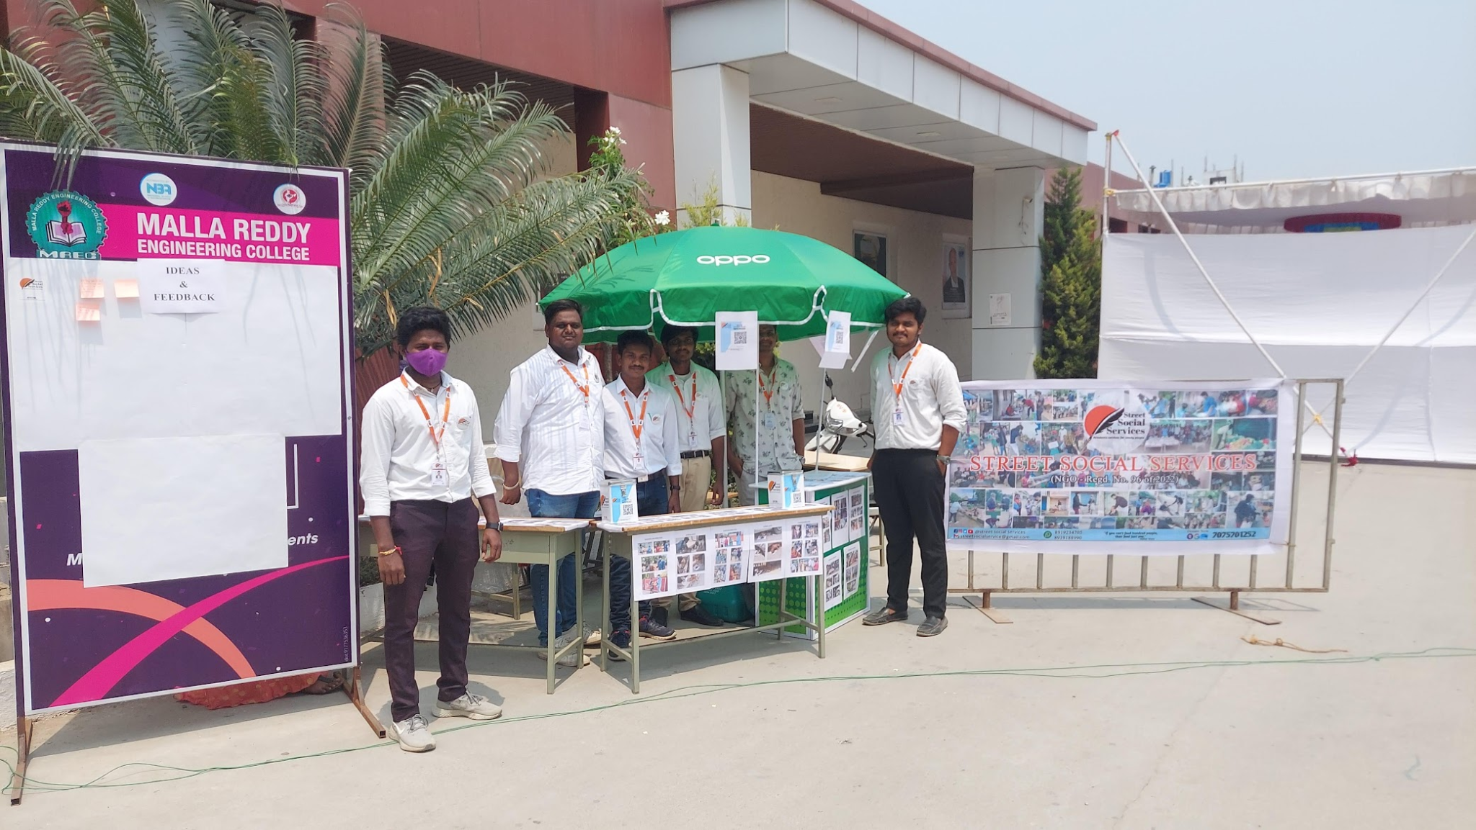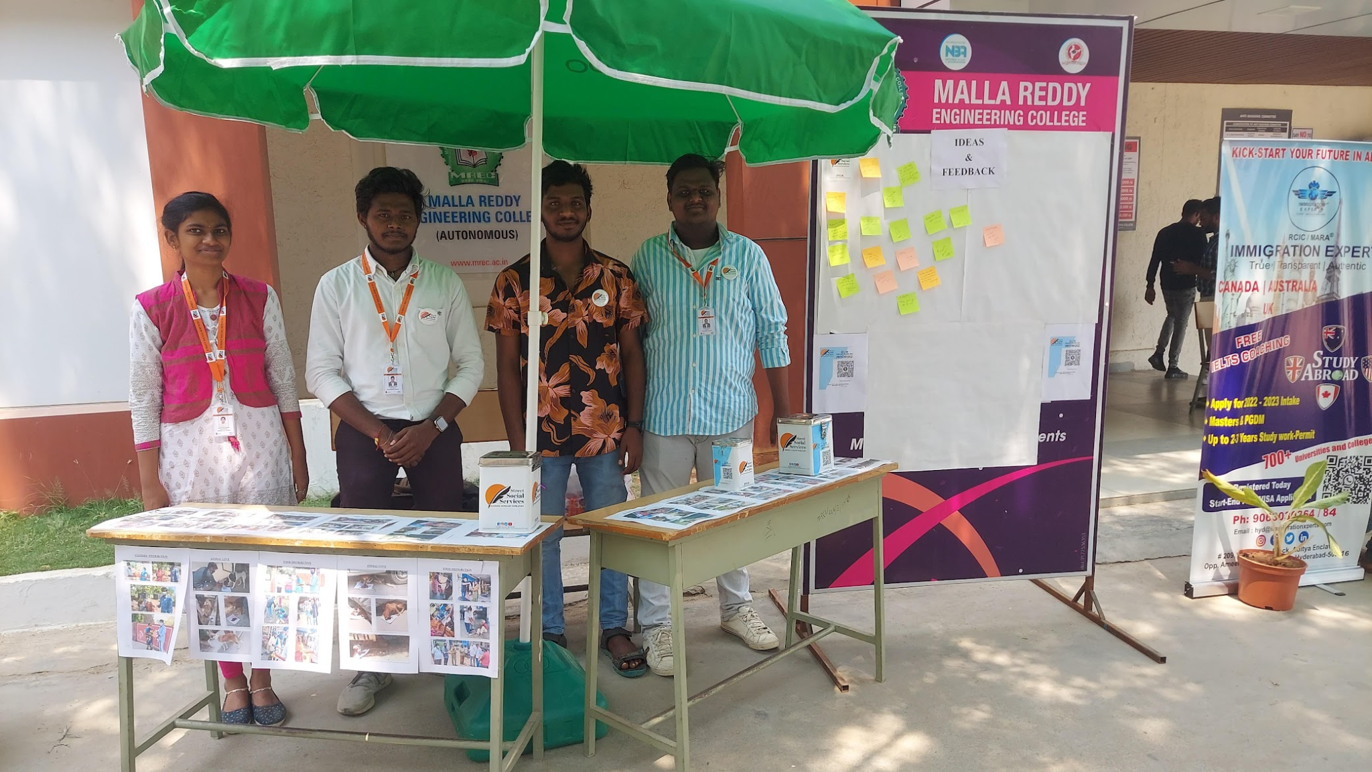

**EVENT-30**

SSS is very happy and proud to celebrate its 1st anniversary in **Sri sathya sai samaja seva trust,kothagudem.**

On this occasion we donated food in the orphanage..

Done by:K.GIRI BHARGAV, M.KALYAN,

SSS ANNIVERSARY

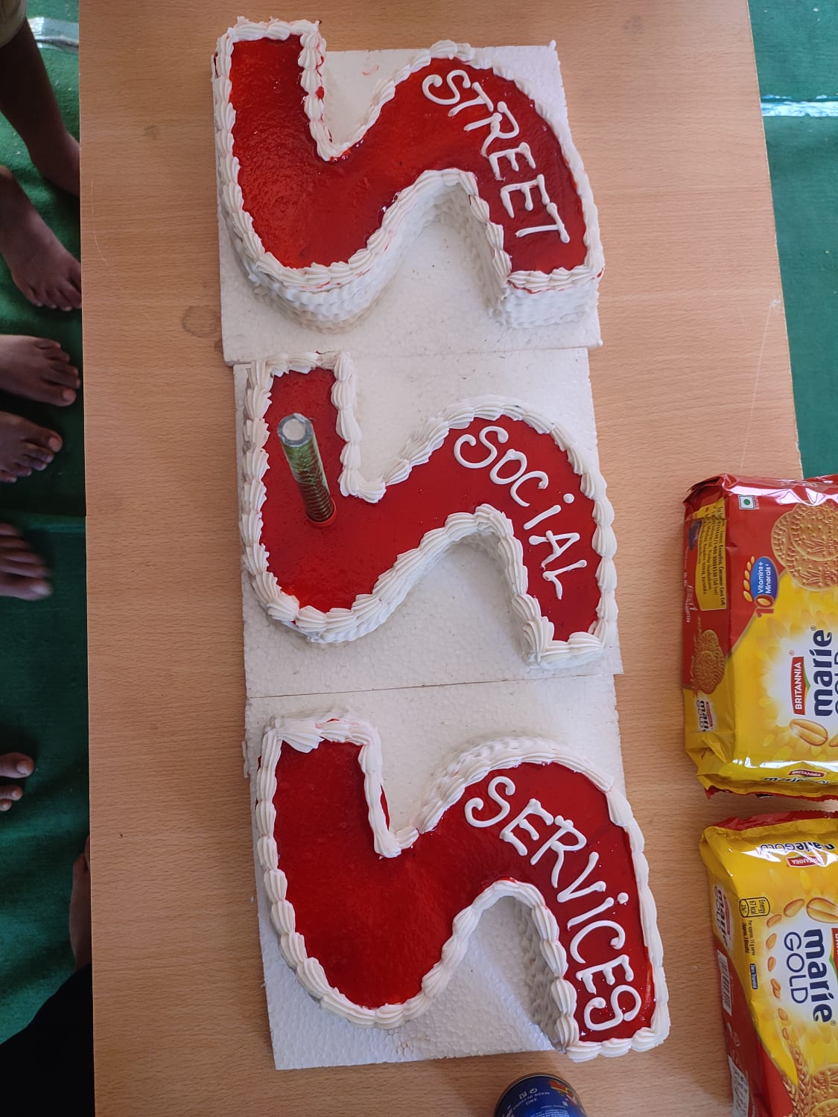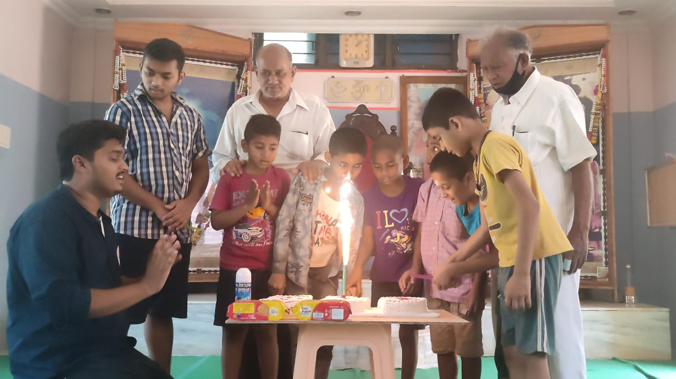

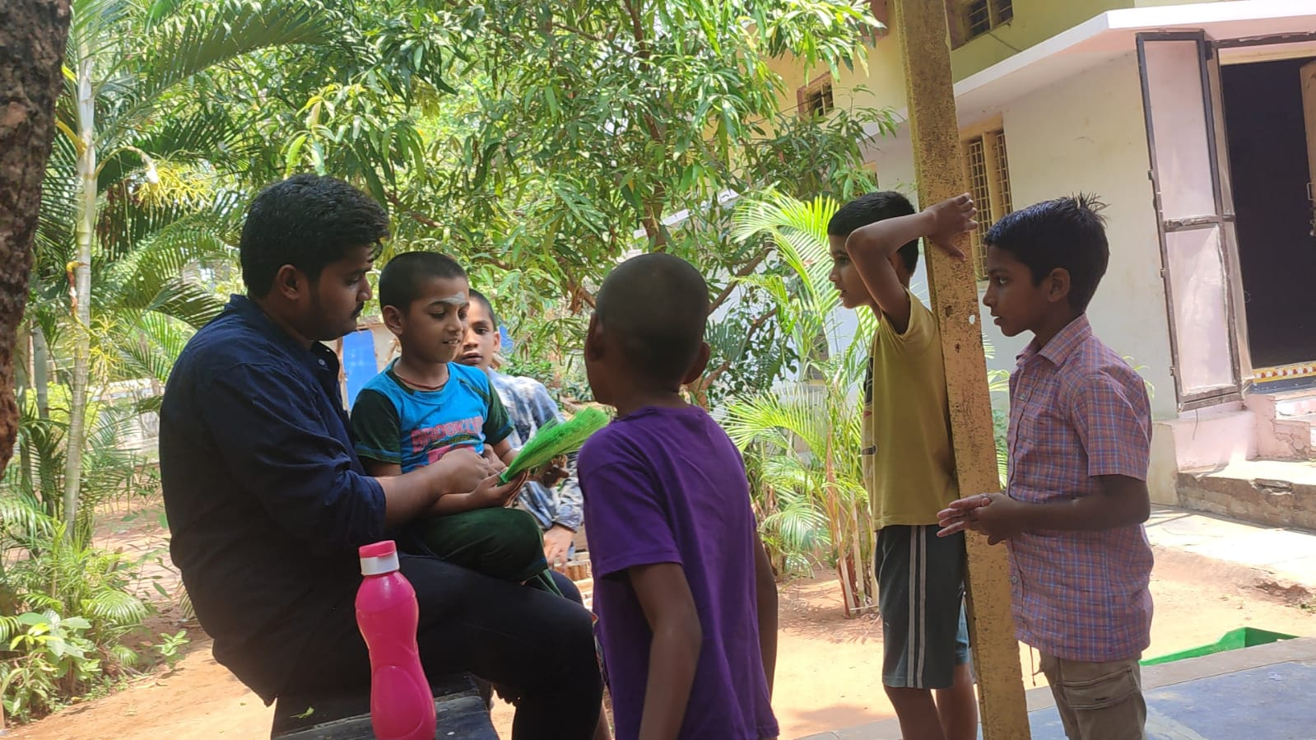

**EVENT-31**

We have 1st anniversary celebrations at KASTHURIBA GANDHI GIRLS SCHOOL bayyaram, Bayyaram, Mahabubabad Dist. Distributed exam pads and stationary to 10th students. on 05-04-2022

Done by; T.NITHIN SAI.

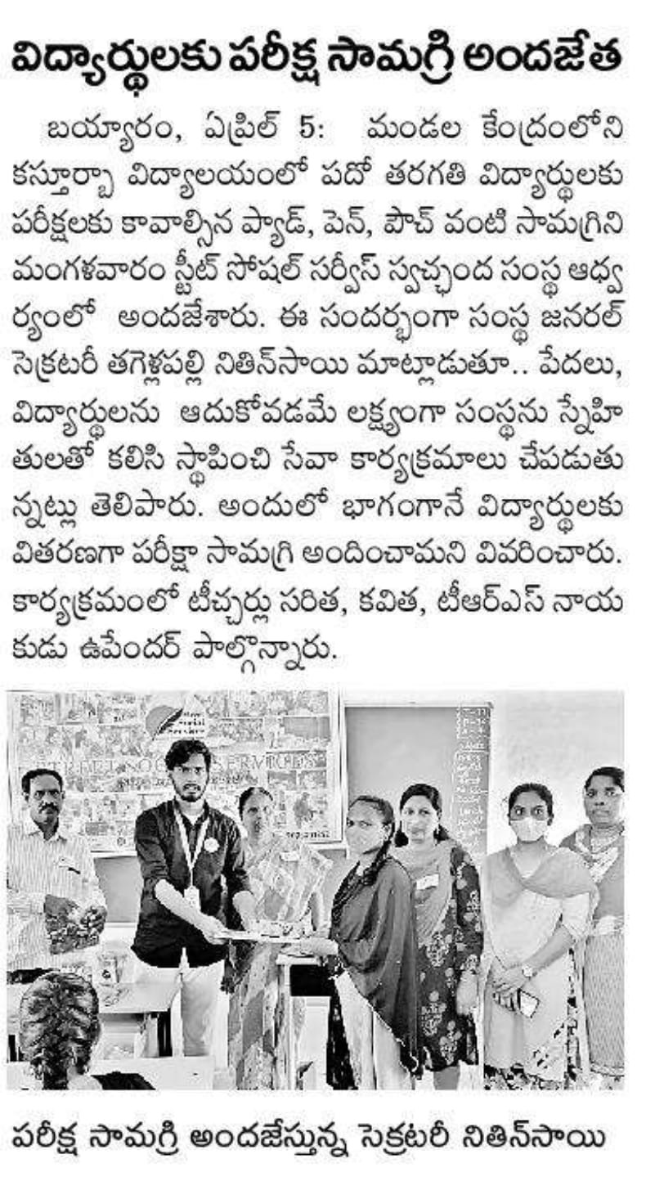

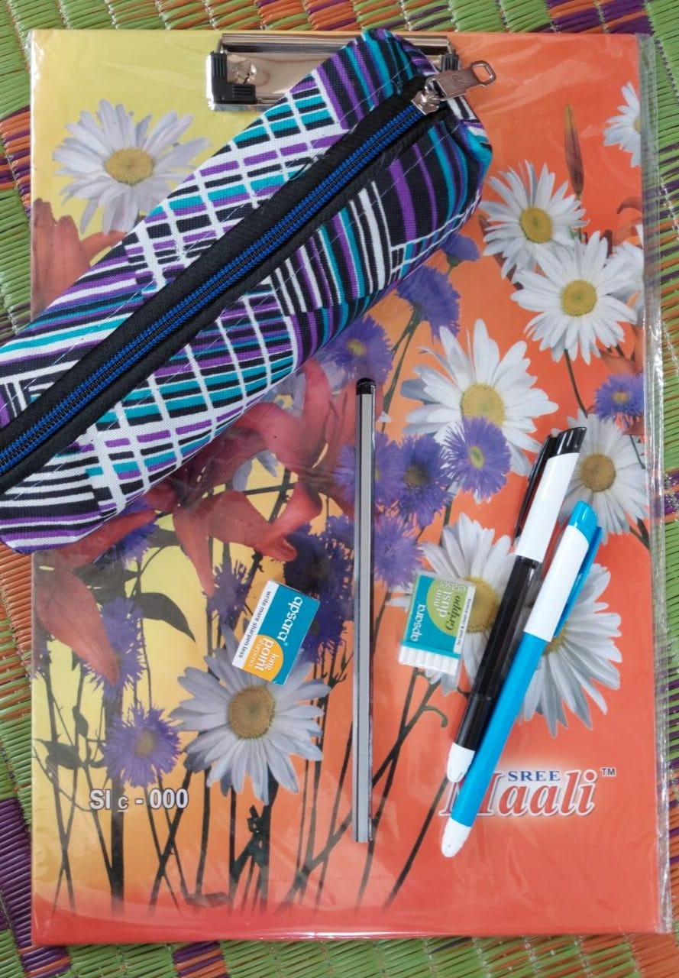

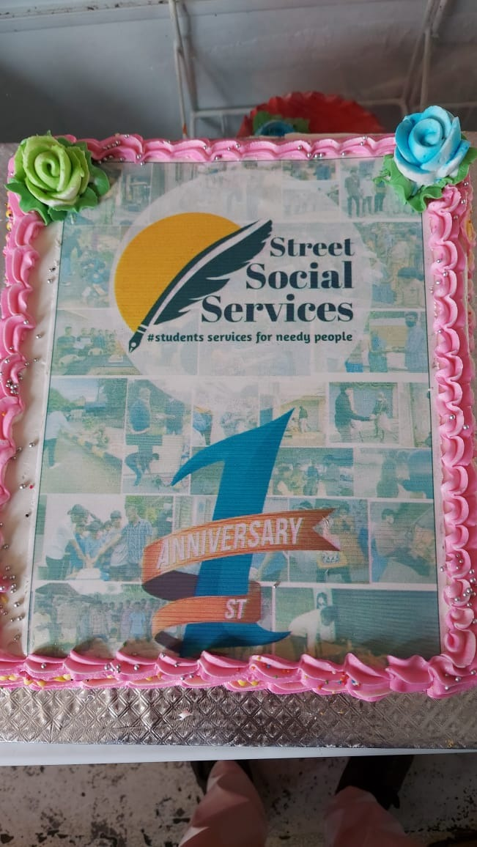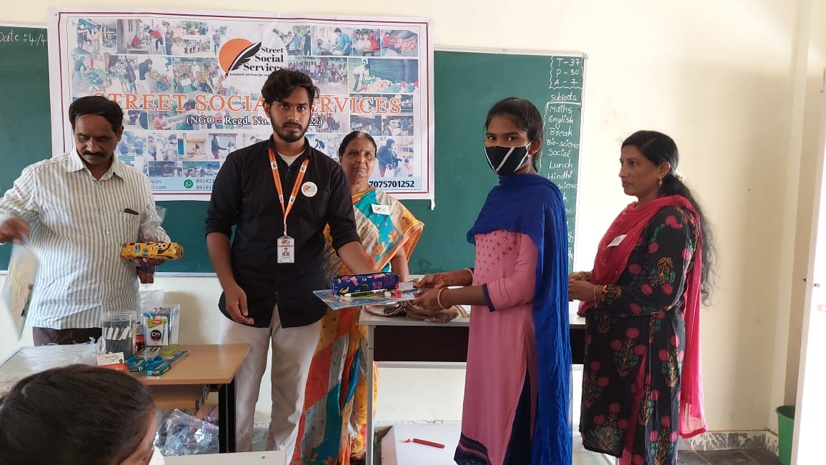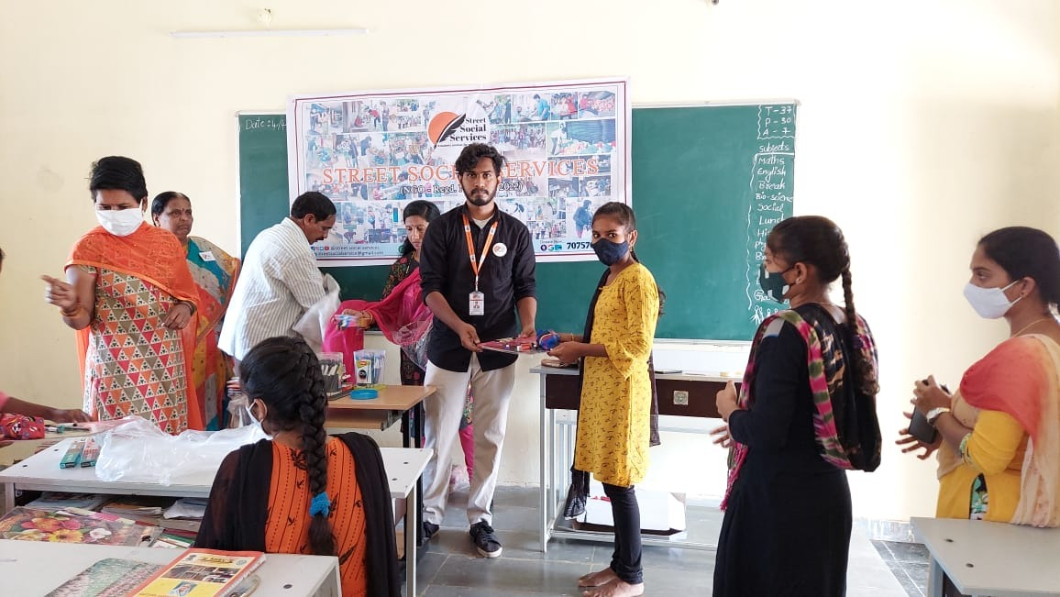

**EVENT-32**

We have distributed BREAK FAST to 50 people in the Hyderabad city on 10-04-2022. Distribution made by our volunteers.

Done by K.GIRI BHARGAV, T. NITHIN SAI,K.NAVEEN, G.SAIRAM, AJAY, MANOJ.

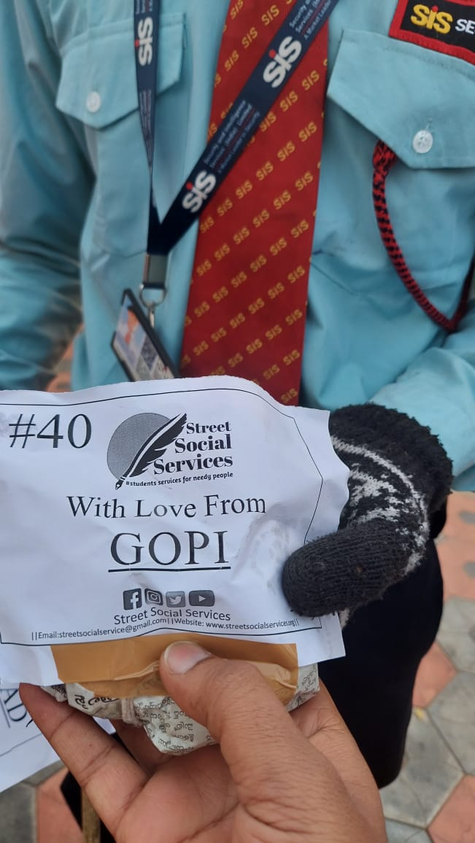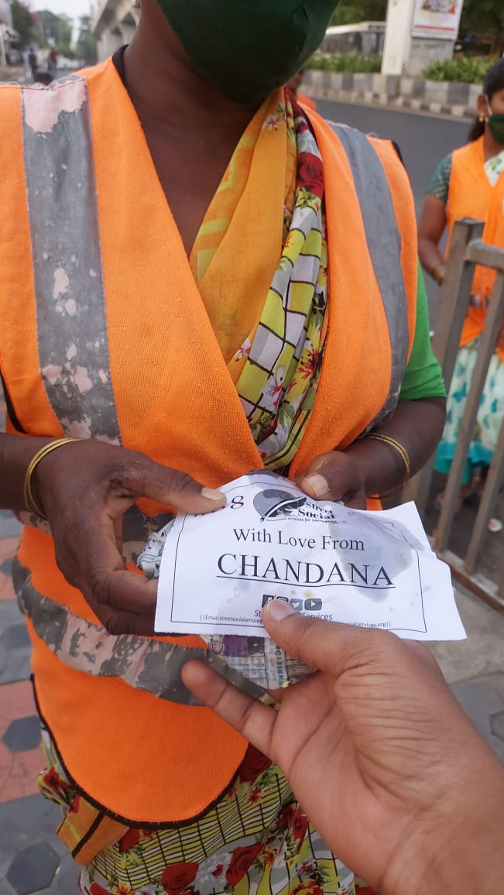

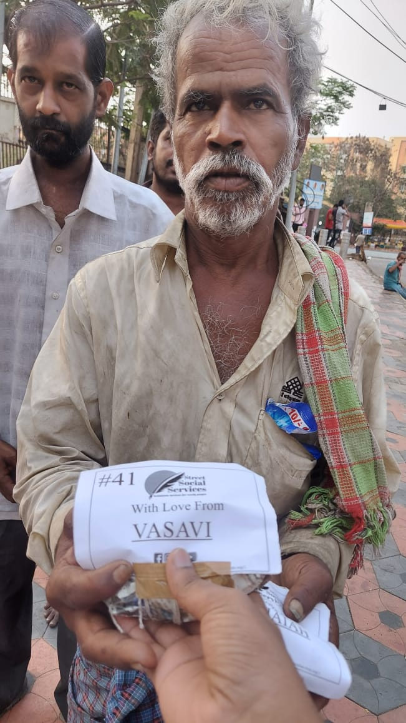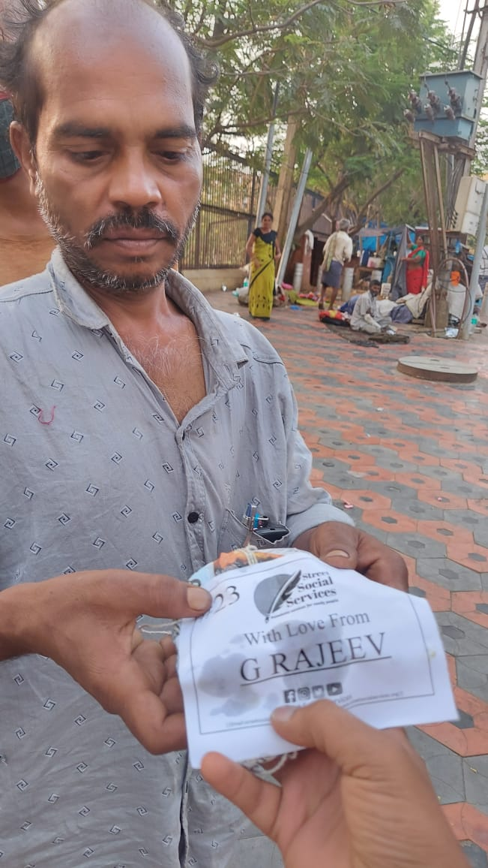

**EVENT-33**

We have distributed FOOD to 50 people in the Hyderabad city on 10-04-2022. Distribution made by our volunteers.

Done by K.GIRI BHARGAV, T. NITHIN SAI, K.NAVEEN, G.SAIRAM

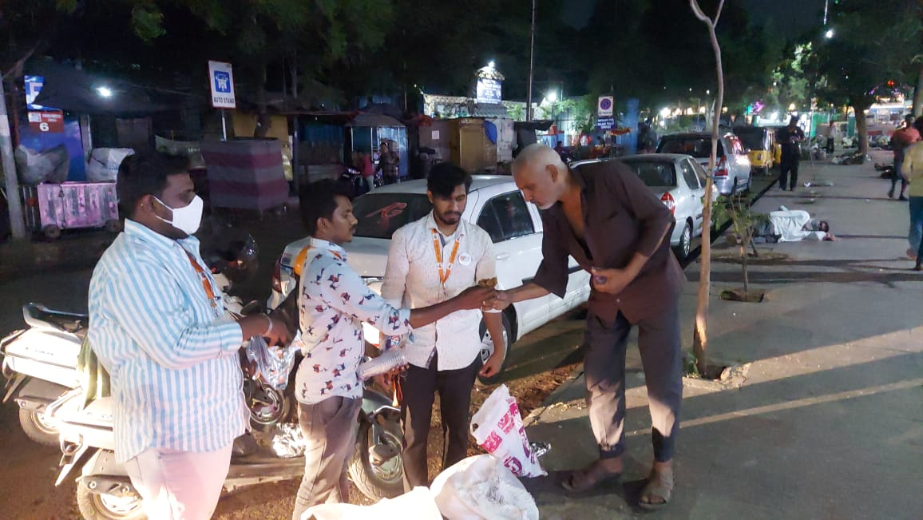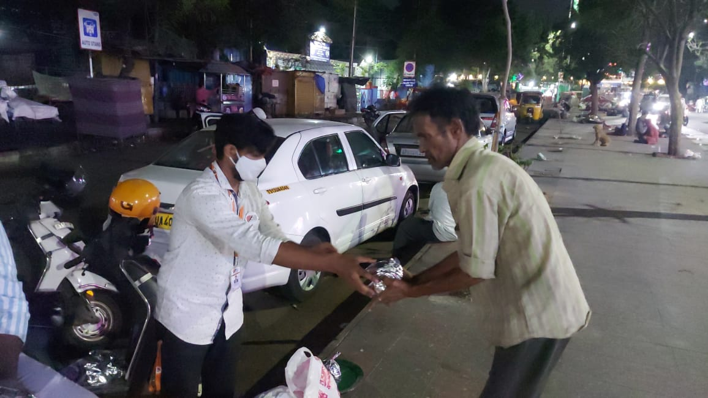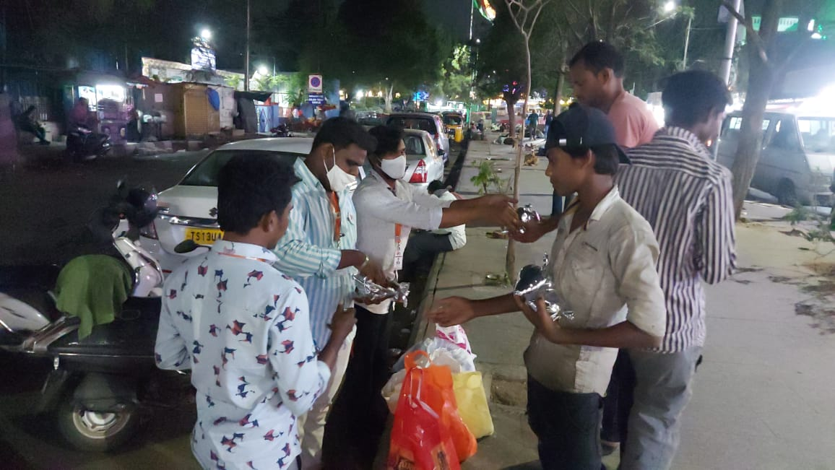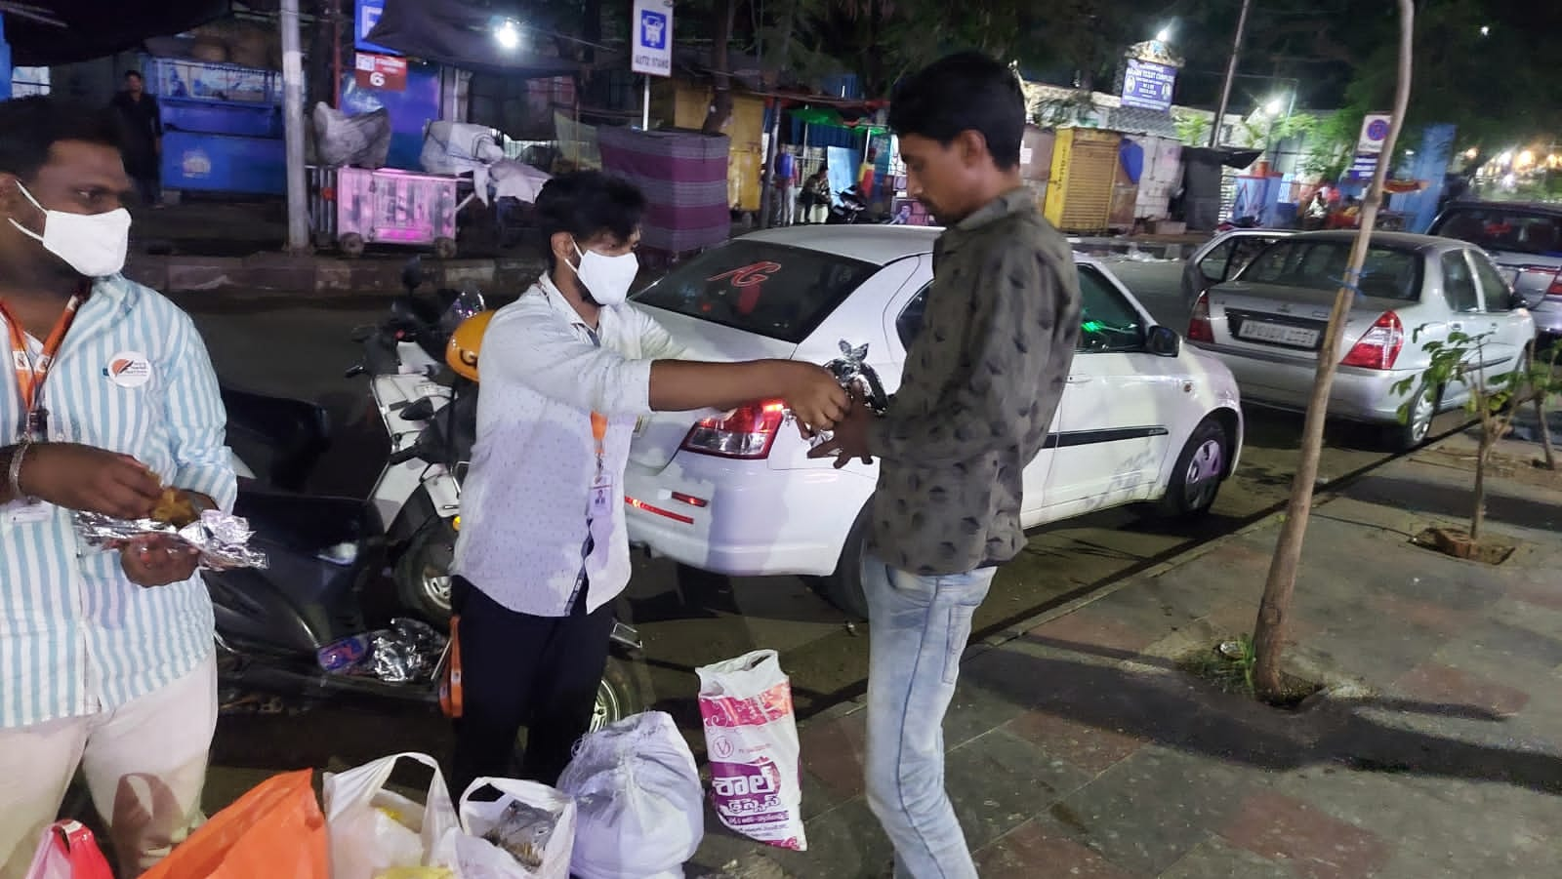

**EVENT-34**

We have distributed FOOD to 50 DOGS in the Hyderabad city on 18-04-2022. Distribution made by our volunteer Manish, on the occasion of his Birthday.

Done by MANISH.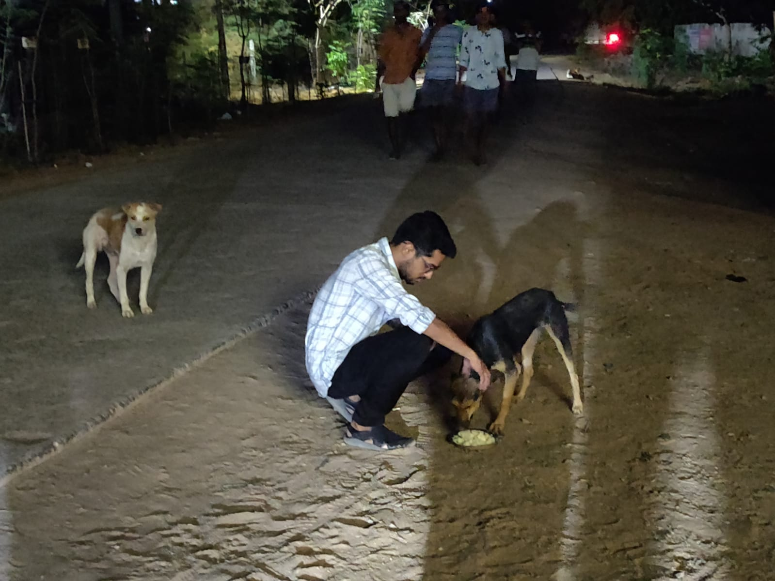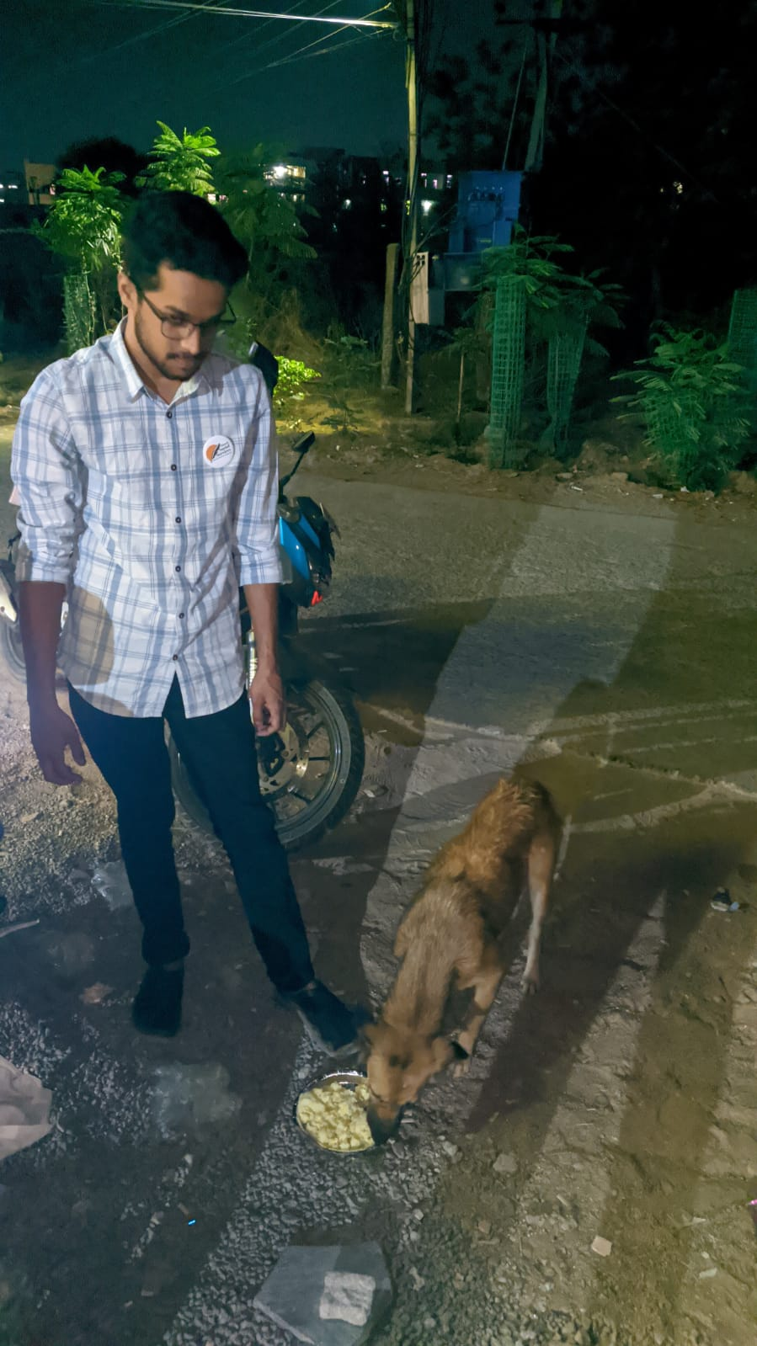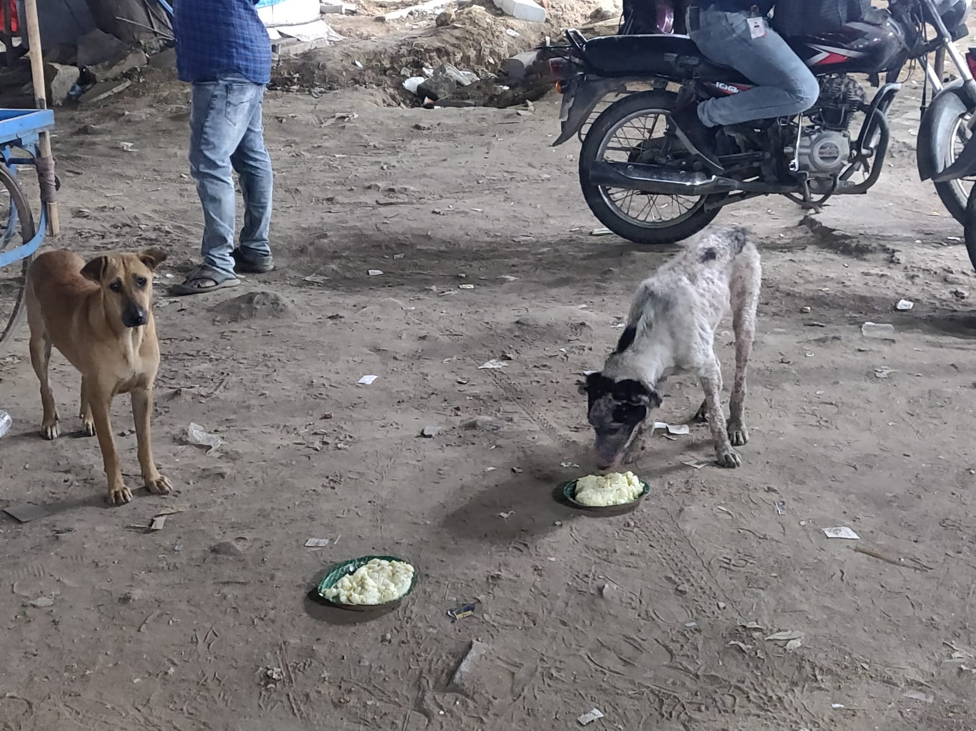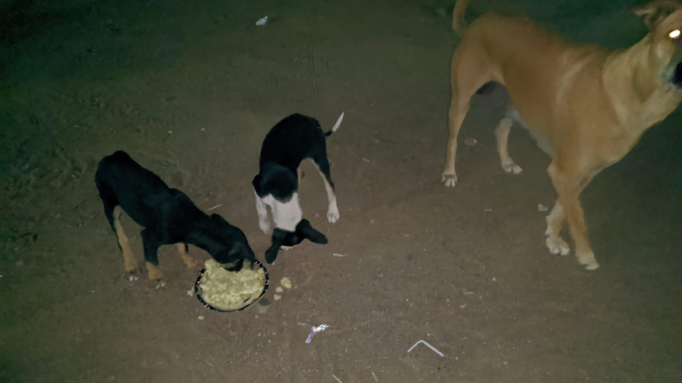

**VOLUNTEERING EVENT-3**

We have conducted a volunteering event on 22-04-2022, on the occasion of NATIONAL EARTH DAY at Malla Reddy Engineering College.

Done by M. KALYAN, T. NITHIN SAI, P.VISHAL, G.SAIRAM, K.NAVEEN, T.VASANTH, G.SUDARSHAN, L.HARSHA VARDHAN.

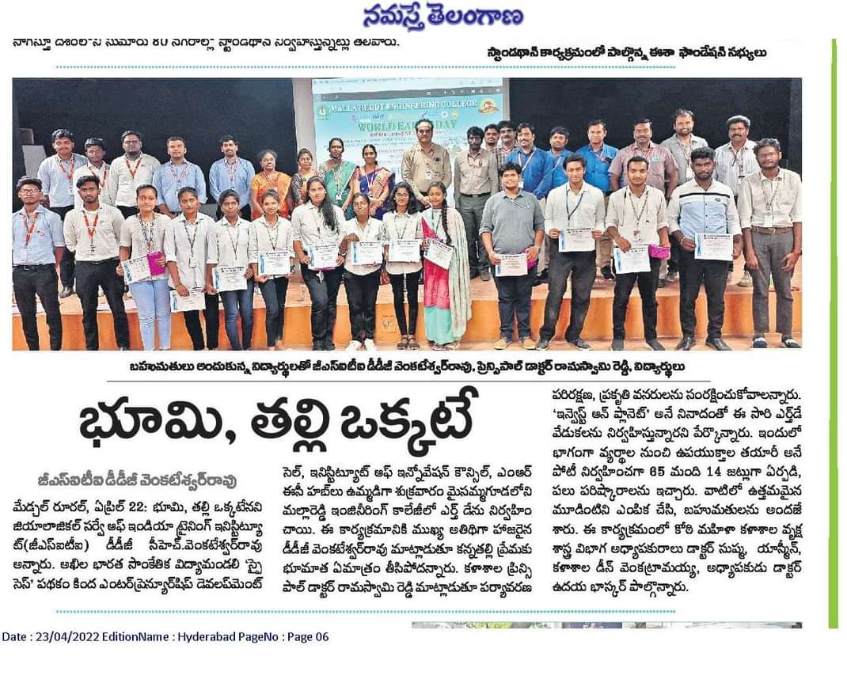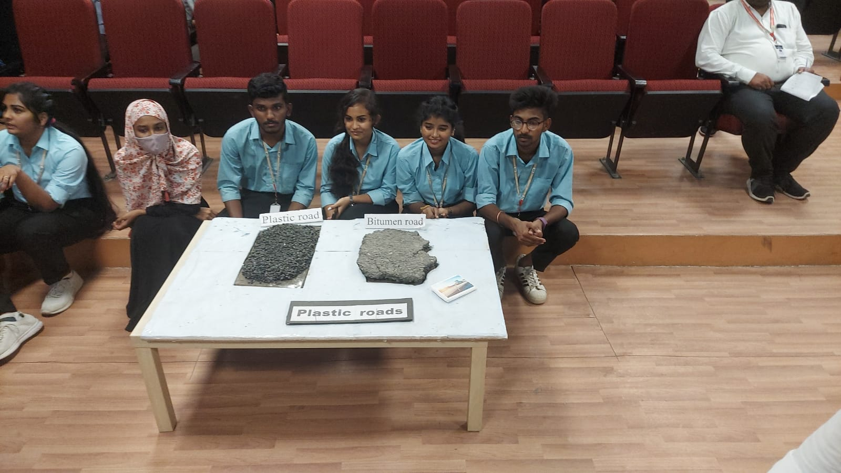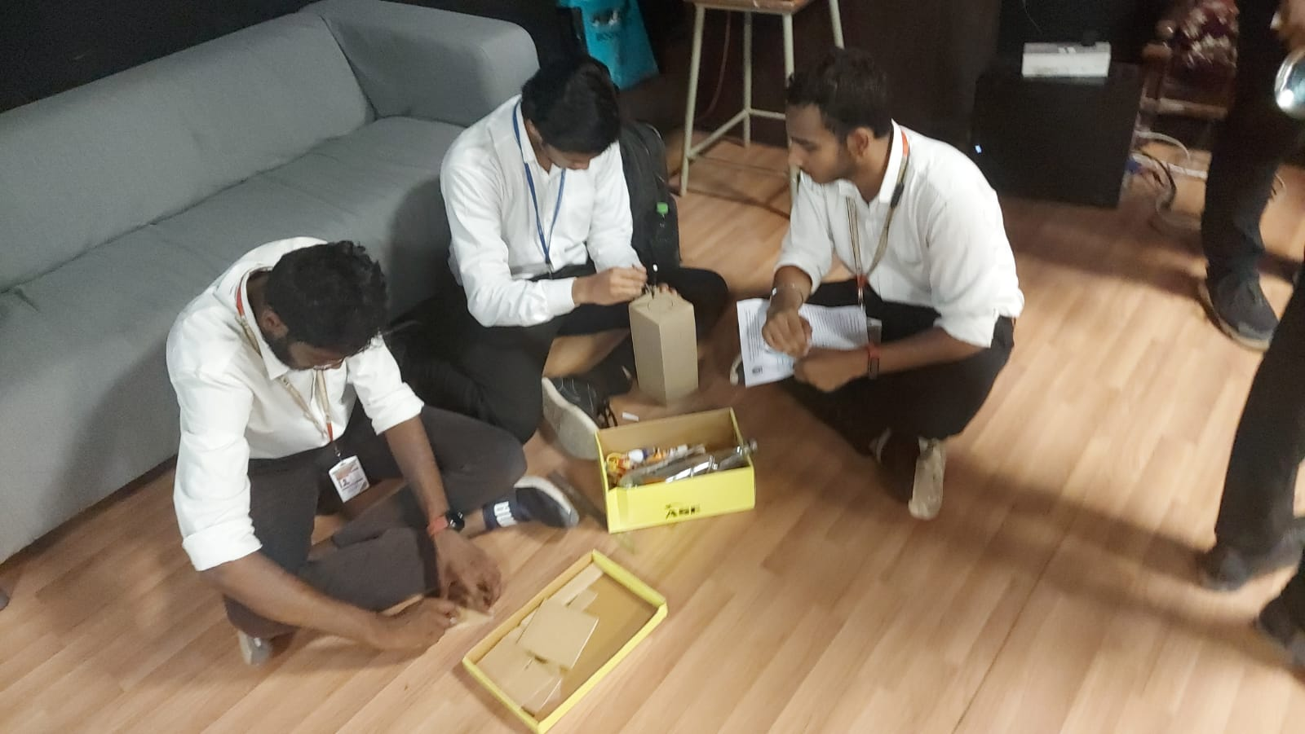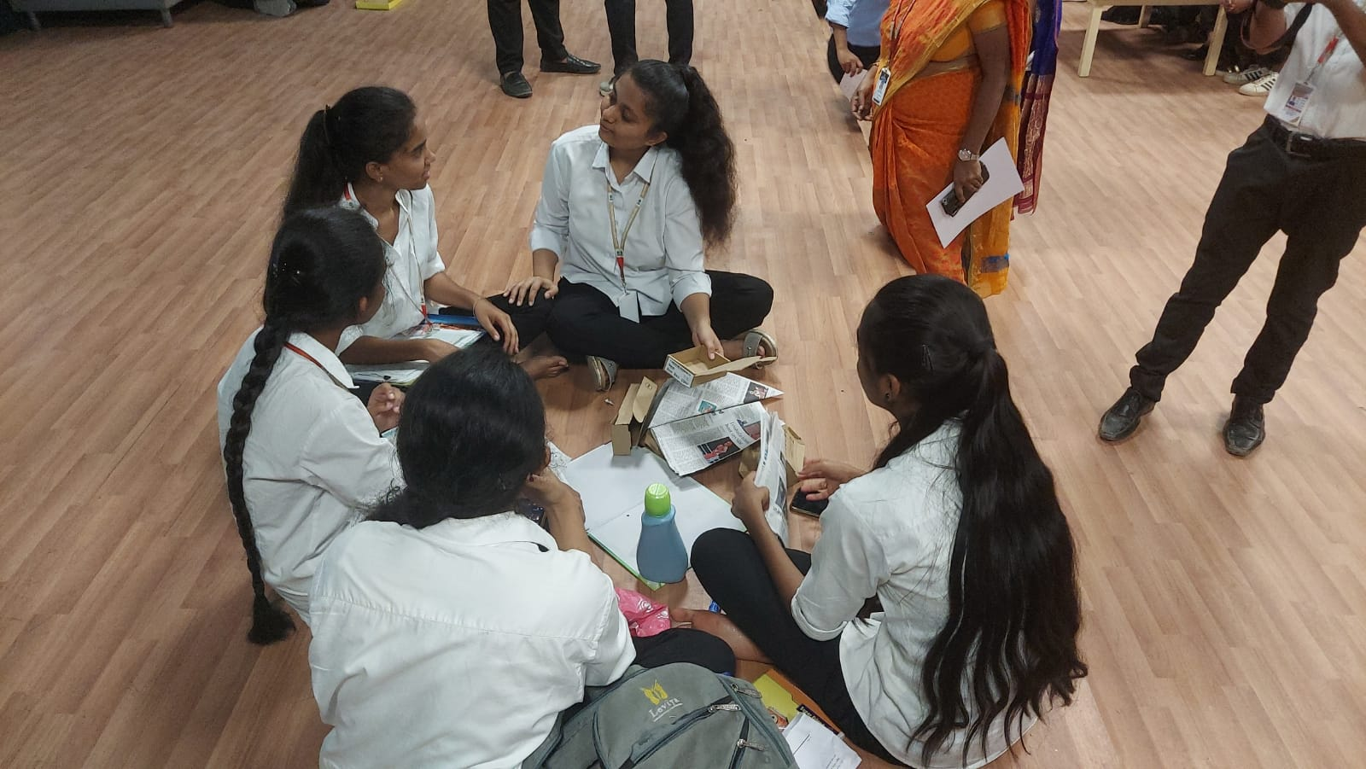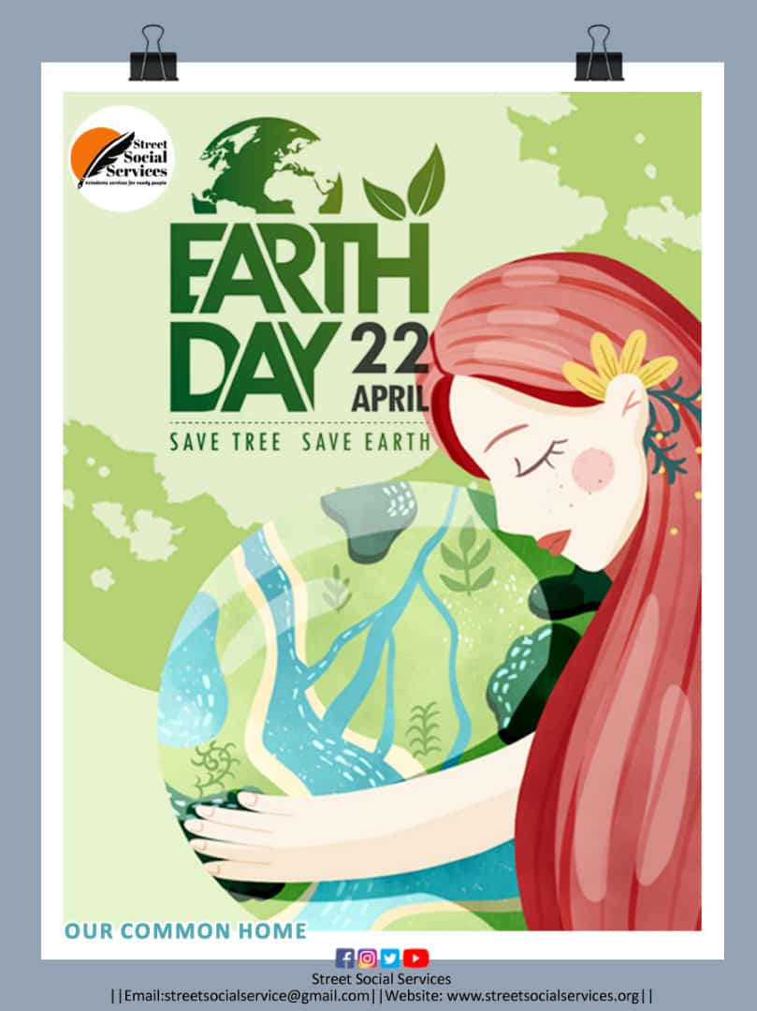

**EVENT-35**

We have distributed FOOD (MEALS) to 100+ people at GANDHI HOSPITAL Hyderabad city on 24-04-2022. Distribution made by our volunteers.

Done by K.GIRI BHARGAV, M.KALYAN, T. NITHIN SAI, G.SAIRAM, P.VISHAL, NAGARAJU, MANISH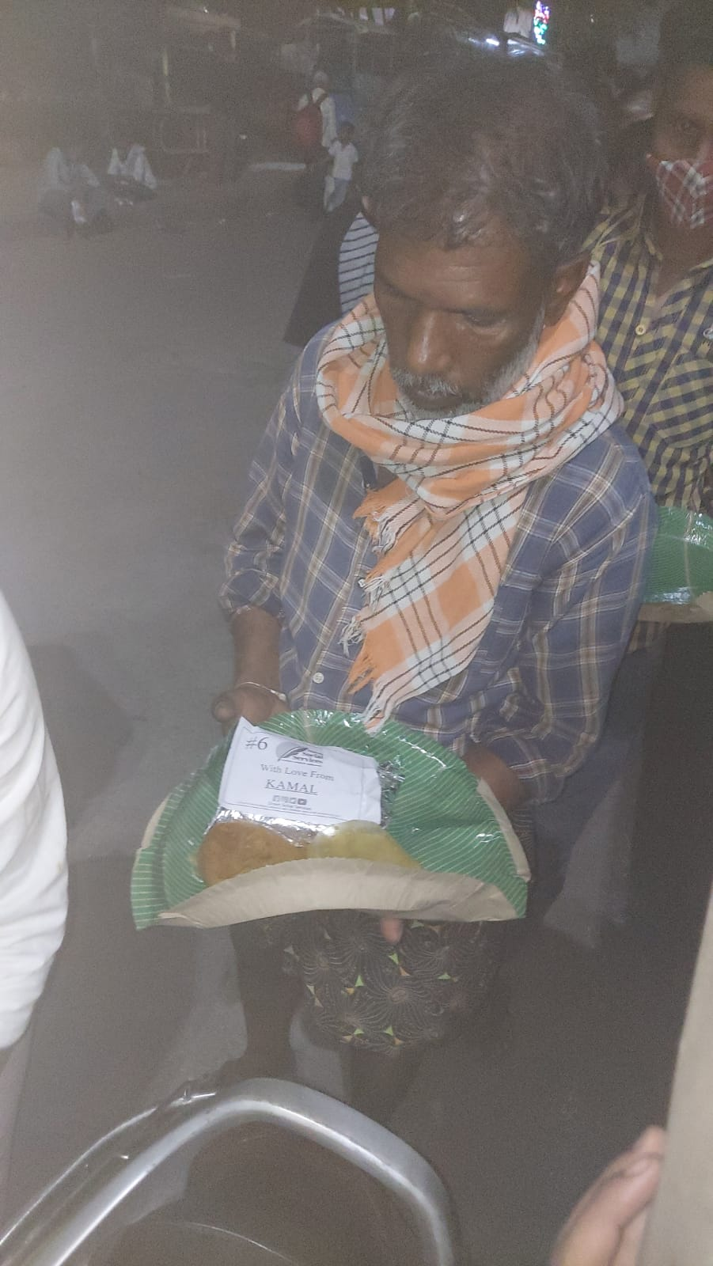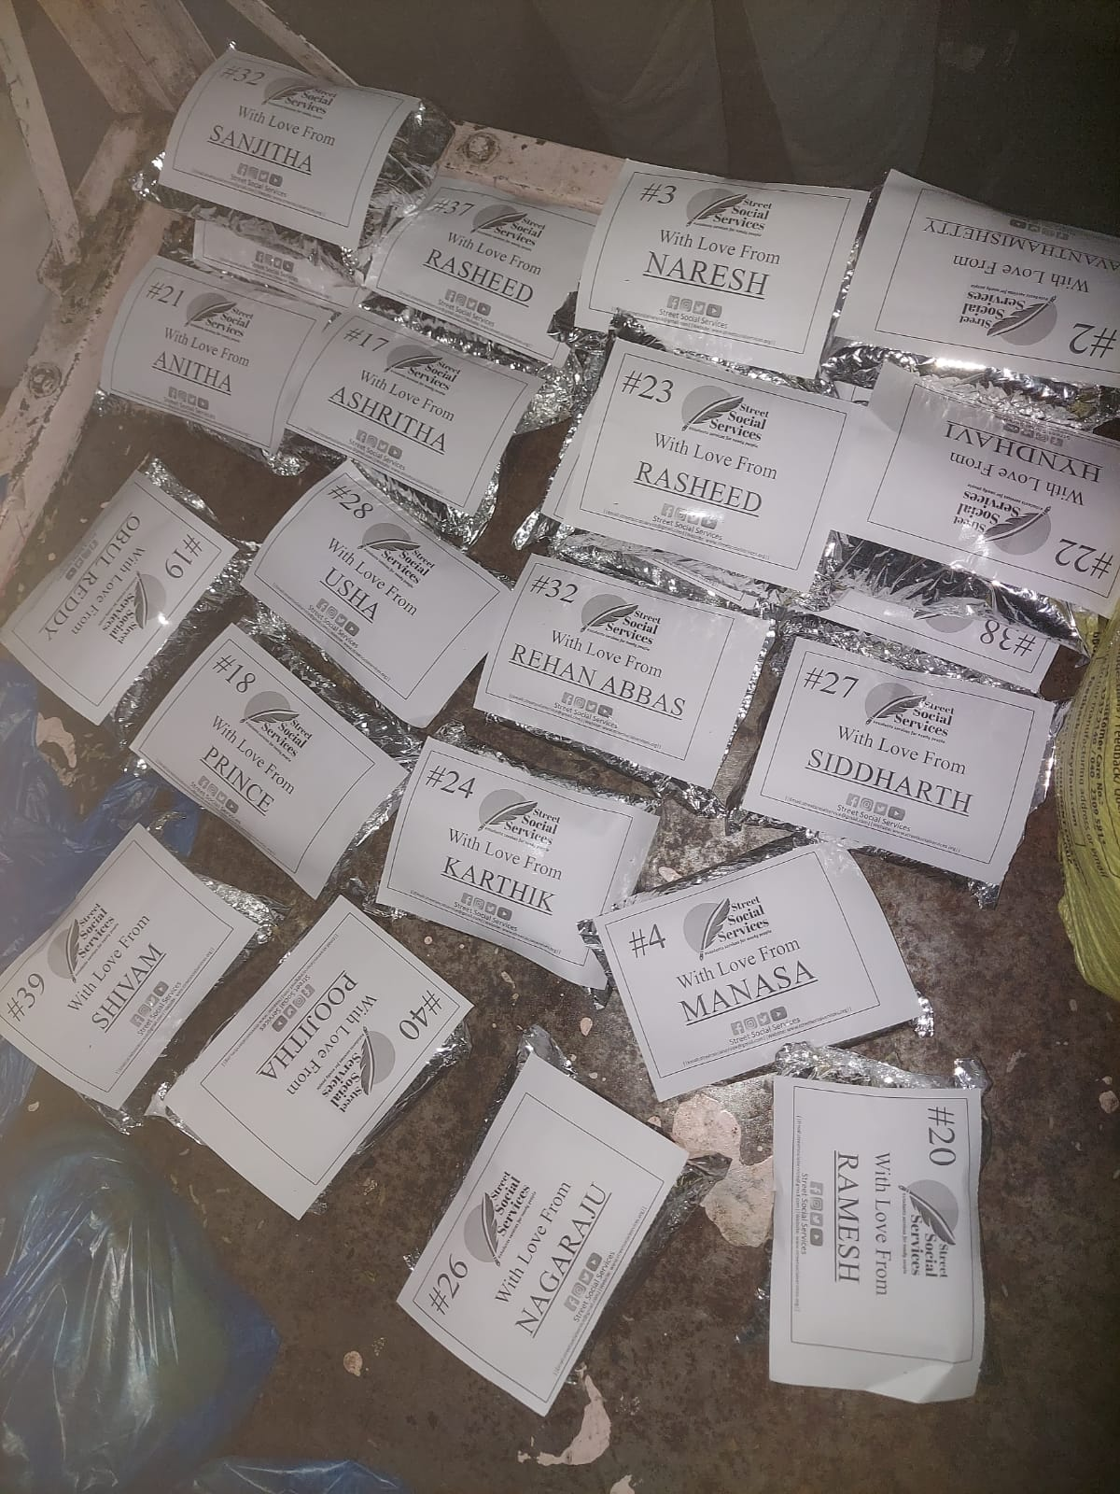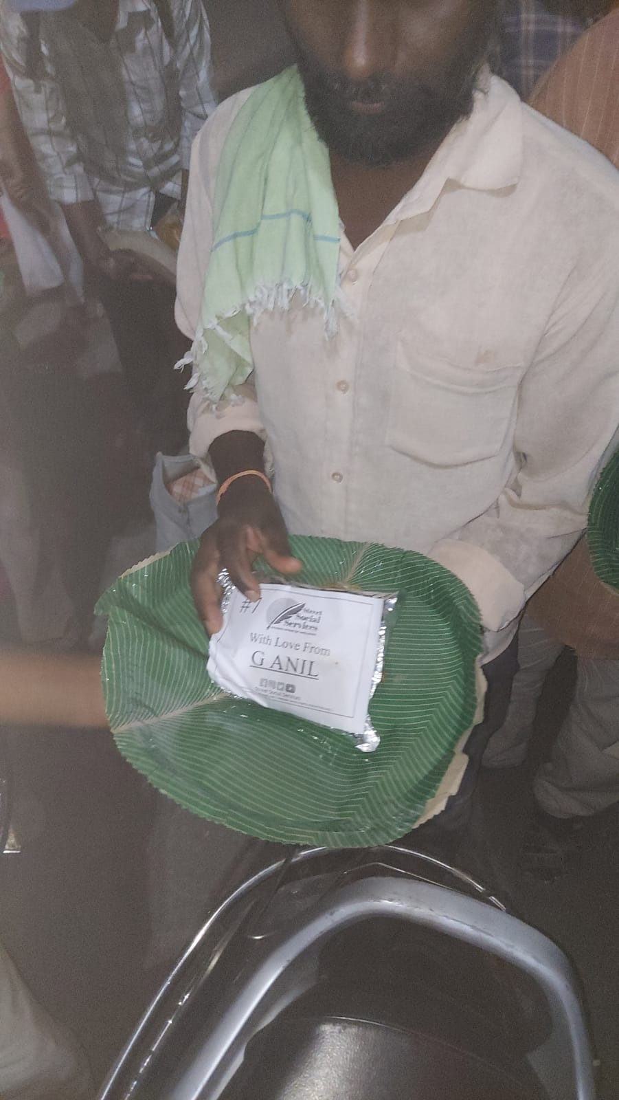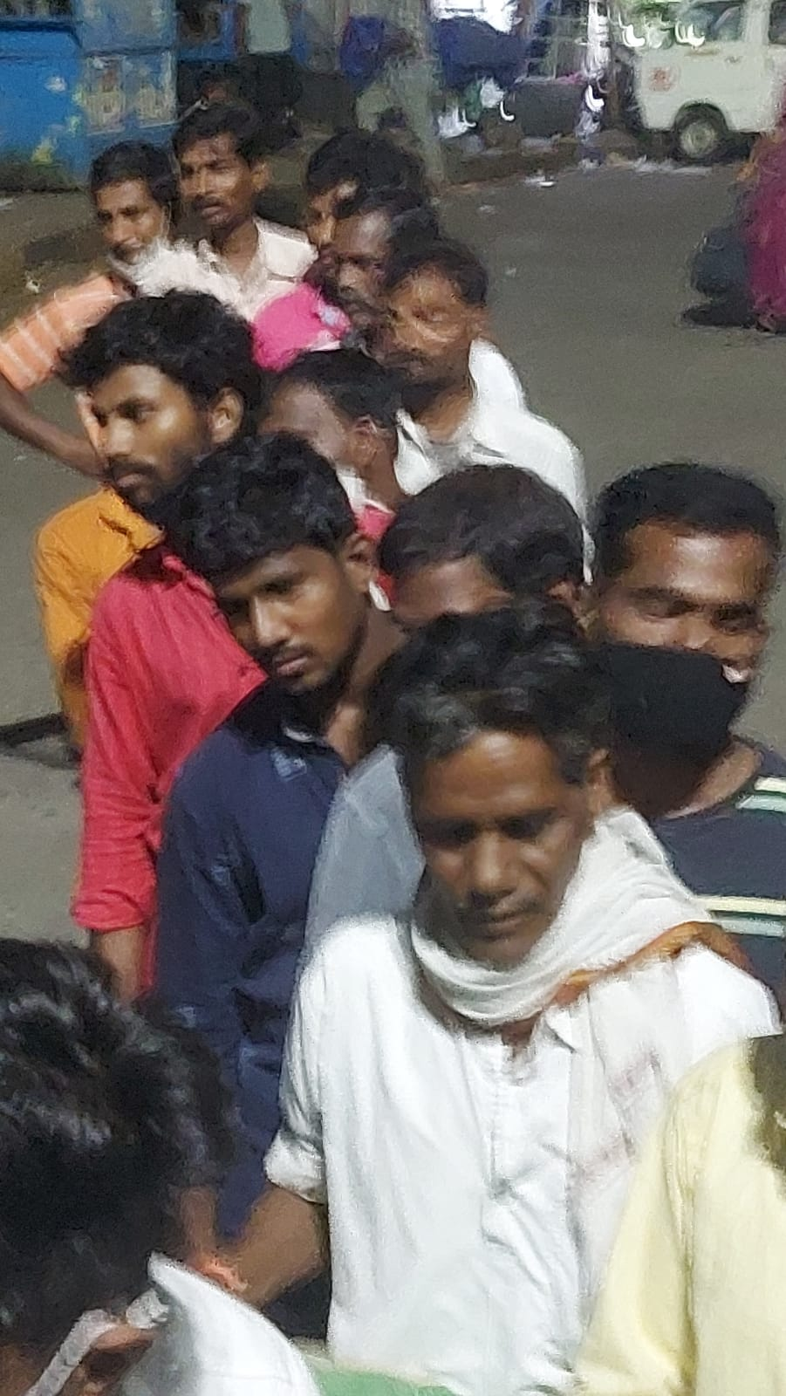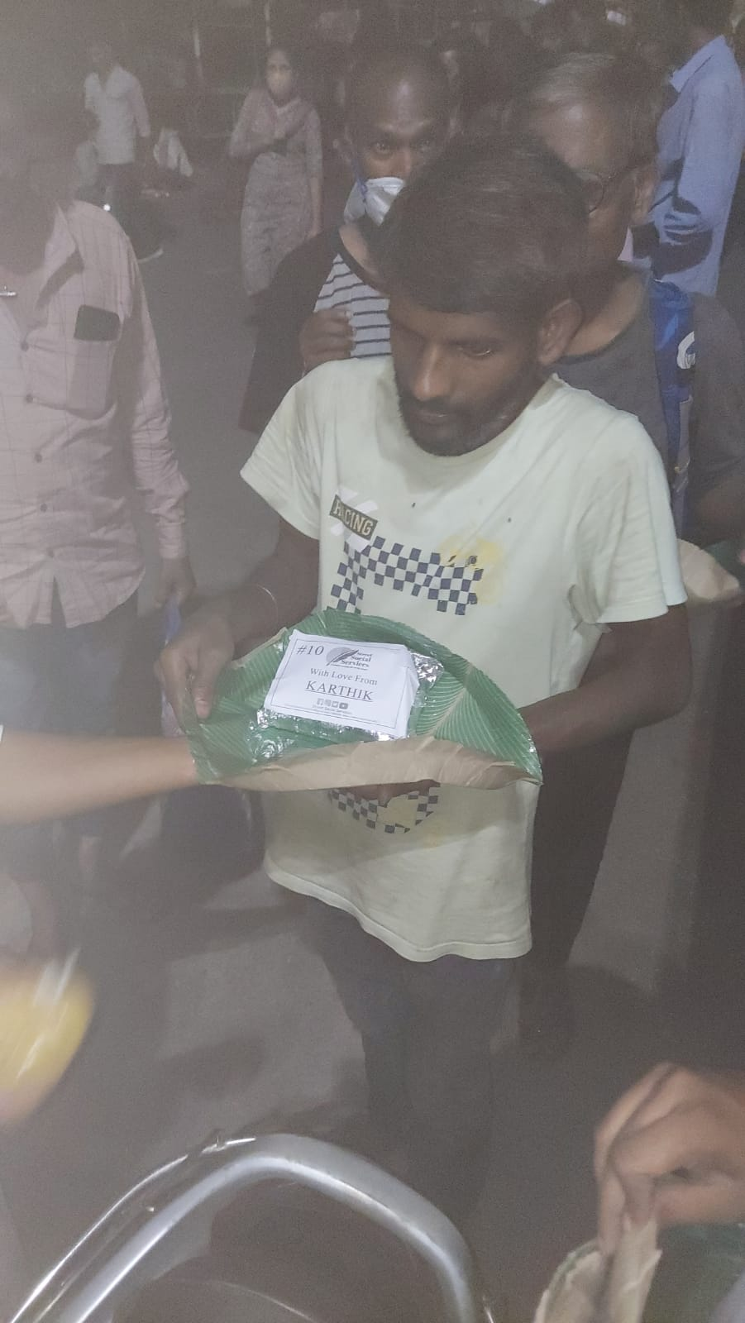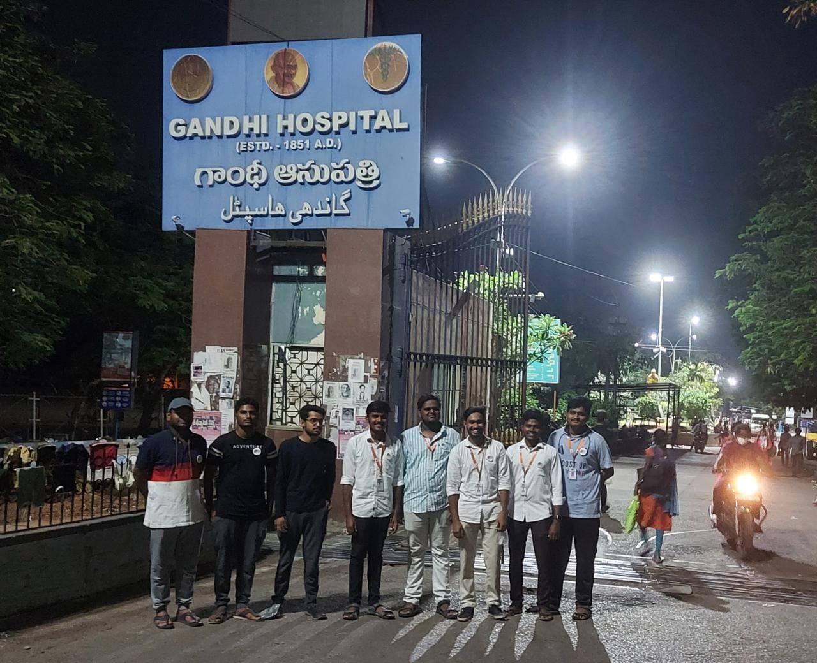

**EVENT-36**

We have